**Dynamic programming :**

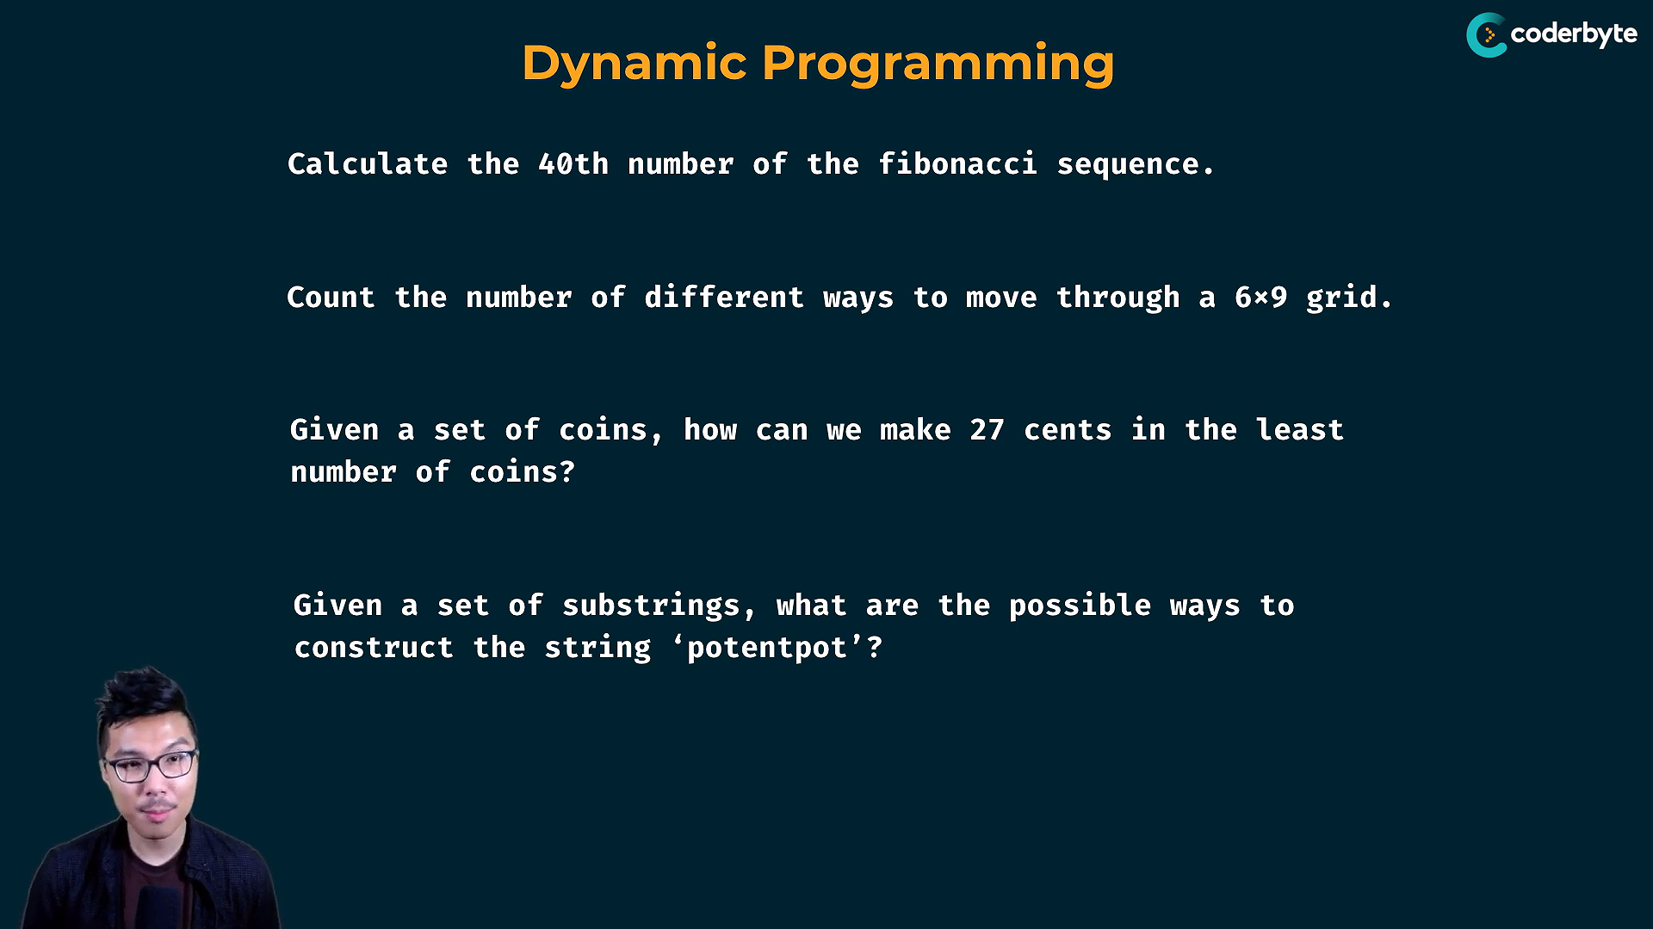

* to understand the working of dyn. prg. – observation of drawing structures is important
* dynamic prg. are solved by

1) memorization( top down approach)

2) tabulation( bottom up approach )

**Fib(n):**

fib(n) – cal. by finding fib n-1 and n-2

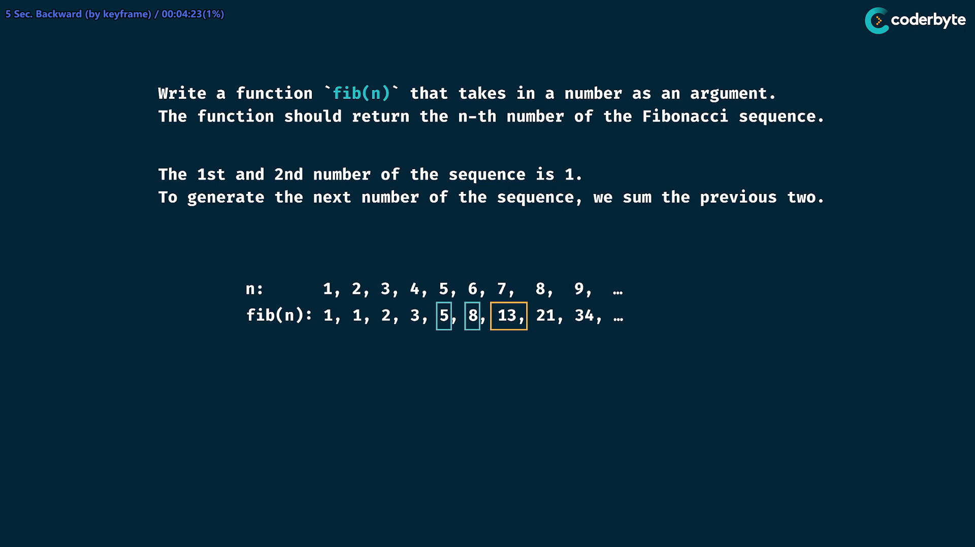

fib(7) = 13 , which is got by previous 2 fibs, i.e fib(5) + fib(6) = 5 + 8 = 13 //

    //+ classical recursive fib

*const* fib = (*n*) *=>* {

        if (*n* <= 2) return 1;

        return fib(*n*-1) + fib(*n*-2);

    };

    console.log(fib(6)) //=> 8

    console.log(fib(7)) //=> 13

    console.log(fib(8)) //=> 21

    console.log(fib(50)) //=> 12586269025 {takes long time}

This method gives correct answer , but for large value of n , it takes long time which is unofferable

fib(7) tree dig:

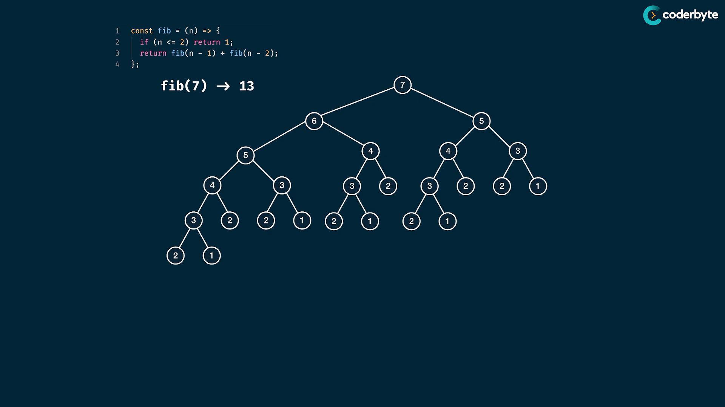

addition of left and right child returns are the parent values ..

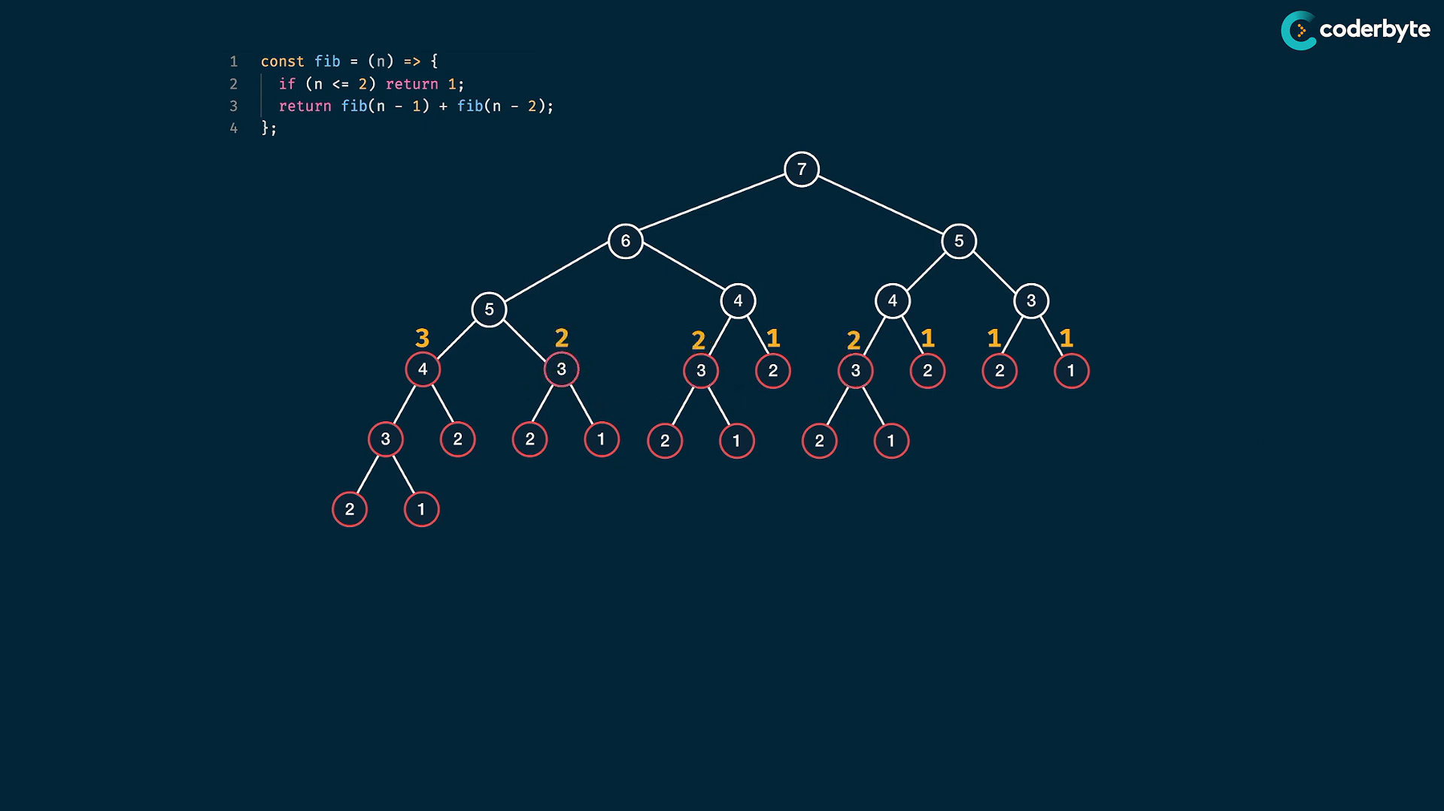

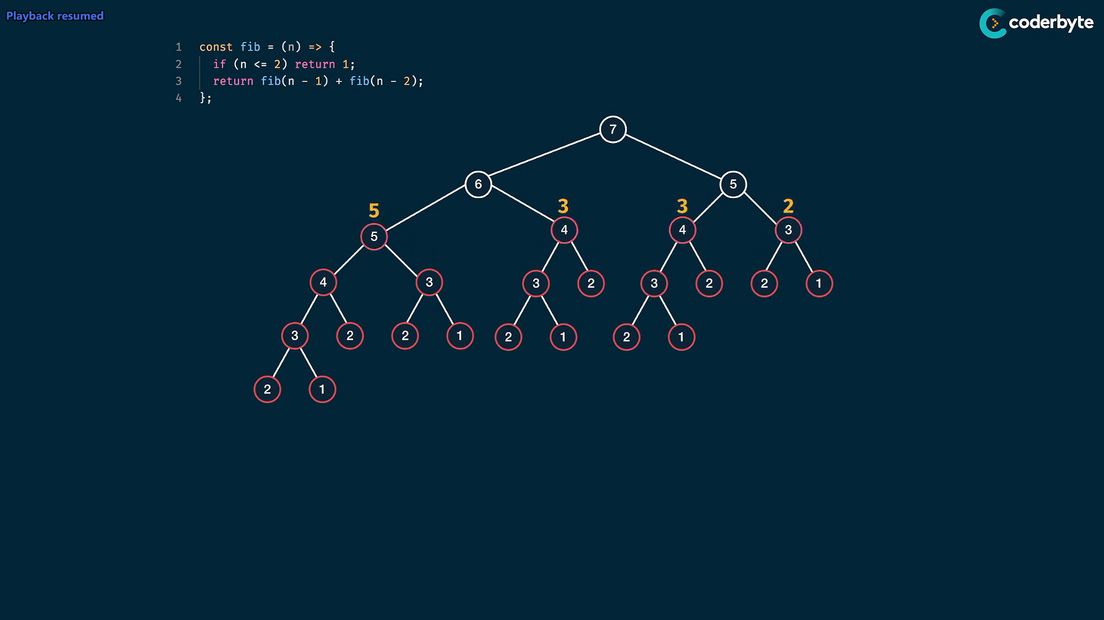

here the graph is asymentric , and the time complexity is 2^n …(which is for symentric , but here asymentric nodes are only calc by run time but they go atmost nodes which we get by symentric tree )

tim cmplx :

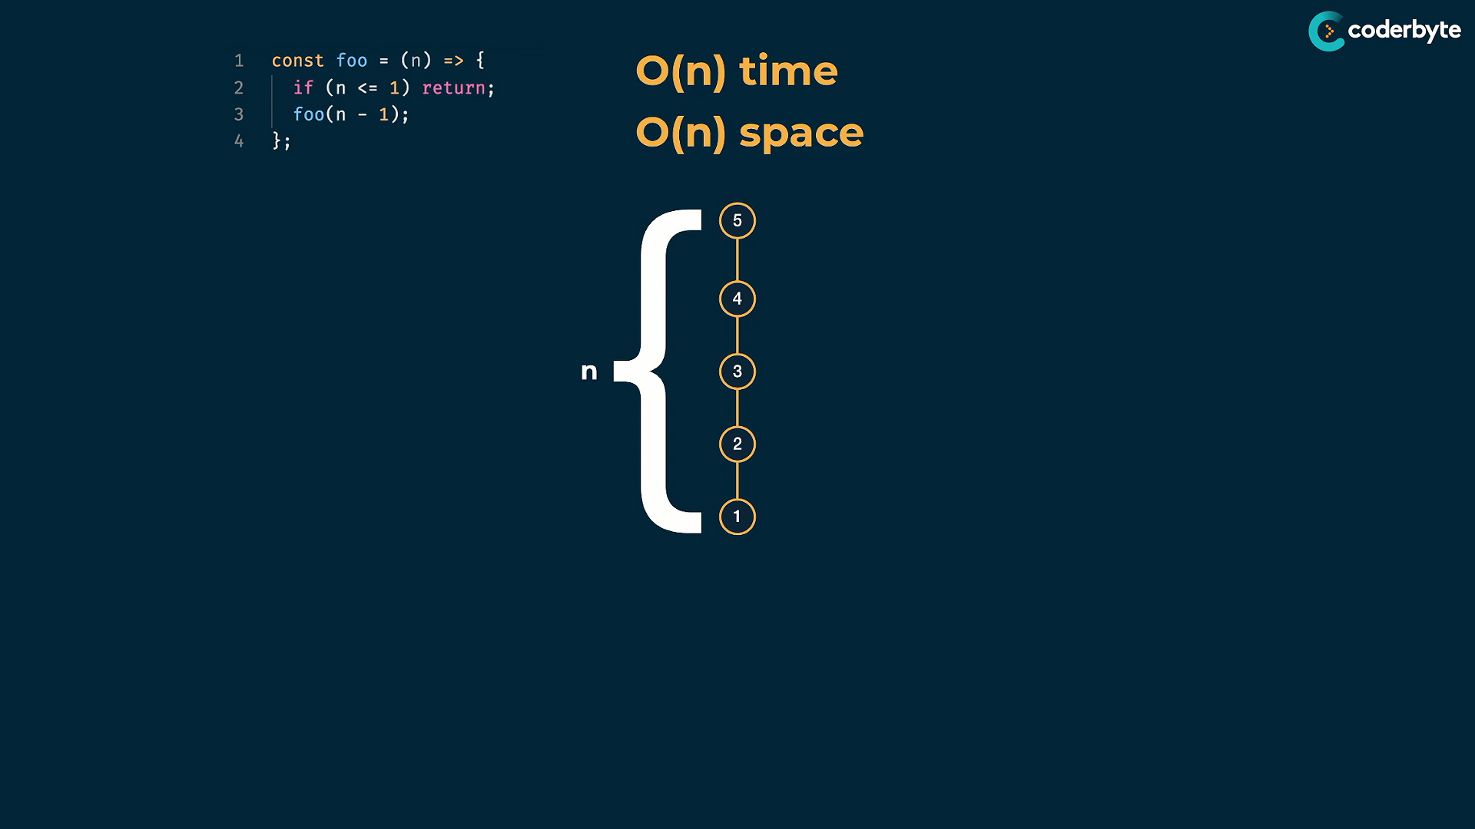

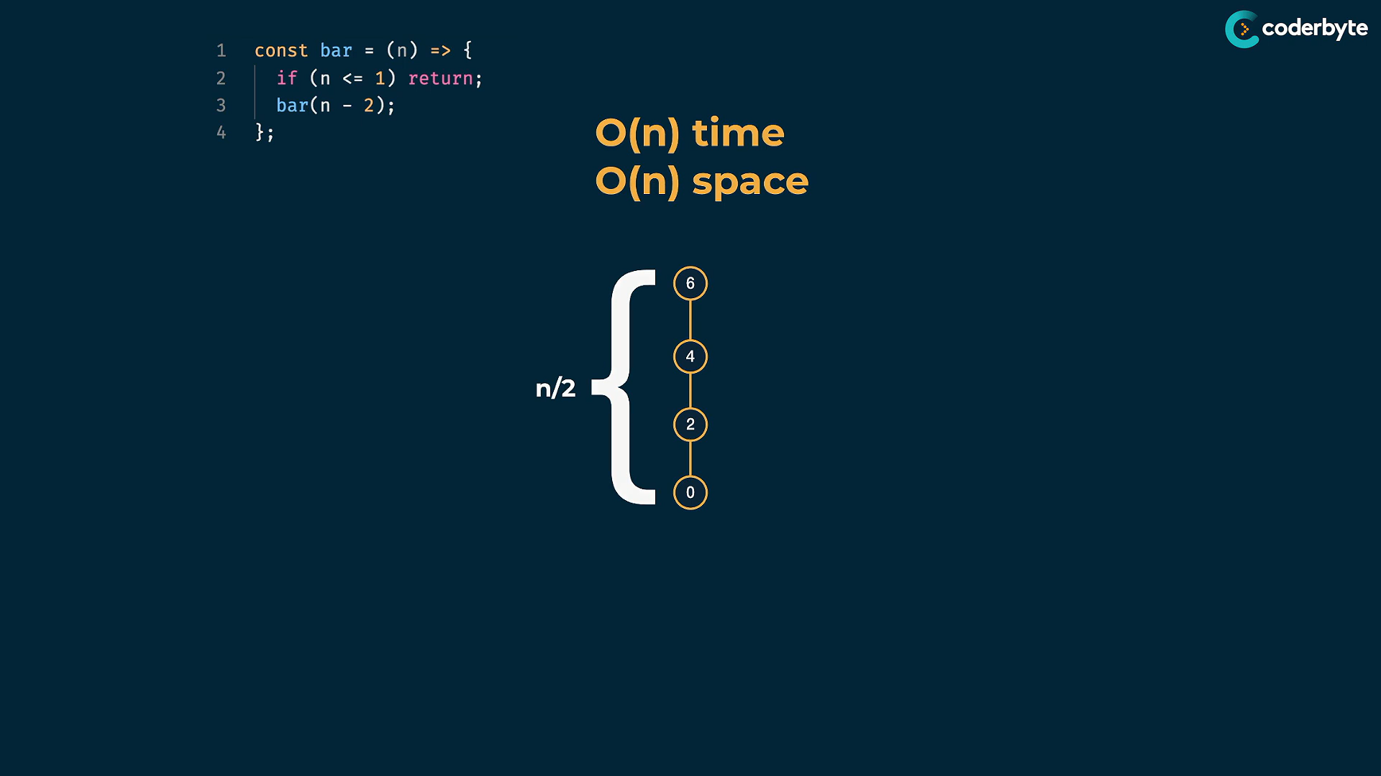

take foo(5),

O(n) time – time got since each time it calls other func. , so for n=5 , it has to call other 4 times fib with different parem ..

O(n) space – space is allocated by comp. in function stack space

take bar(5),recursive call is reducing by 2 , then time and space cmplx. is n/2 i.e approx. of O(n)…

above both are different recursive calls, but identical cmplx. so fib time cmplx is O(n^2)

fib spc:

height of tree – distance from root node to leaf node (to base case) ,here it is 5..

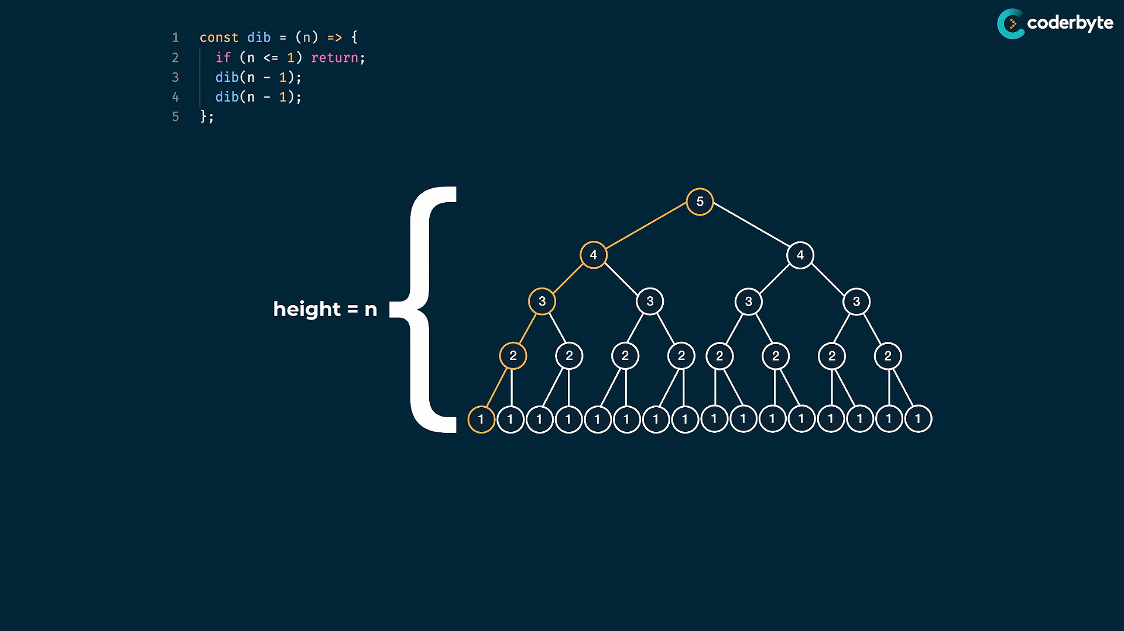

levels – collection of nodes that are same distance from the root

here no.of lvls = 5

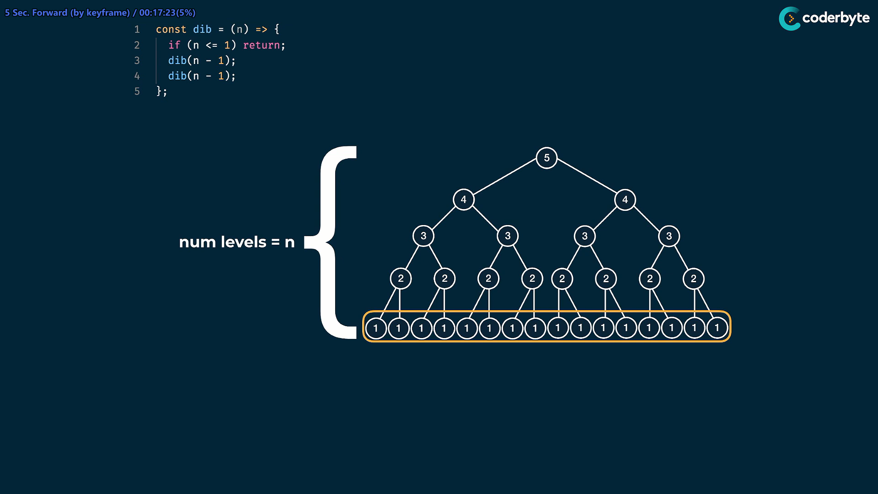

since 1st lvl has one node , then consecutive lvls have doubled the previous nodes count upto n lvls , so time cmplx is O(2^n)

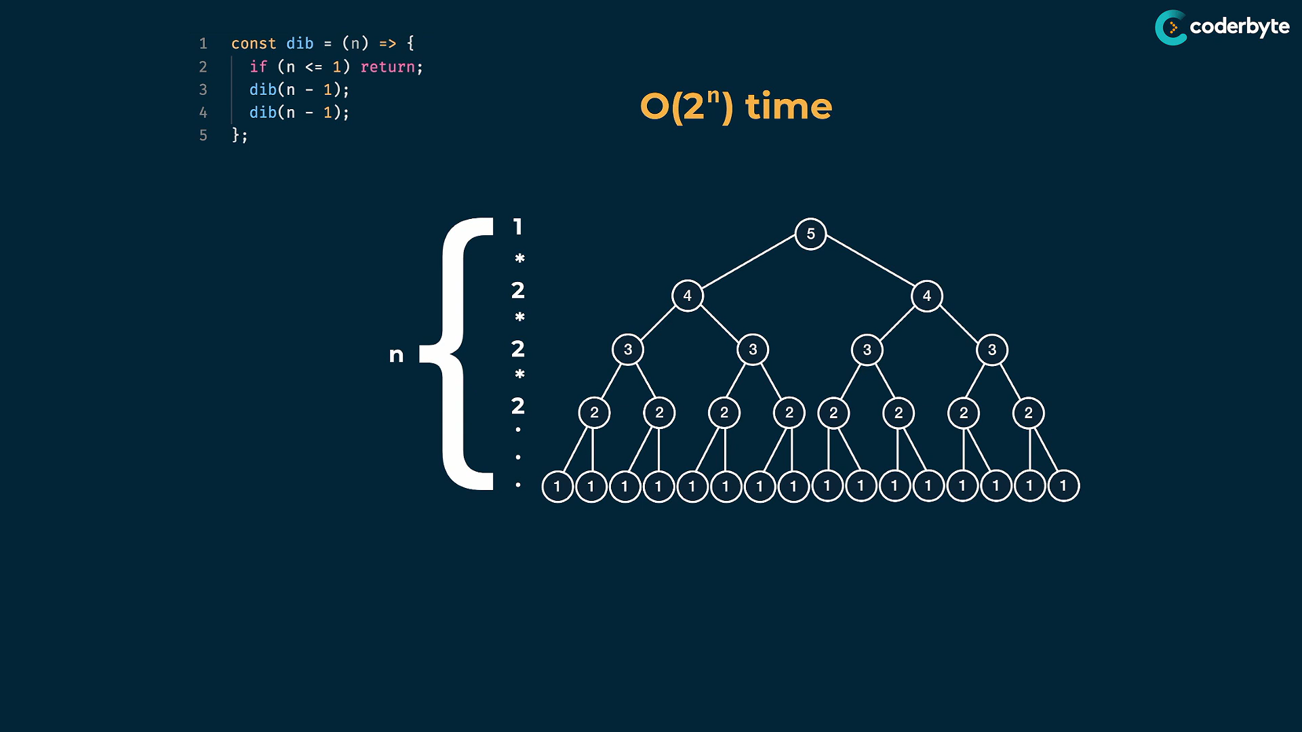

here symentric tree, so perfect O(n^2) tim cmplx …

but miserable mistake is – O(2^n) is not same for space cmplx.

becoz the call stack finishes one full path to the leaf node and go for next path.. so space cmplx. is O(n)

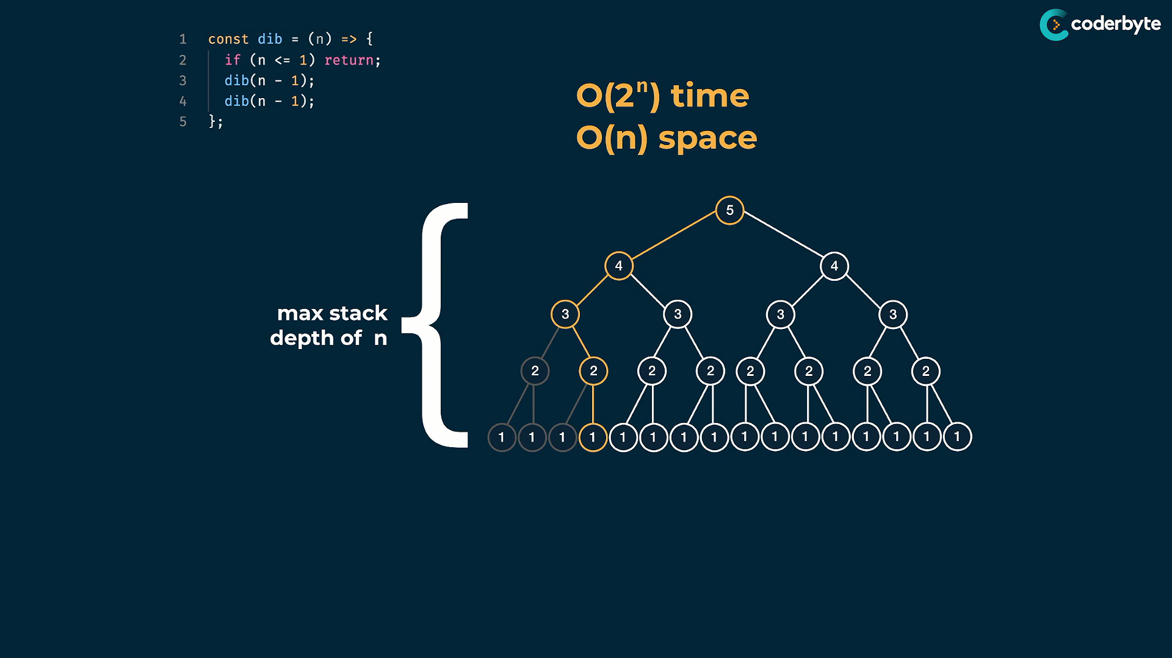

now for func(n - 2)

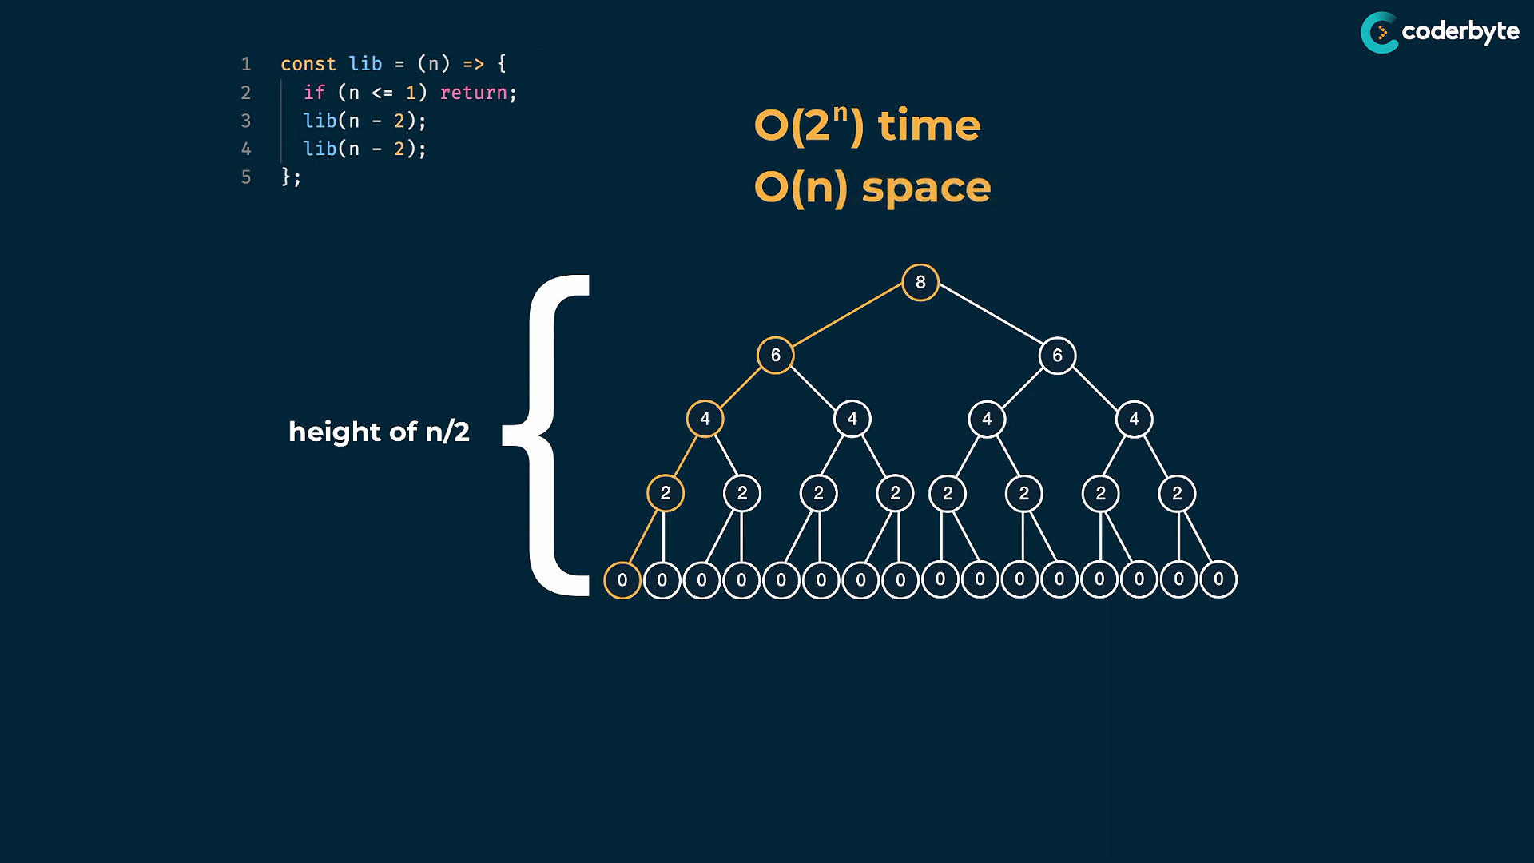

in this , time is O(2^n/2) and space is O(n/2) .. which is approx. . considered as O(2^n) and O(n)

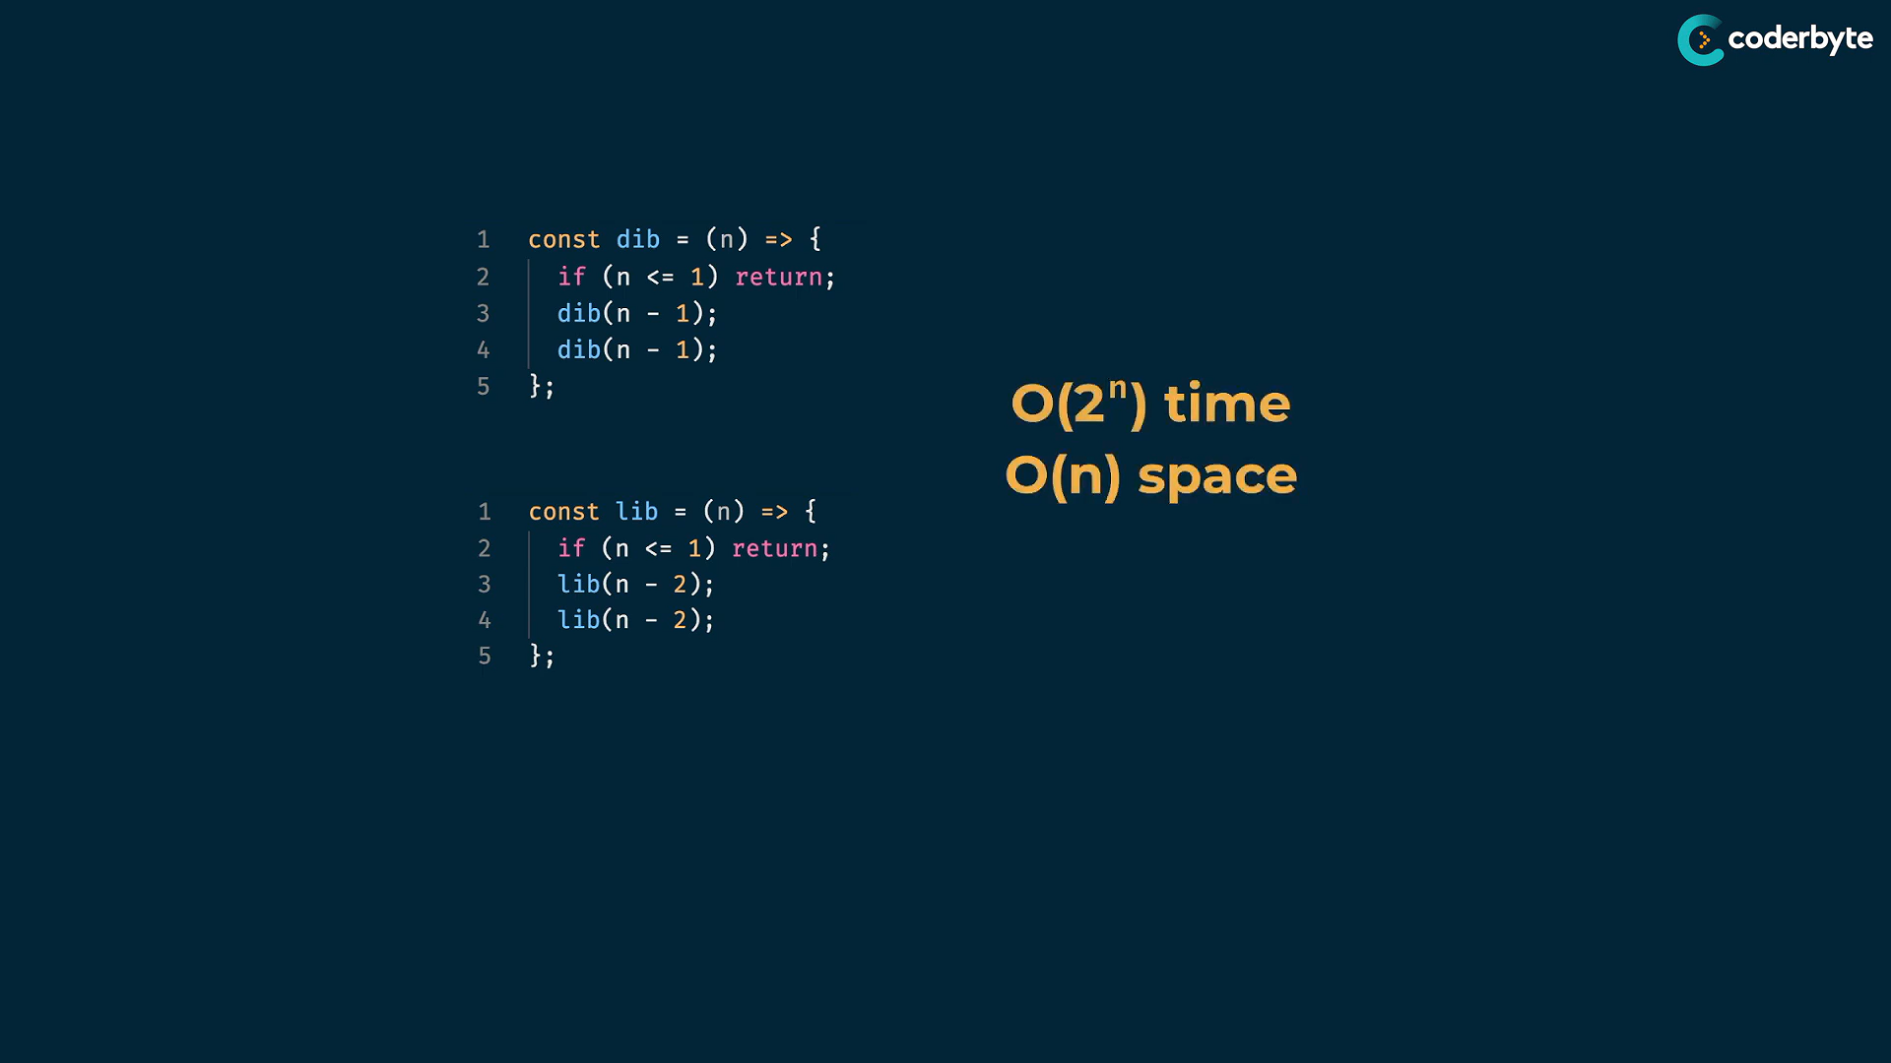

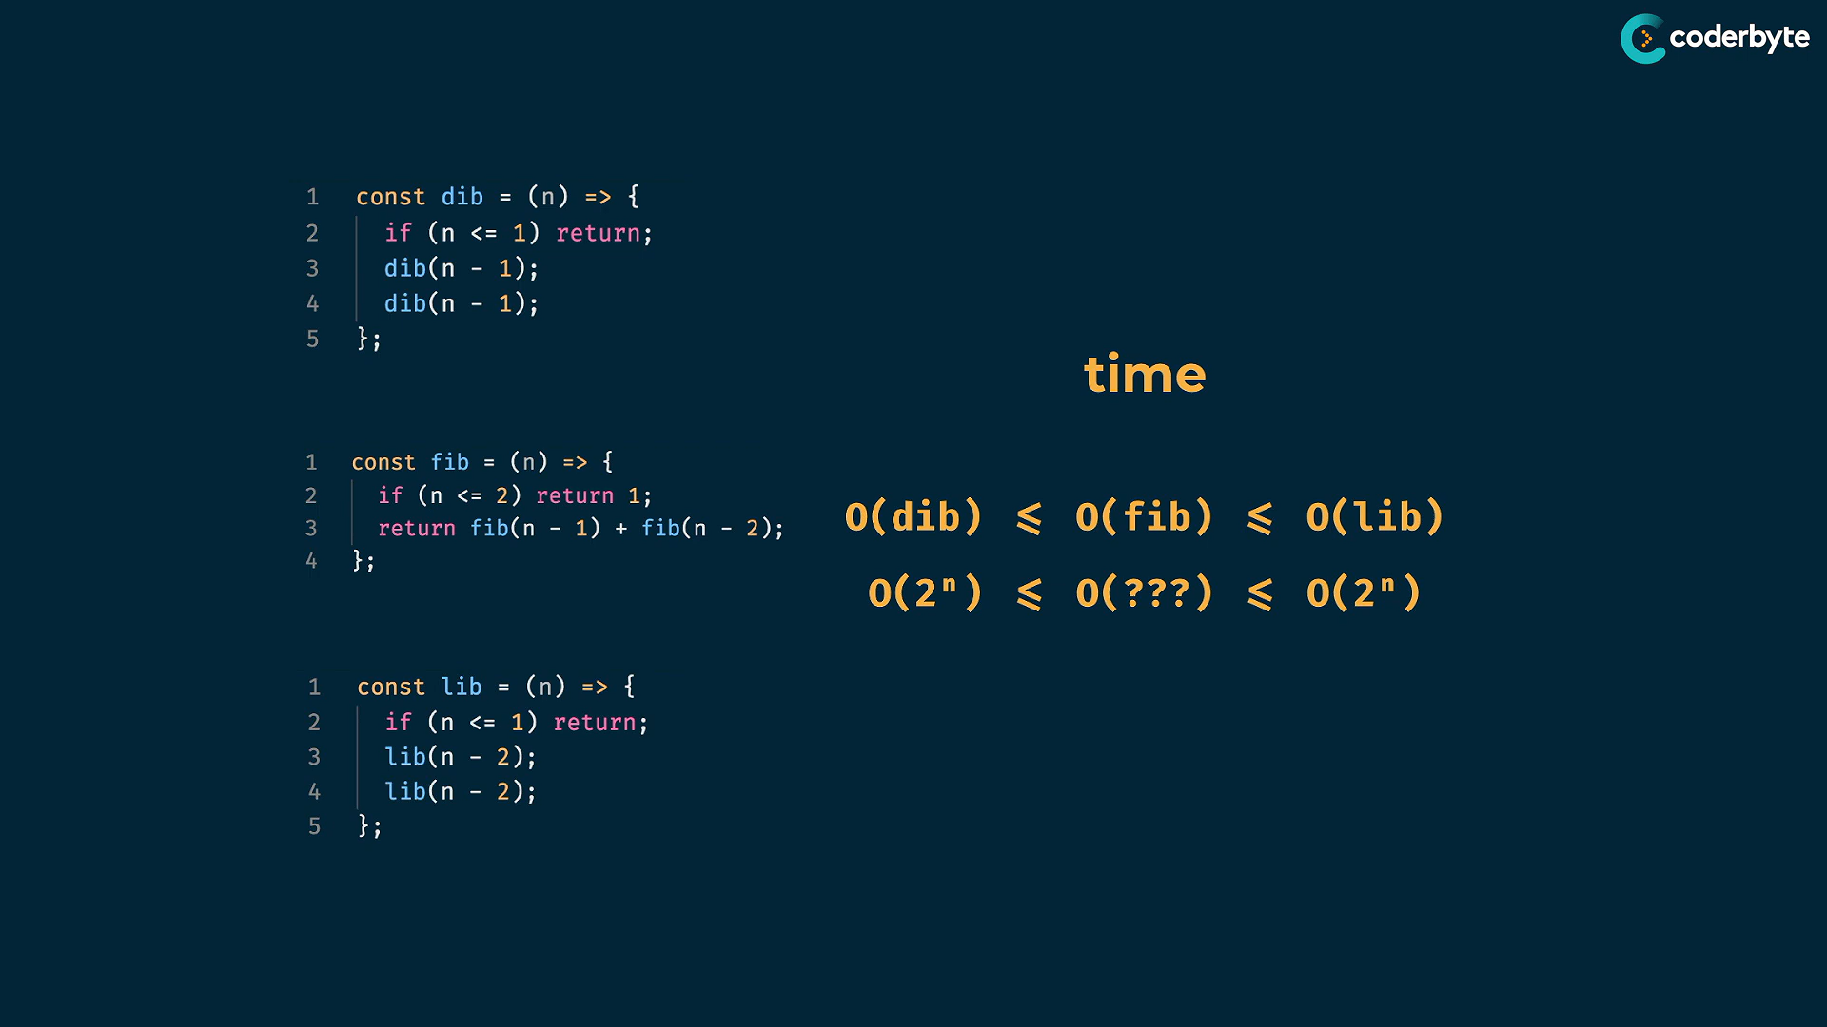

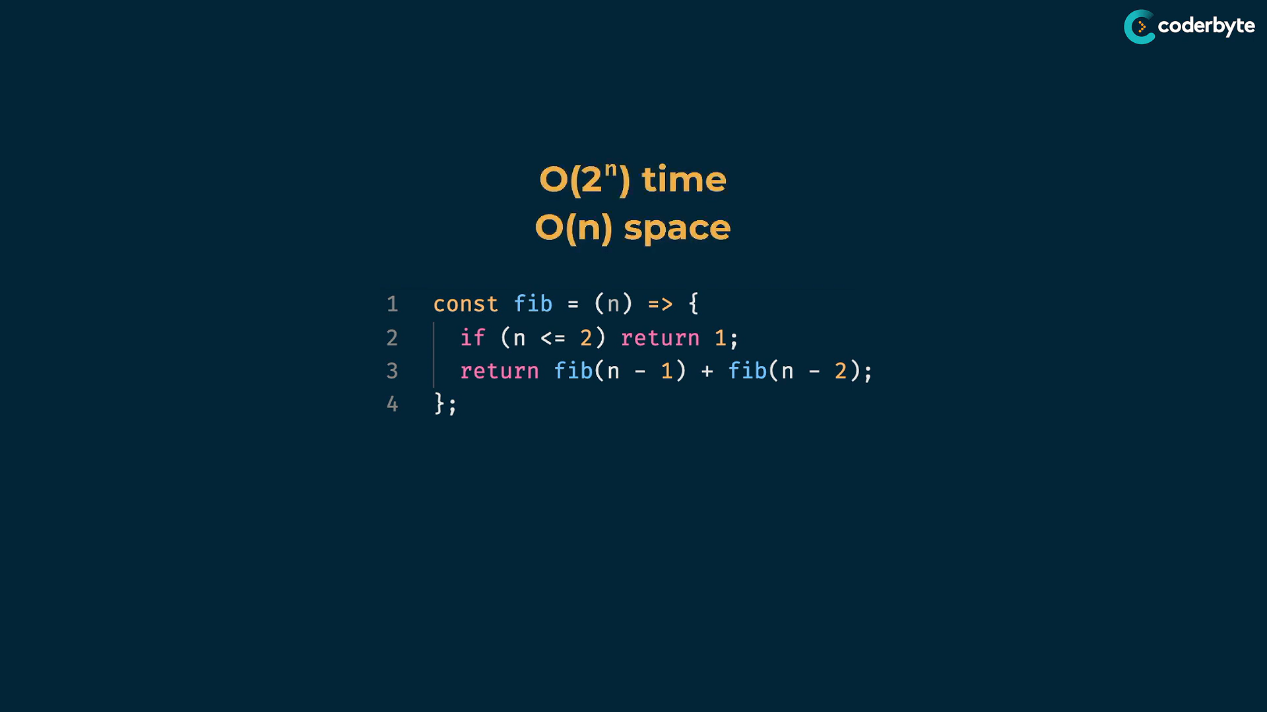

---

**need for dyn prg:**

But O(2^n) is very large time cmplx..

takes large num. of steps and recursive calls when input is greater ..

for n = 10,20,30,50 …. it gets more recusive calls like 1024 ,1048576 ,1073741824 , 1125899906842624 etc .. which is so high..hence we need dynamic programming here …

we can see the repeation of the same steps i.e duplications , which makes the prob. run longer..

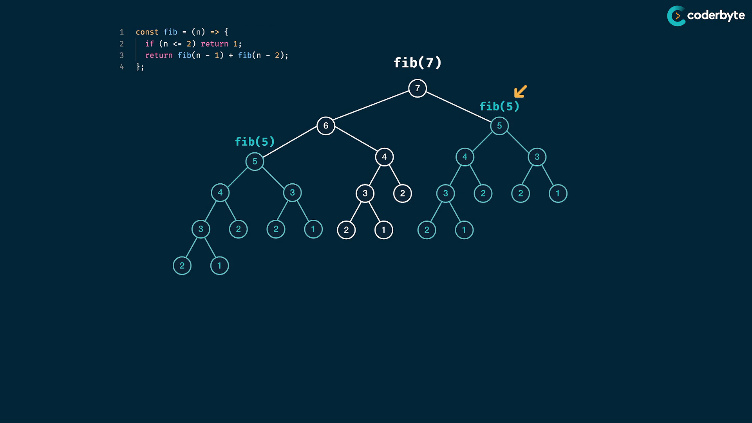

here , fib(5) can be calc. twice , which can be calc once and reused ..

This pattern of overlapping subprob. is called dynamic programming

**Dynamic programming:**

Any instance where we have larger prob. , we can decompose it into smaller instances of the same prob. and also having overlapping structures

**Memoization:**

memoziation fib:

    //+ memoization fib

*const* fib = (*n*, *memo* = {}) *=>* {

        if(*n* in *memo*)  return *memo*[*n*];

        if (*n* <=2) return 1;

*memo*[*n*] = fib(*n*-1,*memo*) + fib(*n*-2,*memo*);

        return *memo*[*n*];

    };

    console.log(fib(1)) //=> 1

    console.log(fib(2)) //=> 1

    console.log(fib(6)) //=> 8

    console.log(fib(7)) //=> 13

    console.log(fib(8)) //=> 21

    console.log(fib(50)) //=> 12586269025

further updation:

//+ moi fib

//memo - hash map

// key - arg of func , here n

// value - return value of n i.e fib(n)

const fib = (n,memo={1:1,2:1}) => {

   // in - checks key of json and return bol

   if(n in memo) return memo[n]; // rtn stored value

   memo[n] = fib(n-1,memo)+fib(n-2,memo) // clc new val

   return memo[n]; // rtn clc val

}

console.log(fib(1)) //=> 1

console.log(fib(2)) //=> 1

console.log(fib(6)) //=> 8

console.log(fib(7)) //=> 13

console.log(fib(8)) //=> 21

console.log(fib(50)) //=> 12586269025

**Complexity changes:**

**tracing for tree structure :**

at left most , the path is fully driven on its own..

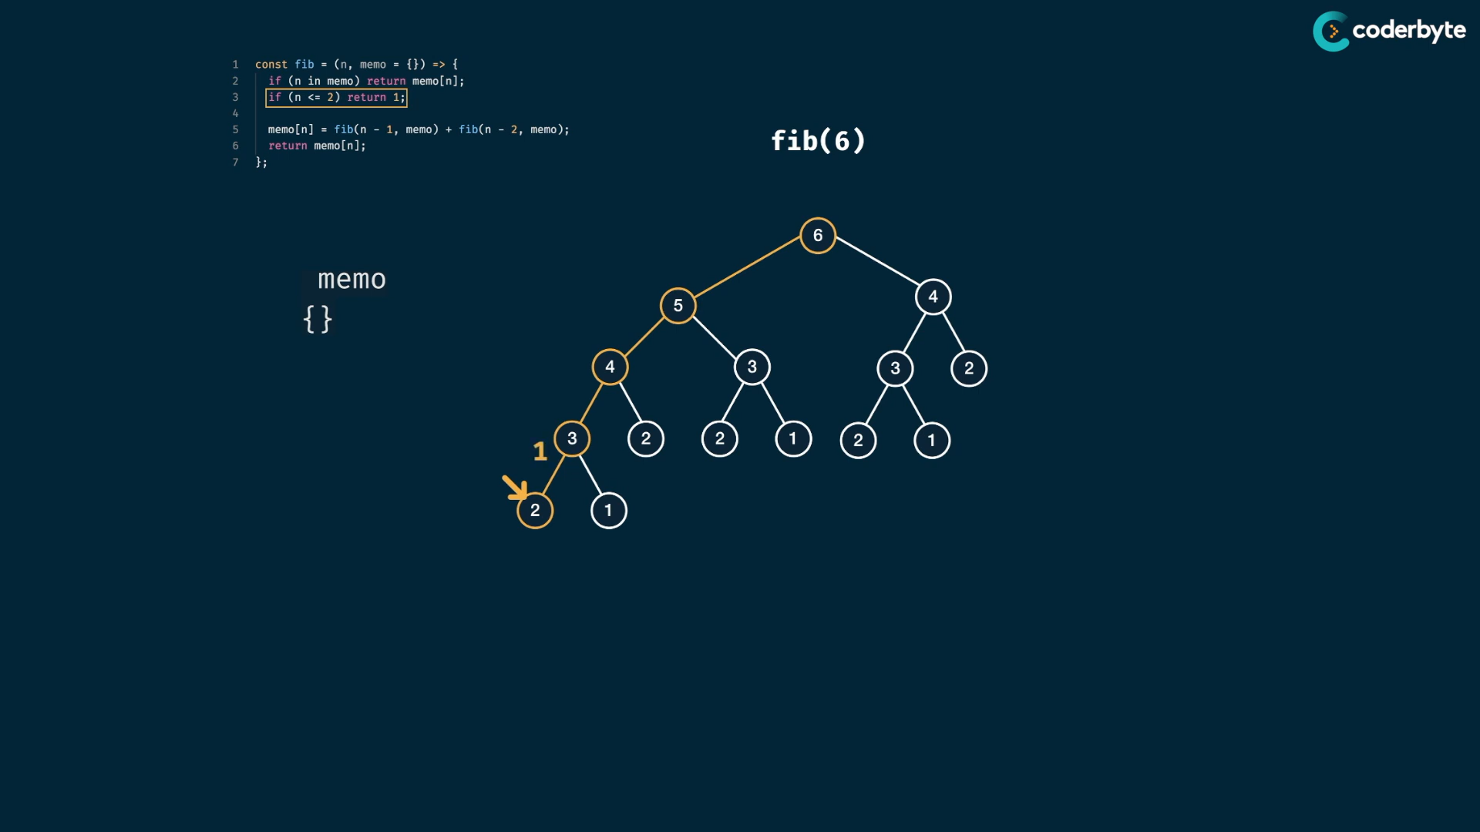

Each time of path end , the result is stored in memo obj.

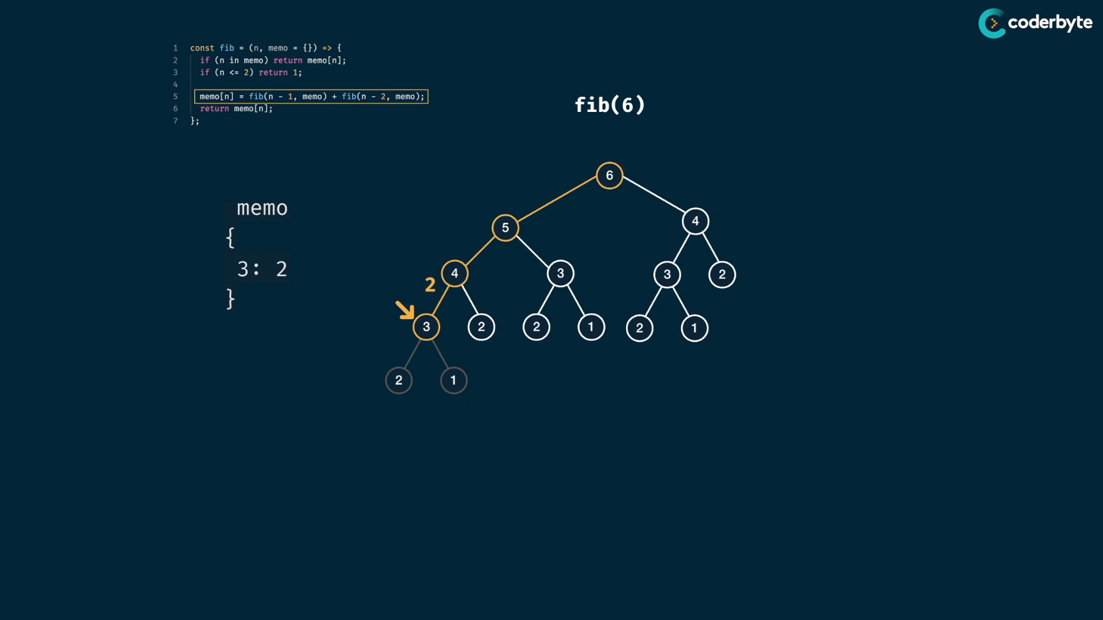

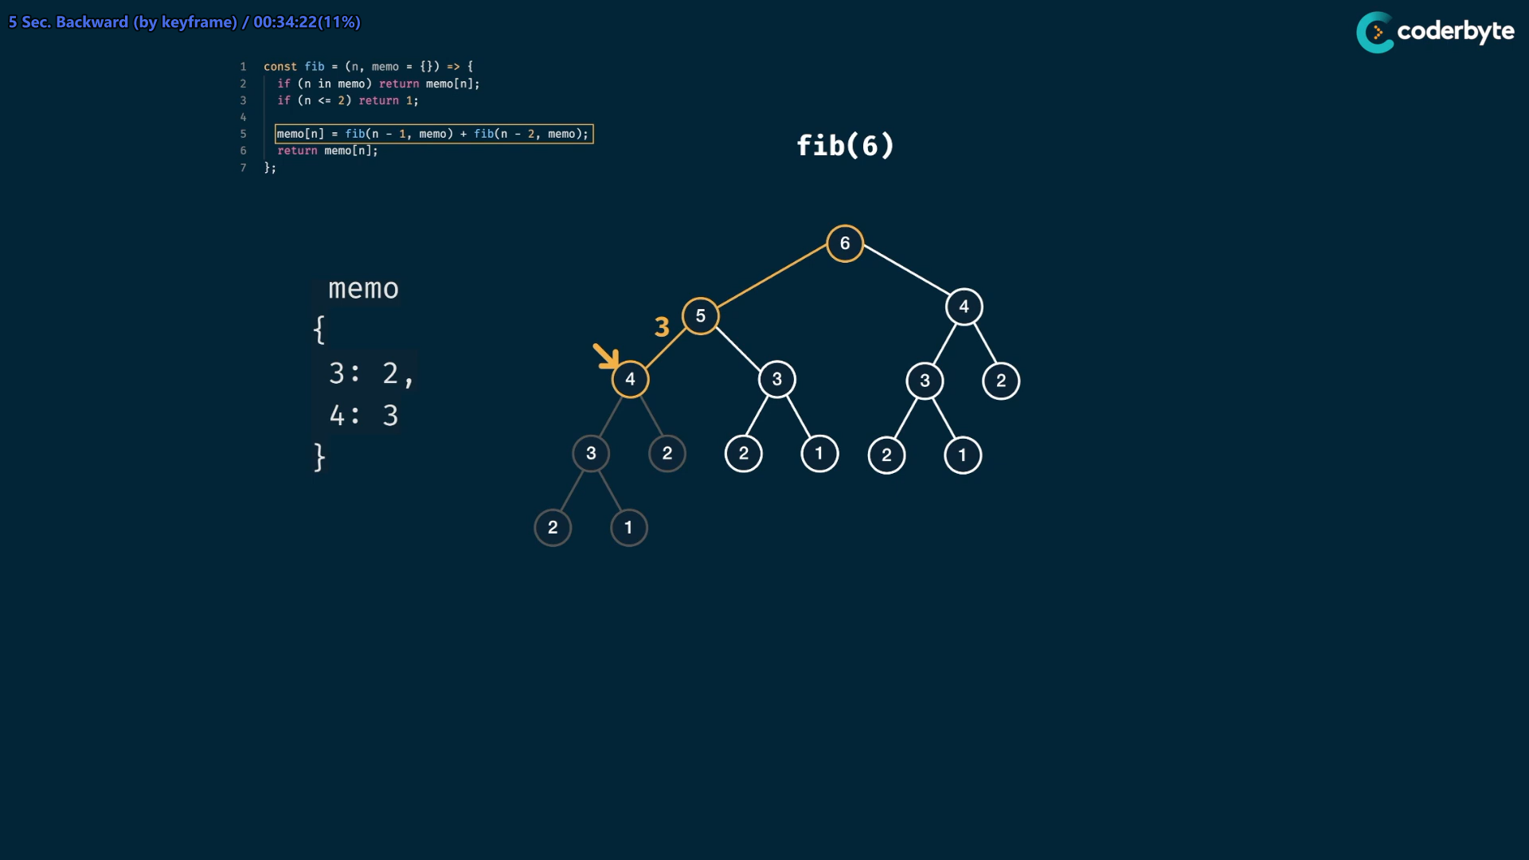

Those stored memo objs. values helpful for maintaining Donot Repeat Yourself policy . and so we use old stored values

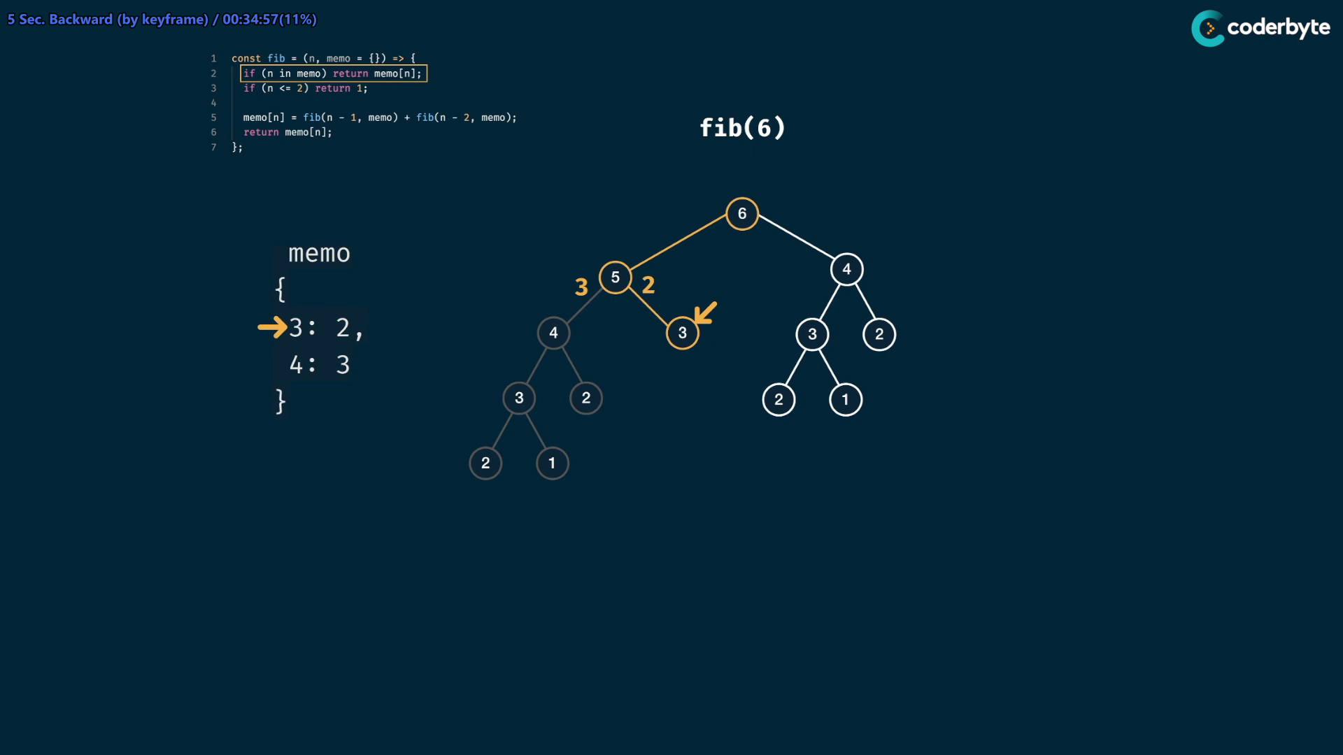

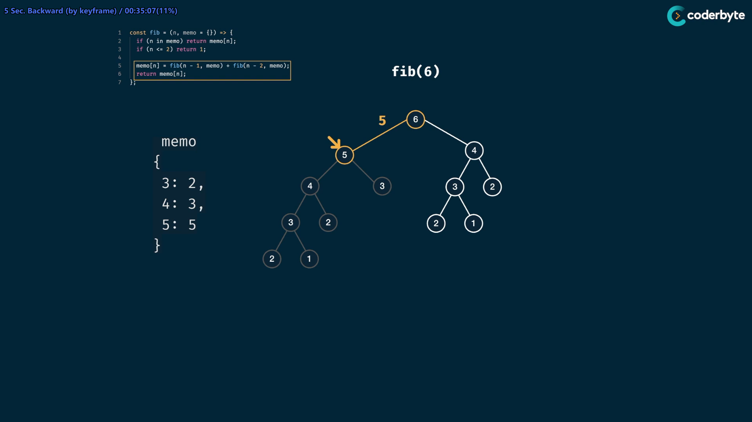

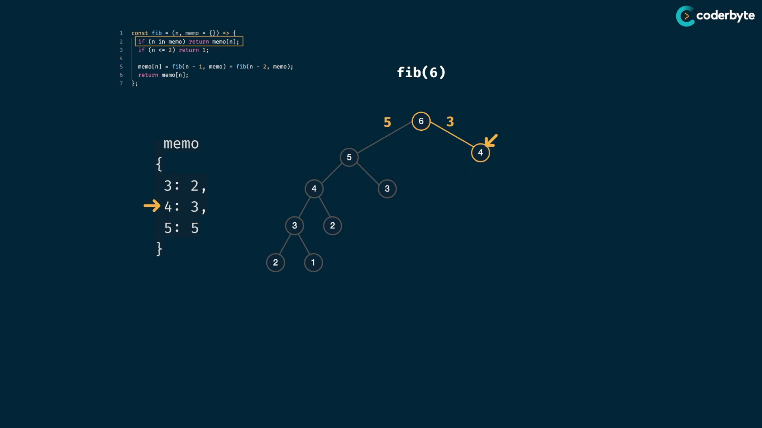

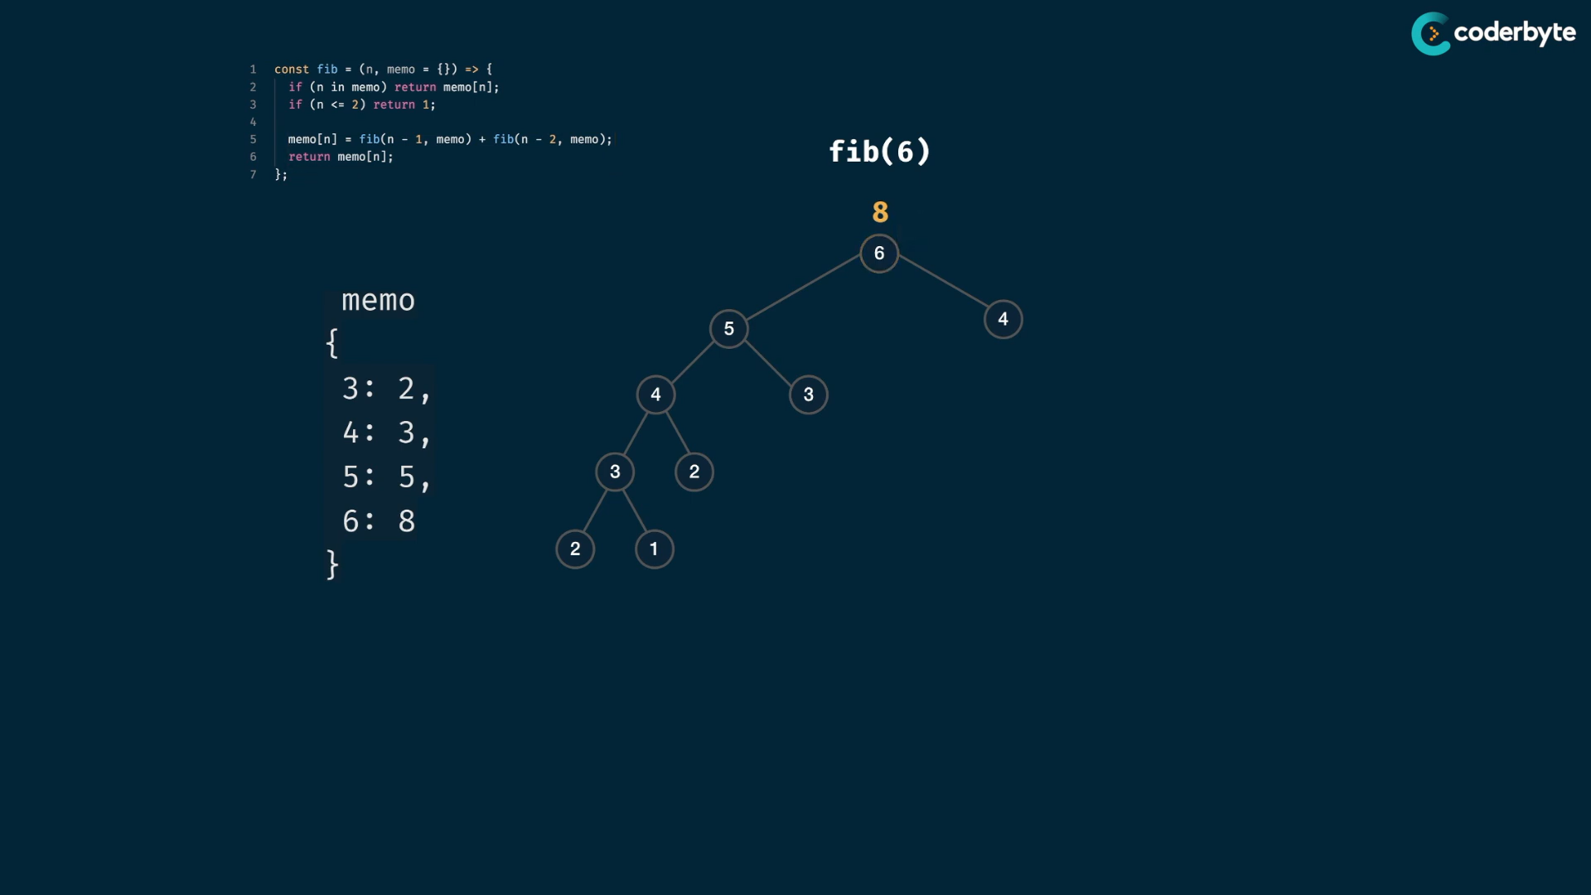

At last , we get ans. quicker and with less space cmplx.

**structure observation:**

the tree that we explored fully .

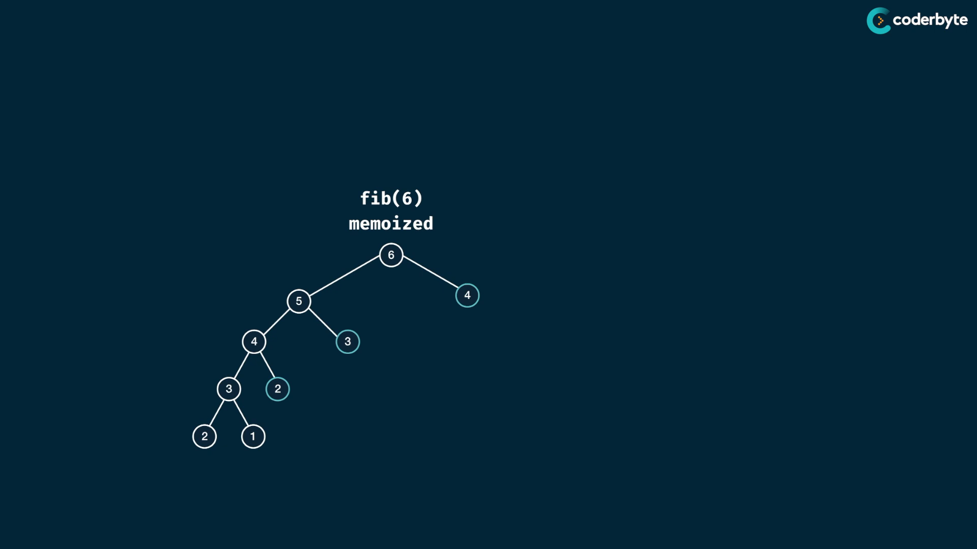

change the shape of tree :

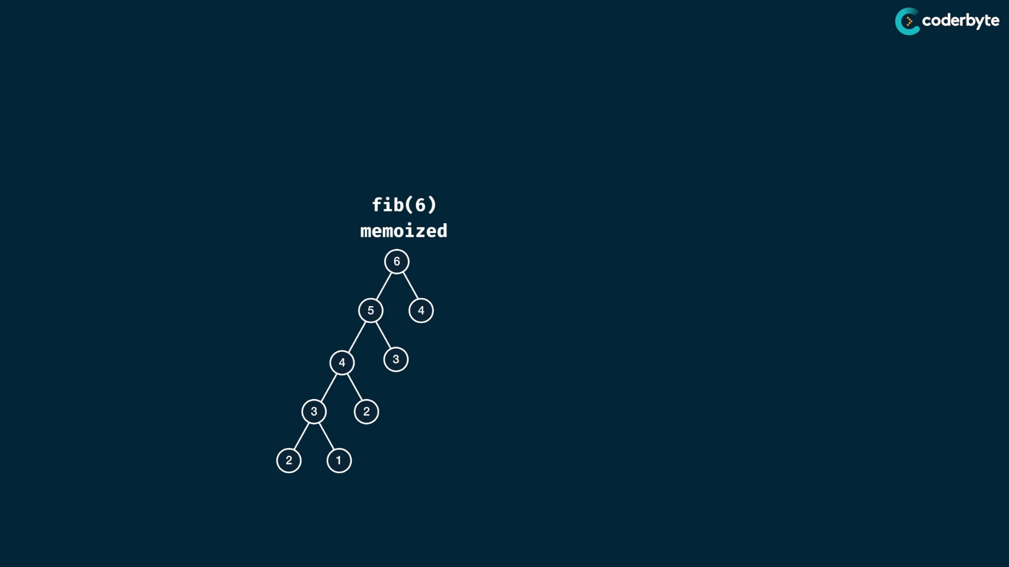

for fib(7)

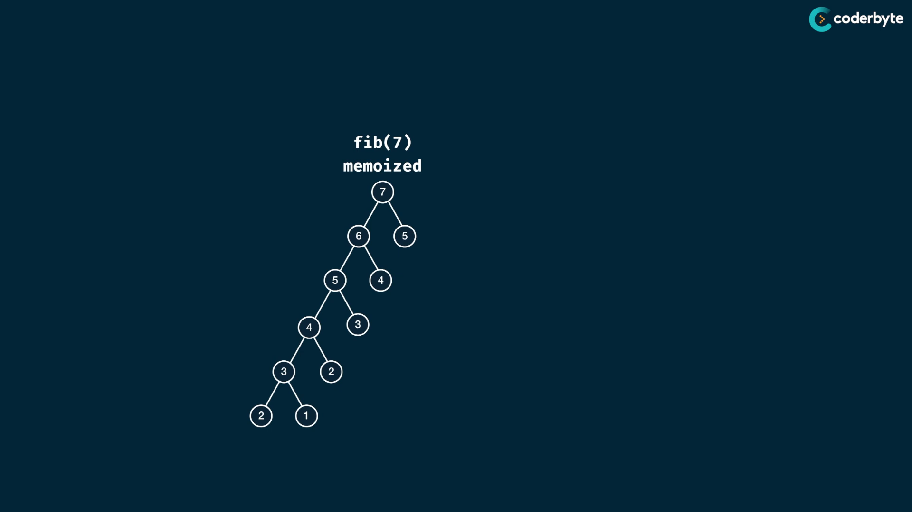

for fib(9)

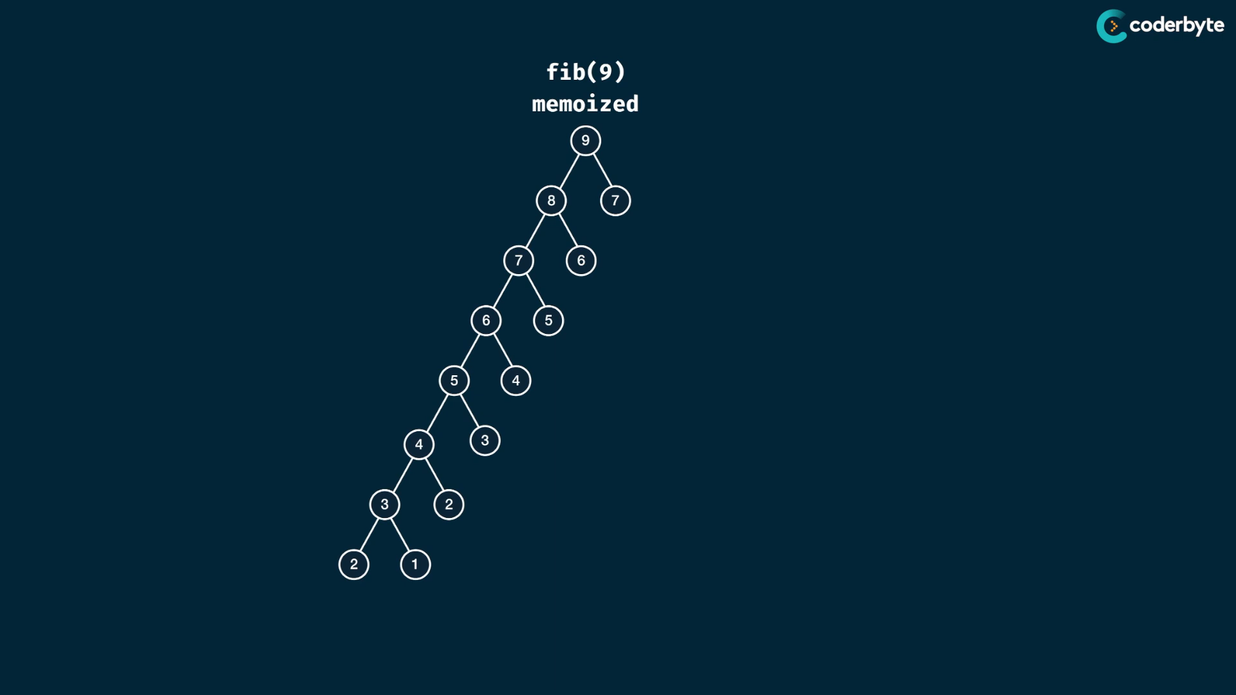

observation:

we just explored n nodes with its pairs i.e n-2(even nos) or n-1 (odd nos) ... , so 2(n) must be their cmplx.

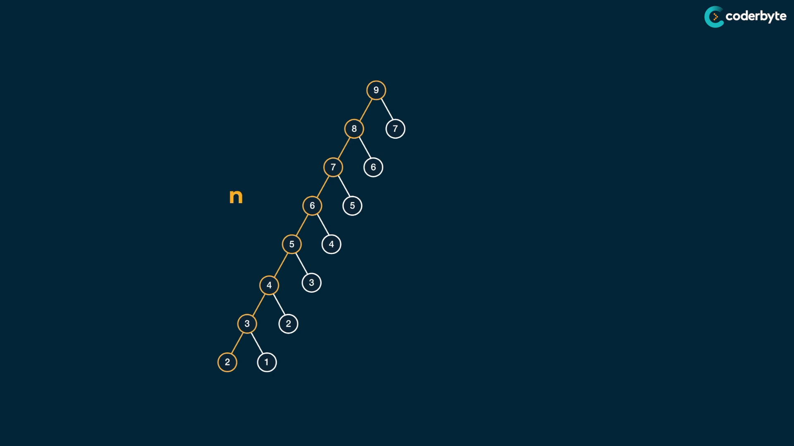

linear chain with pairs …

n nodes with pairs .. so 2n .. which approx. is O(n)

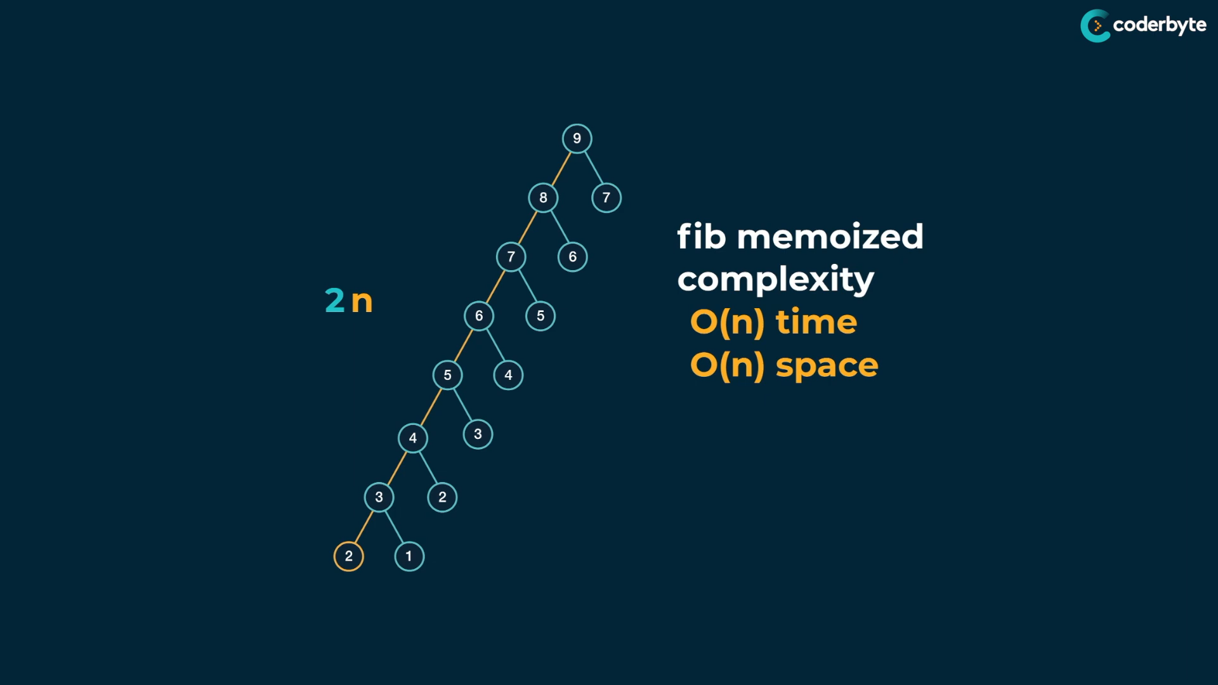

note: by memo fib func. the exponential time cmplx.O(n^2) is modified into linear time cmplx. O(n) …

**Grid Traveller :**

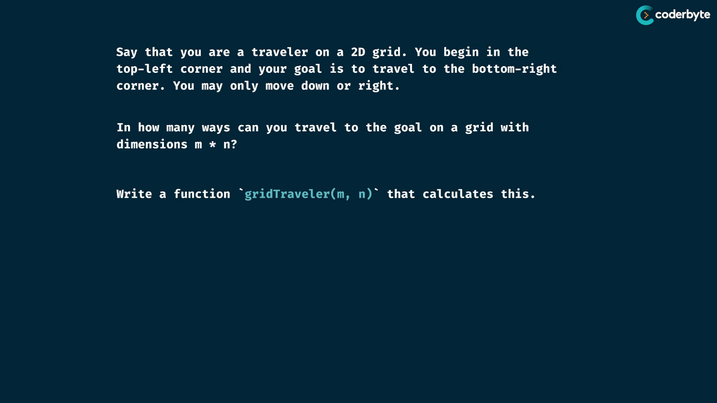

move only down and right .. since top left inclusion makes cycles in path , which results in infinite unique paths ..

exp:

grid(col , row)

grid(2,3) => 3 paths ..

s – start

e - end

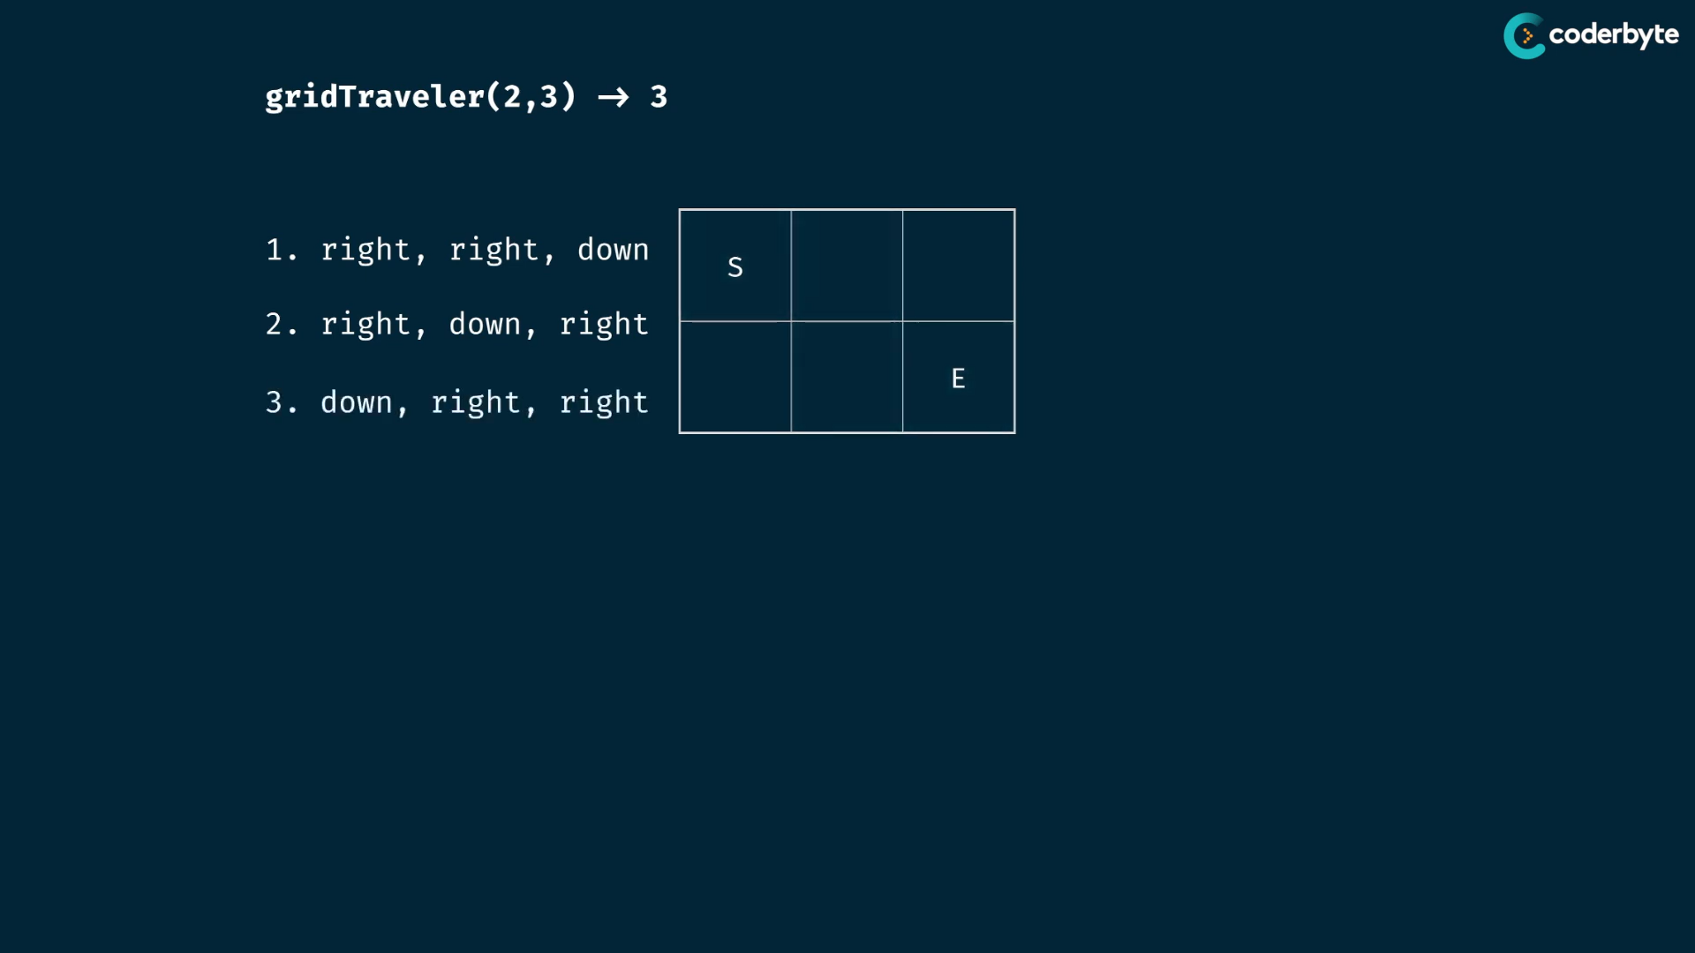

to identify and manage base case , you have to think for small inputs..

single cell grid: return 1

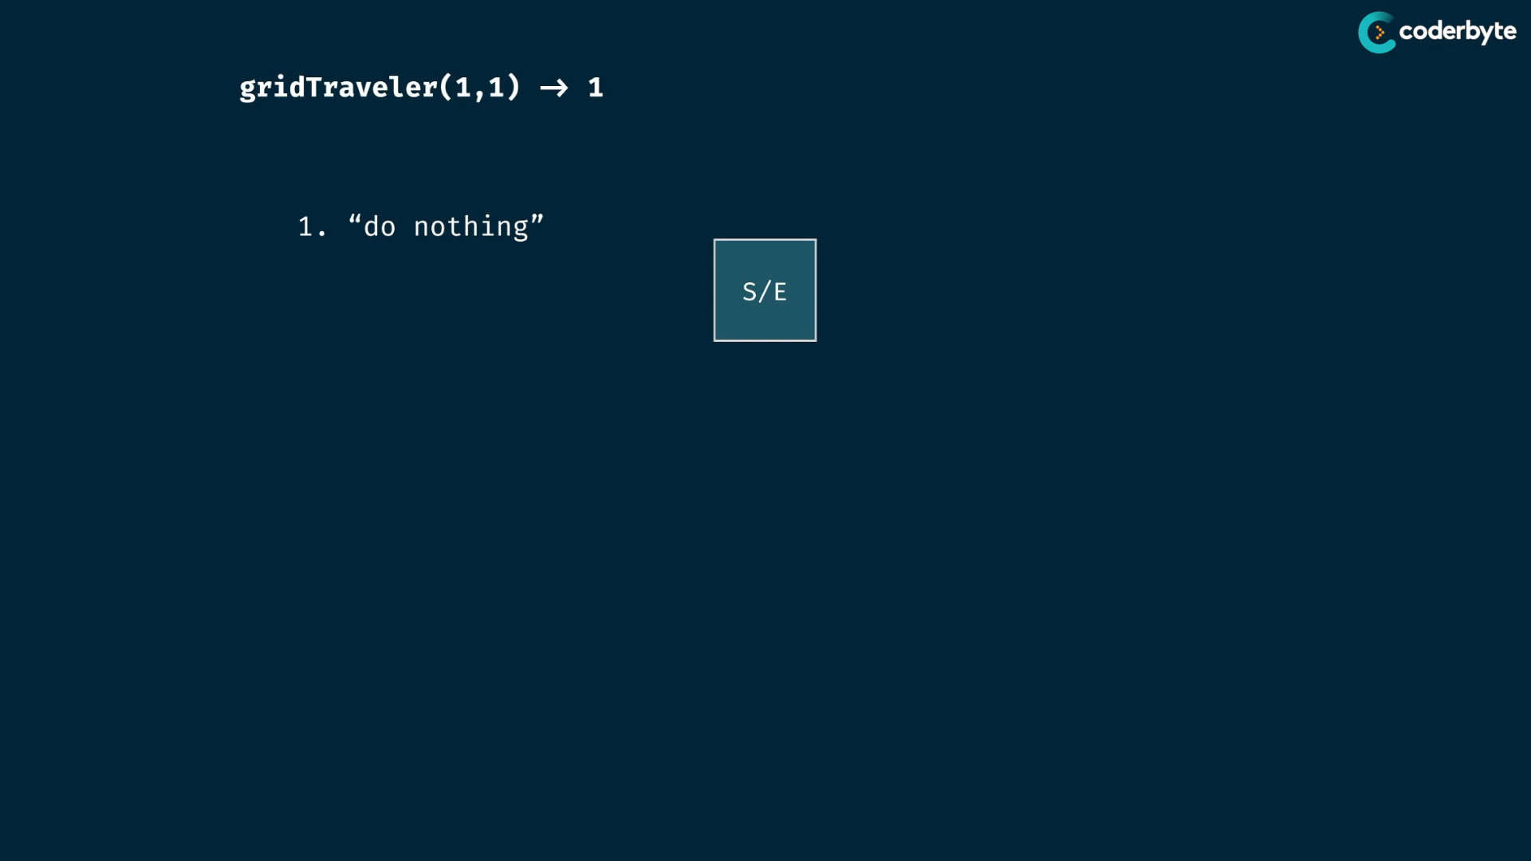

no cell gird: return 0

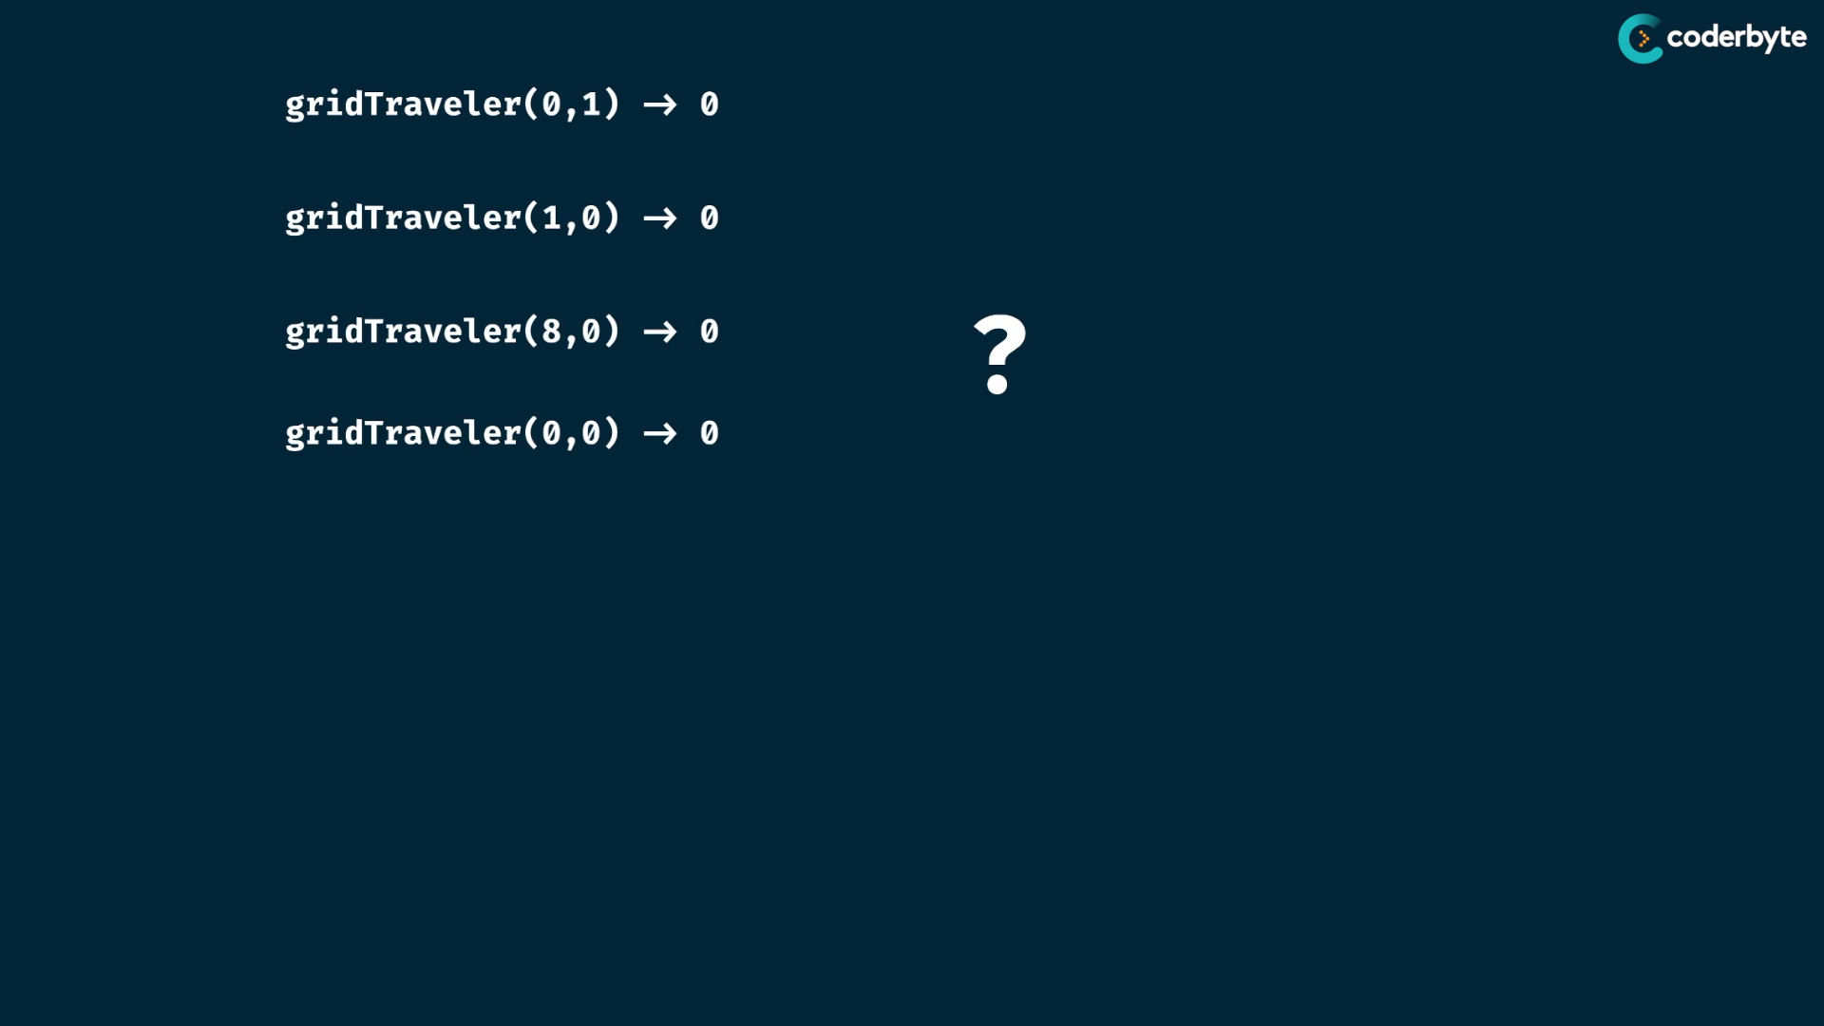

non- base cases:

(3,3) =>

frame the prb. to dec. prb. size one another other by mutating args. ..

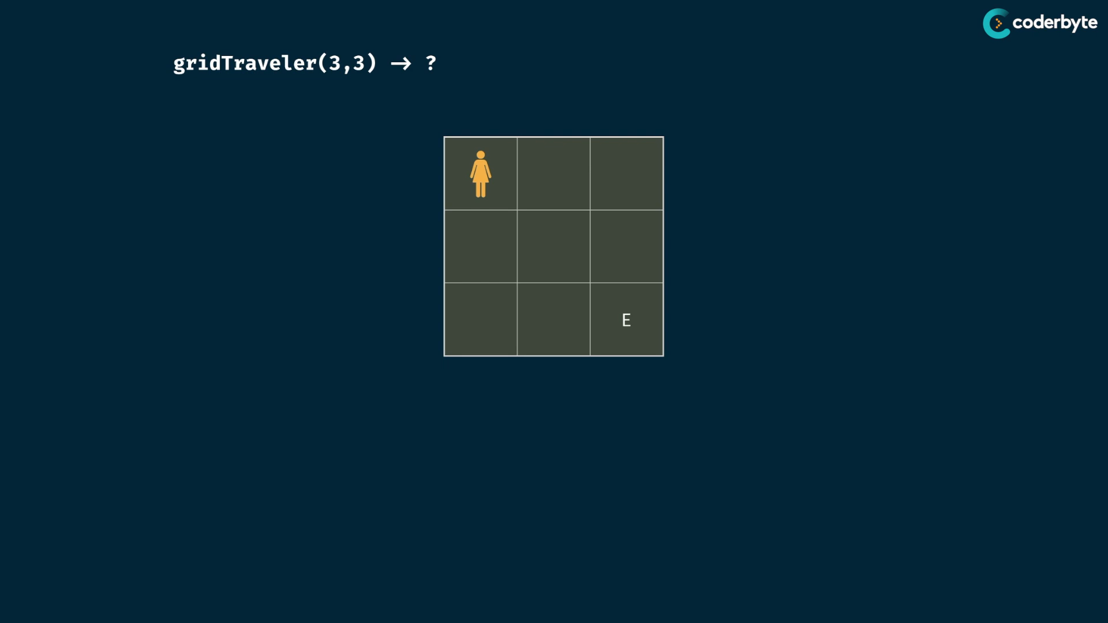

consider moving down..so the prb. is reduced …

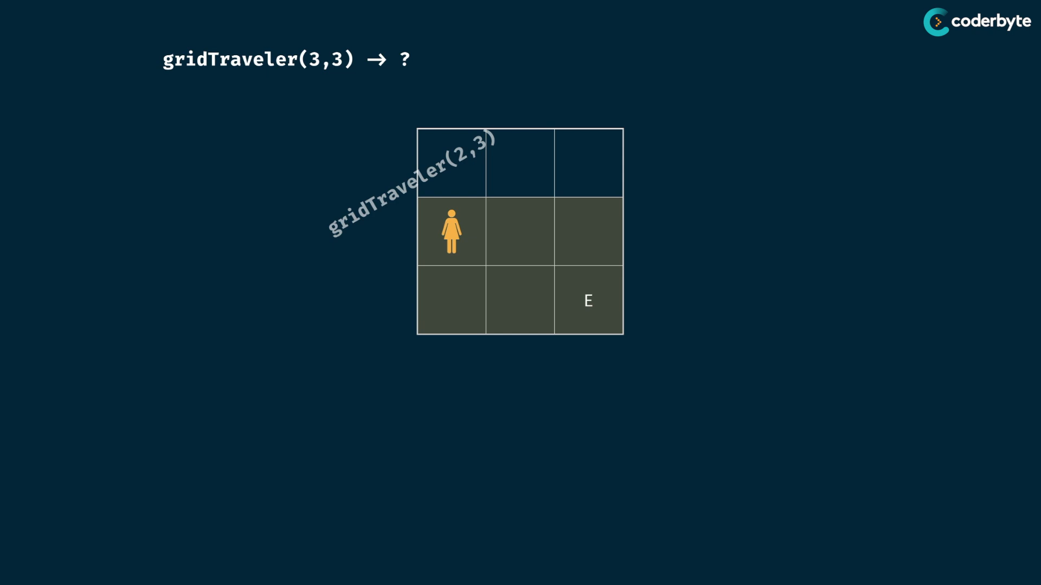

now consider moving right

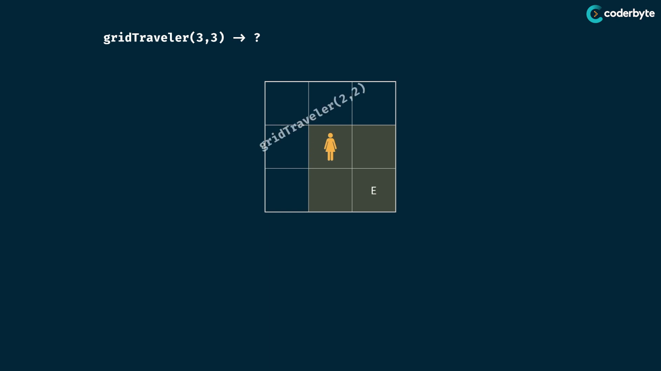

now down,

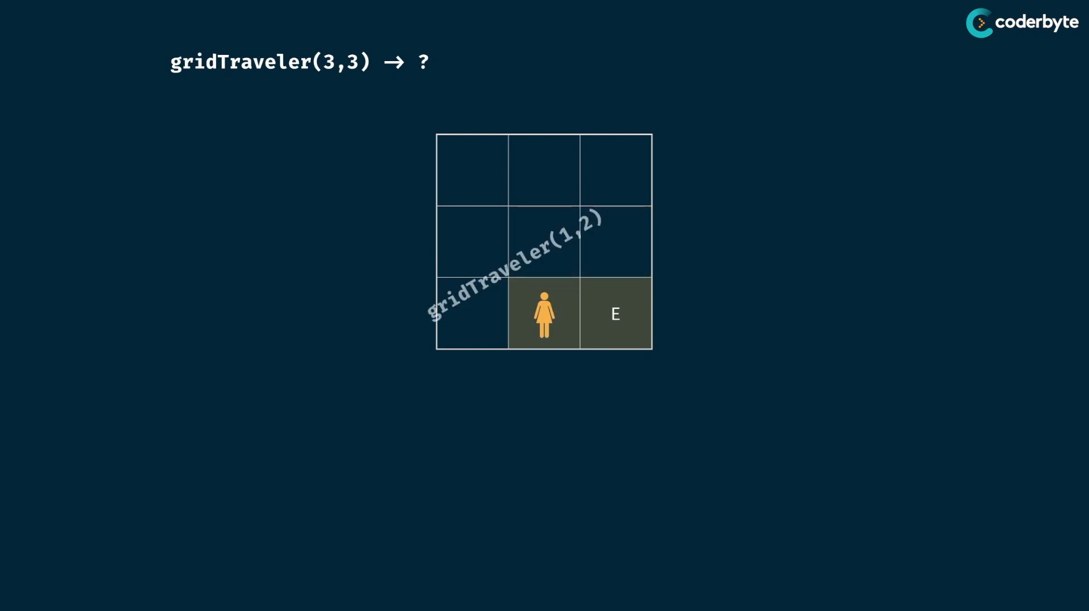

now right ,

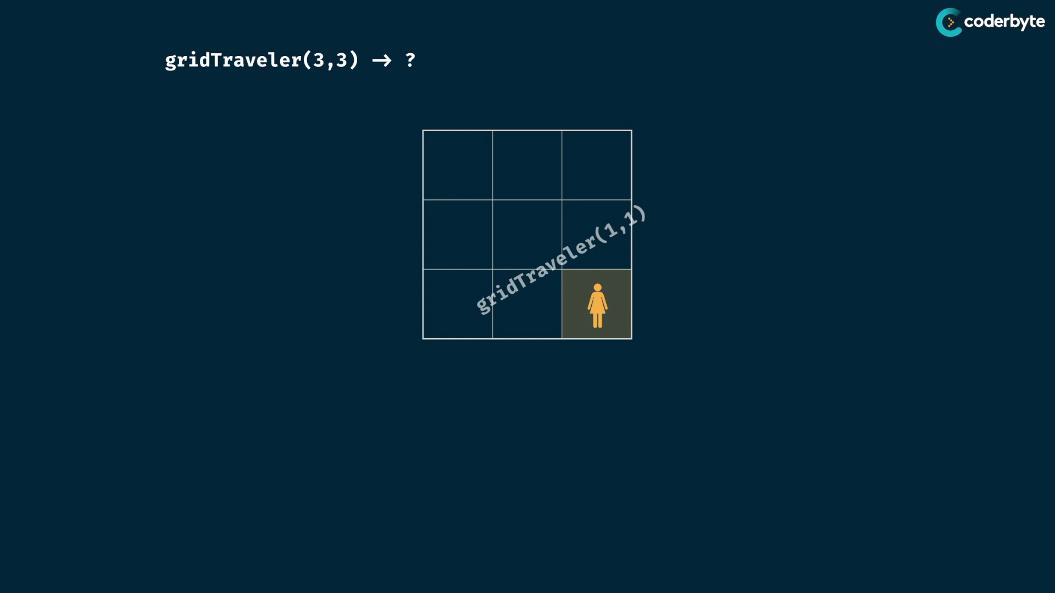

which ends in our base case …

**Tree based understandings :**

(2,3) => 3 ways …

at each time , you have the option of going right or down ..

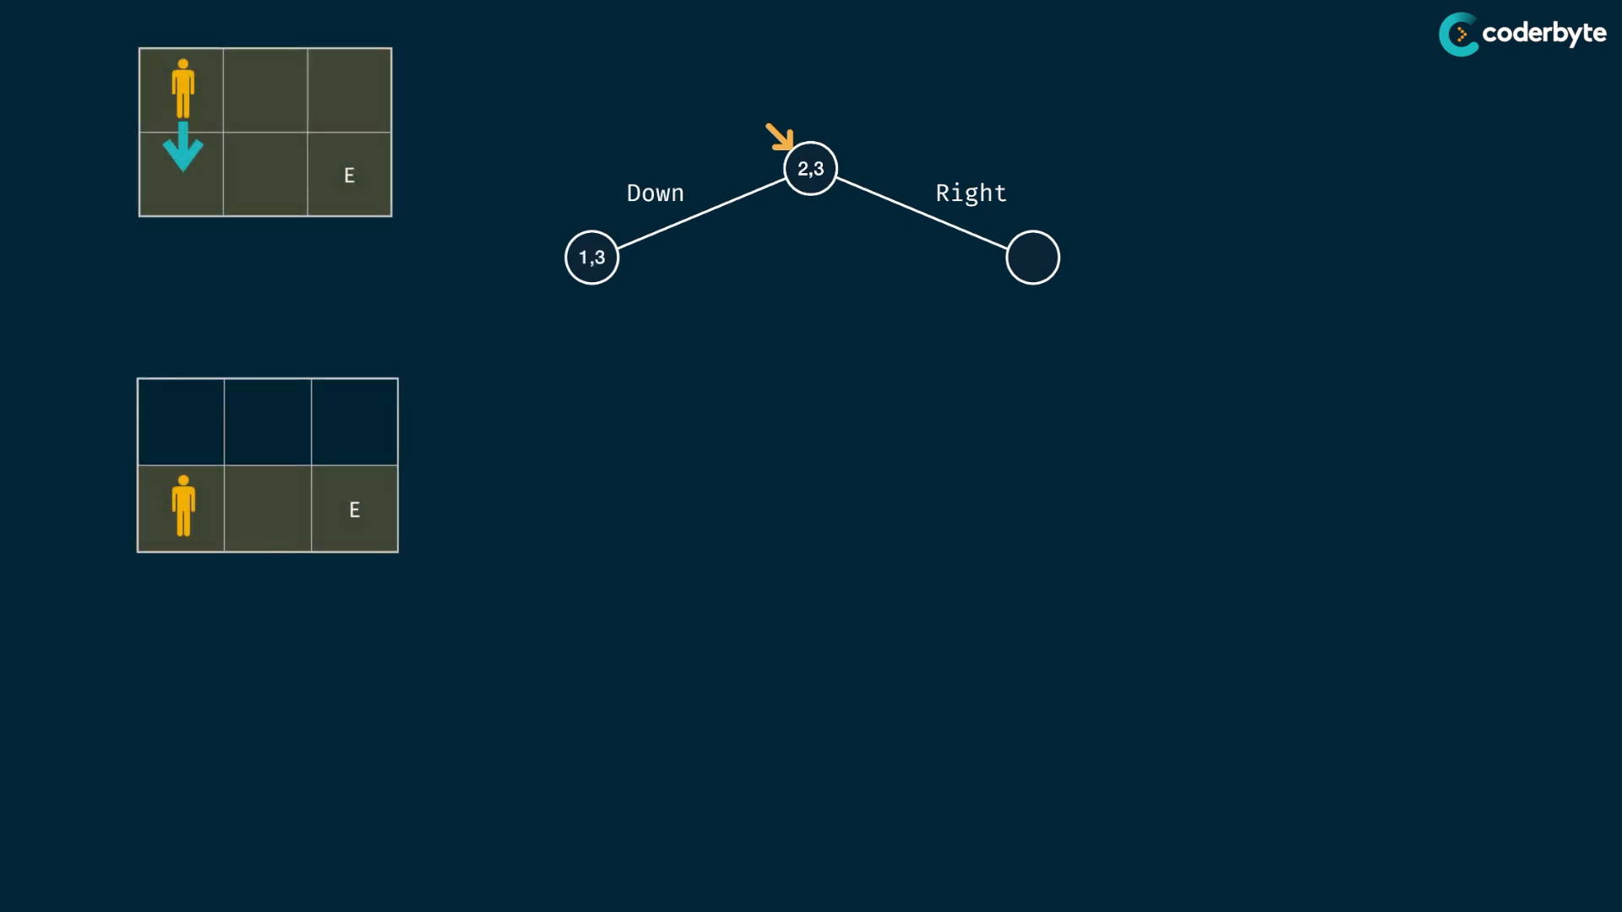

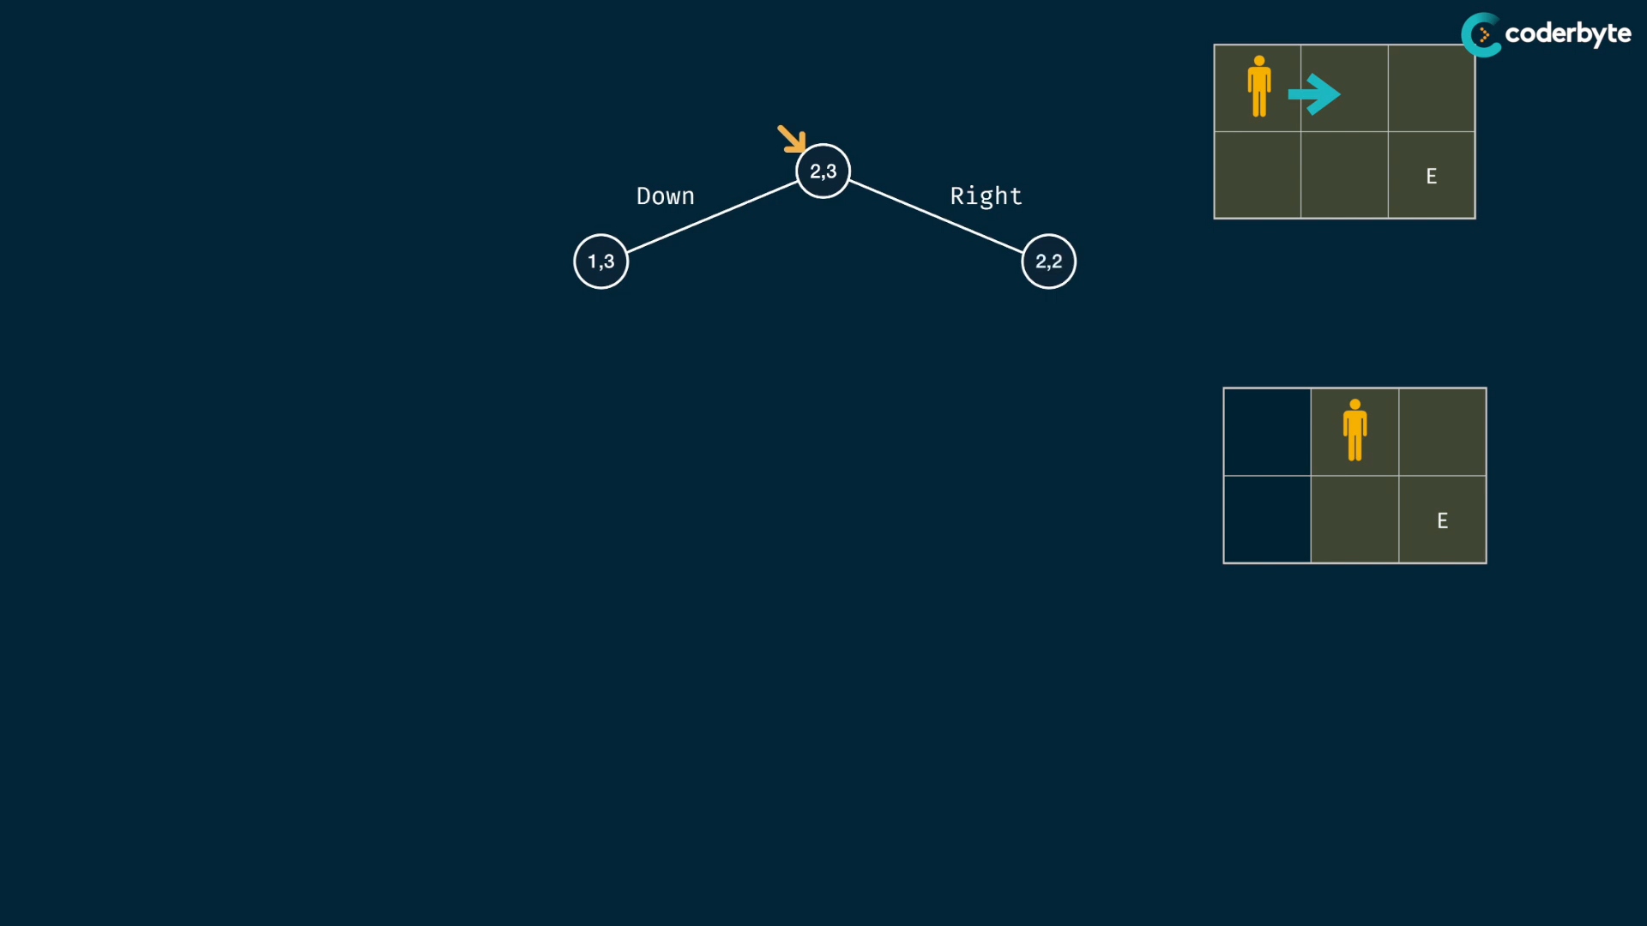

observe that reducing the one of the arg. of parent child is happen ..

while doing so .. we end up with 1,1 for true and 0,x for false for node paths ..

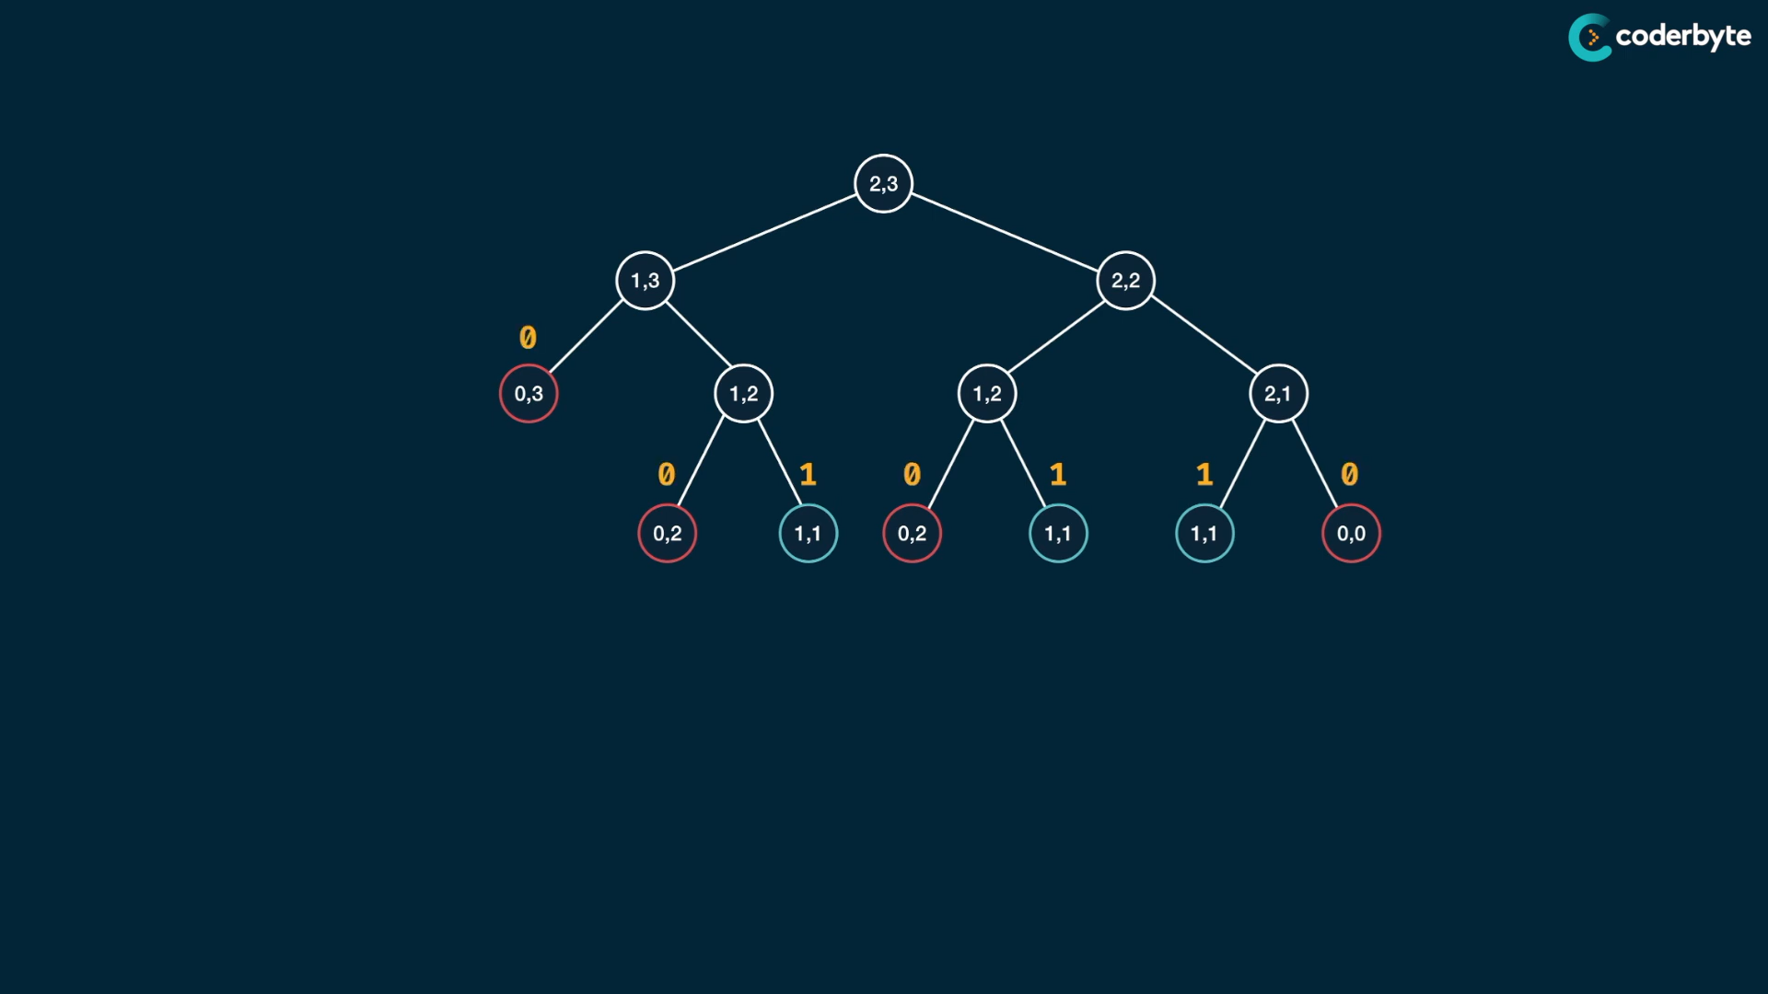

add operations of children’s return goes to parent nodes ..

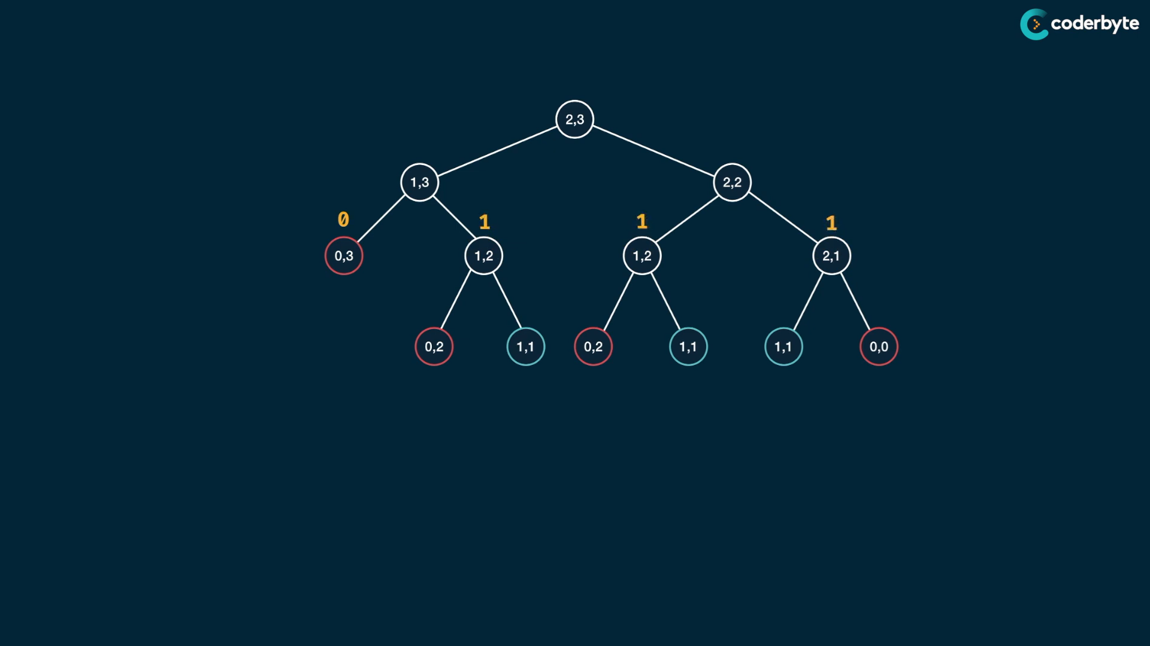

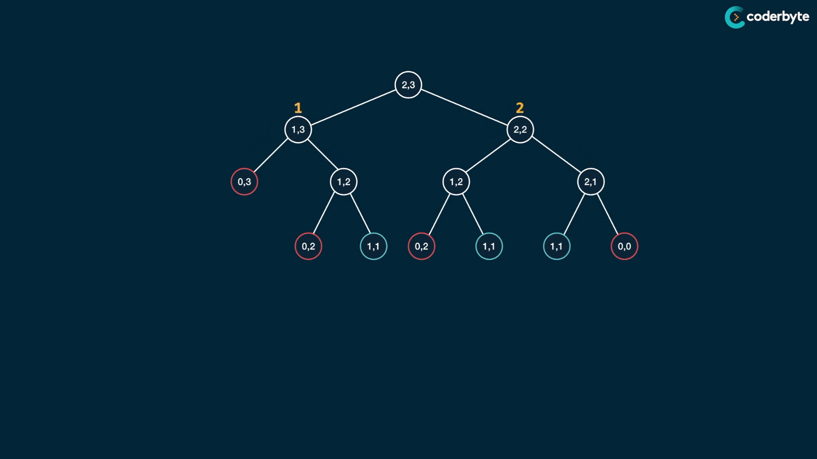

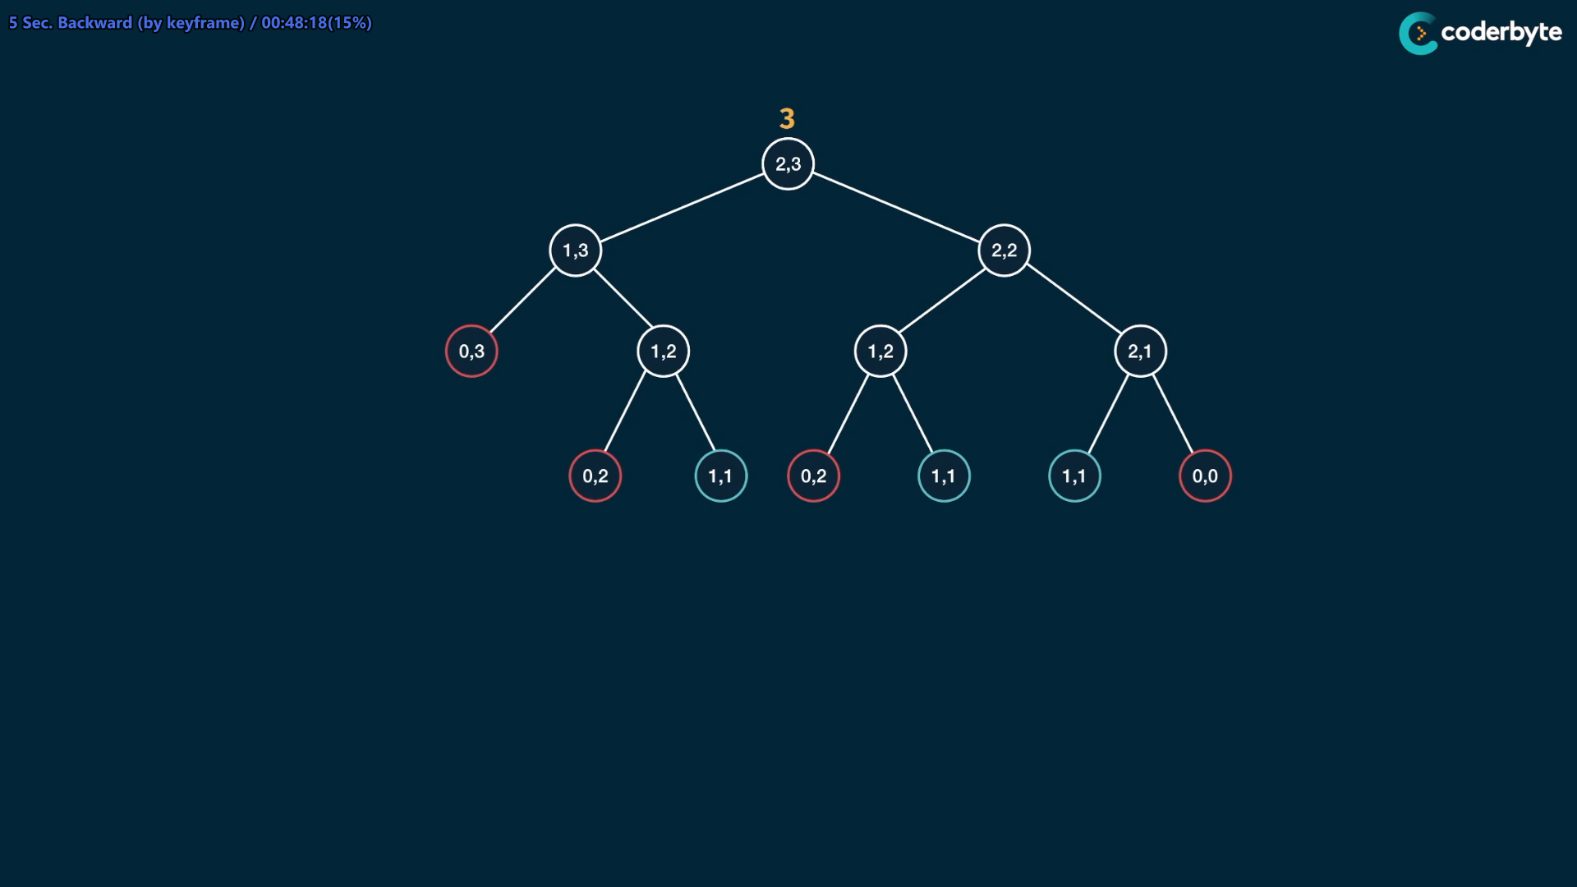

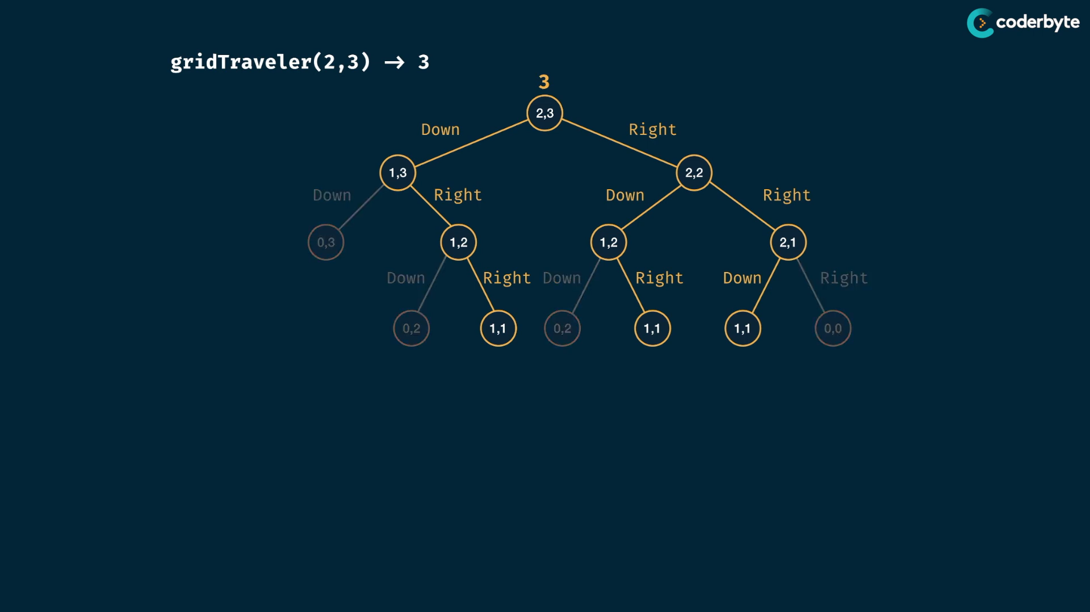

we found the exact possible path with lot of info.. i.e not only howmany possible ways , but also possible paths …

The prb. is same like fib …

//+ recursive grid solve

const gridTraveler = (m,n) => {

   if( m === 1 && n == 1 ) return 1;

   if( m == 0 || n == 0 ) return 0;

   return gridTraveler(m-1,n) + gridTraveler(m,n-1);

}

console.log(gridTraveler(1,1)); //=> 1

console.log(gridTraveler(2,3)); //=> 3

console.log(gridTraveler(3,2)); //=> 3

console.log(gridTraveler(3,3)); //=> 6

console.log(gridTraveler(18,18));//=> 2333606220 {takes extra little time }

why this approach is slower …

actual tim. cmplx.

understanding time cmplx. here is observing understanding the func. call we make , which is the no.of nodes in tree …

this tree looks like binary , since at one point we have 2 possibility of going right or down …

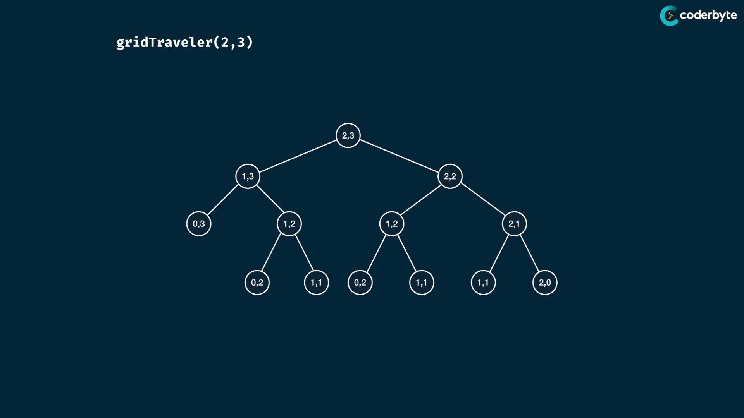

at one time , we dec. row by one or col. by one but not both .. so no.of lvls . is row + col at max..

Since its binary decisions , the tim. complx is 2 power n+m

space compx is height of tree => since it give max. stack depth needed for solving prob. here its n+m – 1 , which is approx. of n+m

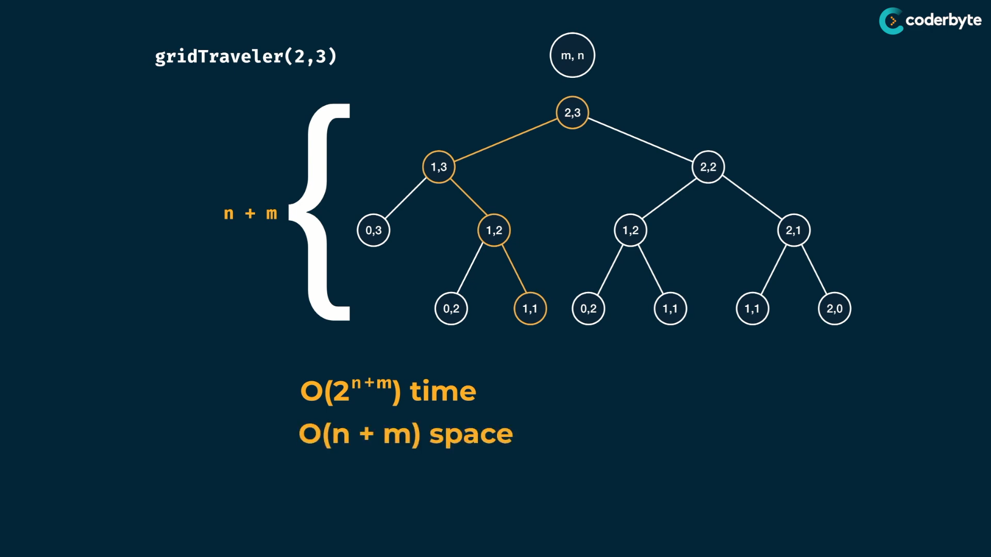

tip : always explain why your algo give this time cmplx. which is more imp. in interviewer prespective.

here high time cmplx , we have to improve this … since we have overlapping of subprobs..

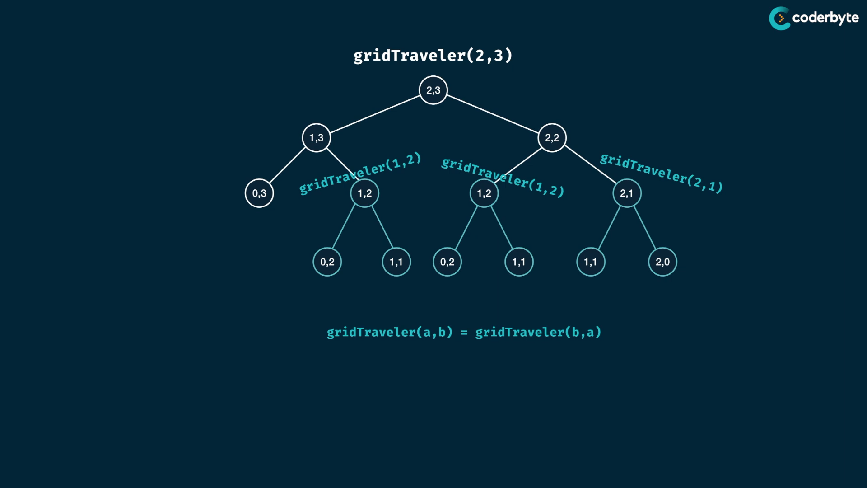

overlapping subprob.. we eval (1,2) twice in a prob and (2,1) is same for (1,2) for this prob. which inc. further performance .

asking to travel through a (1 , 2) gird is same as asking to travel through (2,1) grid .. i.e flipping rows and colms gives same path and number of ways..

flipping args only works for this prob .. remember …

//+ memo grid traveler

*const* gridTraveler = (*m*,*n*,*memo*={}) *=>* {

    // without comma , args are not identified uniquely

*const* key = *m*+','+*n*;

    if ( key in *memo* ) return *memo*[key];

    if( *m* === 1 && *n* == 1 ) return 1;

    if( *m* == 0 || *n* == 0 ) return 0;

*memo*[key] = gridTraveler(*m*-1,*n*,*memo*) + gridTraveler(*m*,*n*-1,*memo*);

    return *memo*[key];

}

console.log(gridTraveler(1,1)); //=> 1

console.log(gridTraveler(2,3)); //=> 3

console.log(gridTraveler(3,2)); //=> 3

console.log(gridTraveler(3,3)); //=> 6

console.log(gridTraveler(18,18));//=> 2333606220

donot look before you leap starategy here like (m-1 , n) in memo …

, since your recursive calls manage that effectively by its base cases ....

further updation:

*//+ memo grid traveler updated*

const gridTraveler = ( m,n,memo = { '1,1':1 } ) => {

   const key = m+','+n;

   const rkey = n+','+m;

   if ( key in memo ) return memo[key];

   if ( rkey in memo ) return memo[rkey];

   if( m == 0 || n == 0 ) return 0;

   return (memo[key] = gridTraveler(m-1,n,memo) + gridTraveler(m,n-1,memo));

}

console.log(gridTraveler(1,1)); *//=> 1*

console.log(gridTraveler(2,3)); *//=> 3*

console.log(gridTraveler(3,2)); *//=> 3*

console.log(gridTraveler(3,3)); *//=> 6*

console.log(gridTraveler(18,18));*//=> 2333606220*

console.log(gridTraveler(80,80));*//=> 2.3156006494021195e+46*

new tim. cmplx :

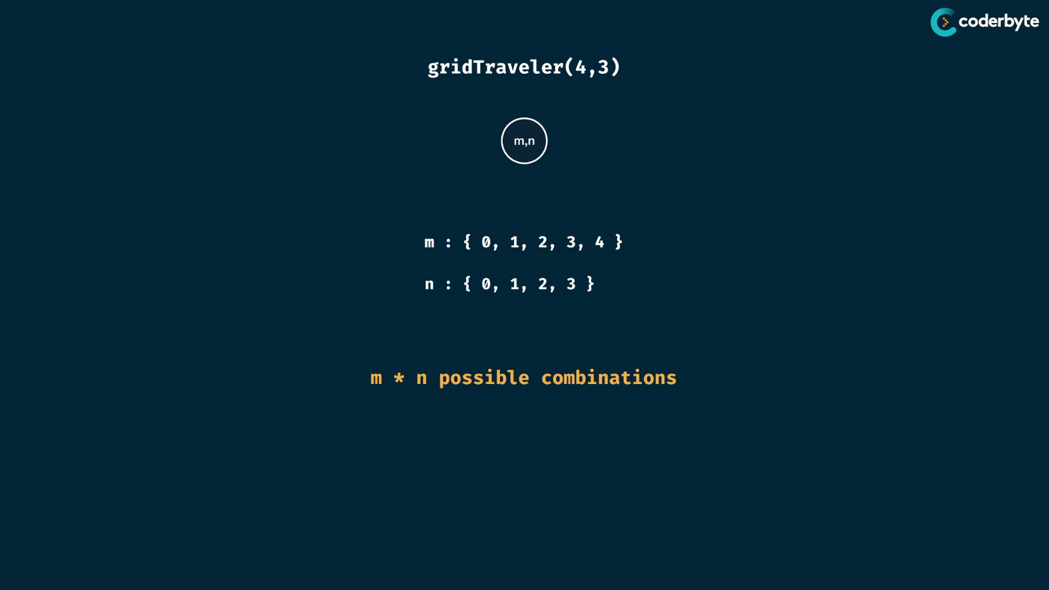

m and n are no- of nodes of cols and rows …

Therefore there are m*n possible combinations of nodes .. i.e colms and rows

by memo obj. we minimize duplicate expressions ..

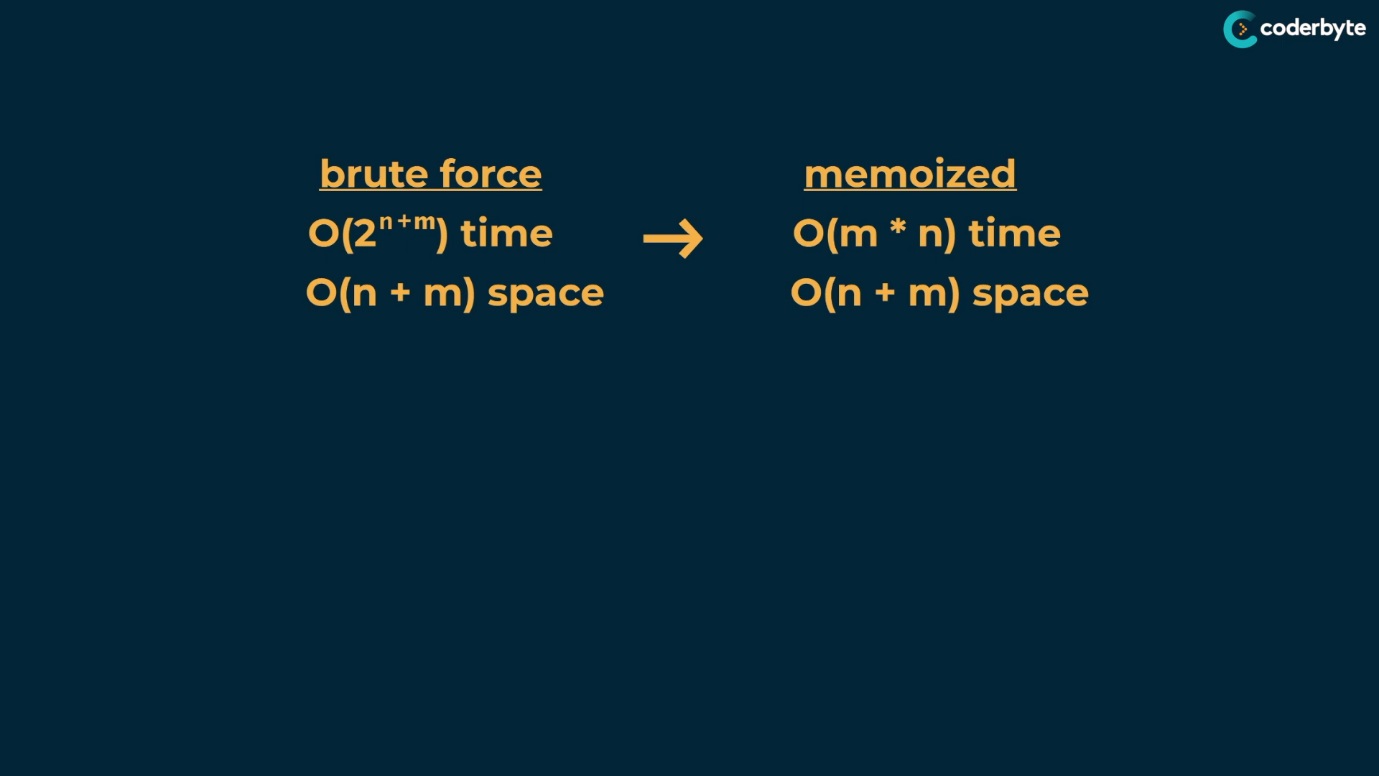

Outline :

* see the recursive func. as tree with their info…
* using tree we implement brute force and cut overlapping by memoi. which gives optimal soln ..

**Memoization strategy :**

Correctness:

* first make is work by recursive brute force and then go for efficient ones i.e first look for correctness , then look for efficient
* large prob. are break into smaller ones of same probs. by visualizing them as tree

nodes of tree as each sub prob

edges b/w trees – shrinking size of prob.

* solve tree by recursion , by considering leaf as base cases and others are main cases . , by the way we can find the brute force
* test the code for correctness , so we are confident enough to go through ..

Efficientness:

* then add memo objs, keys are args of func and values are return values of func
* add new base cases that capture memo
* store founded values in memo before returning
* donot forget to pass memo objs on recursive calls

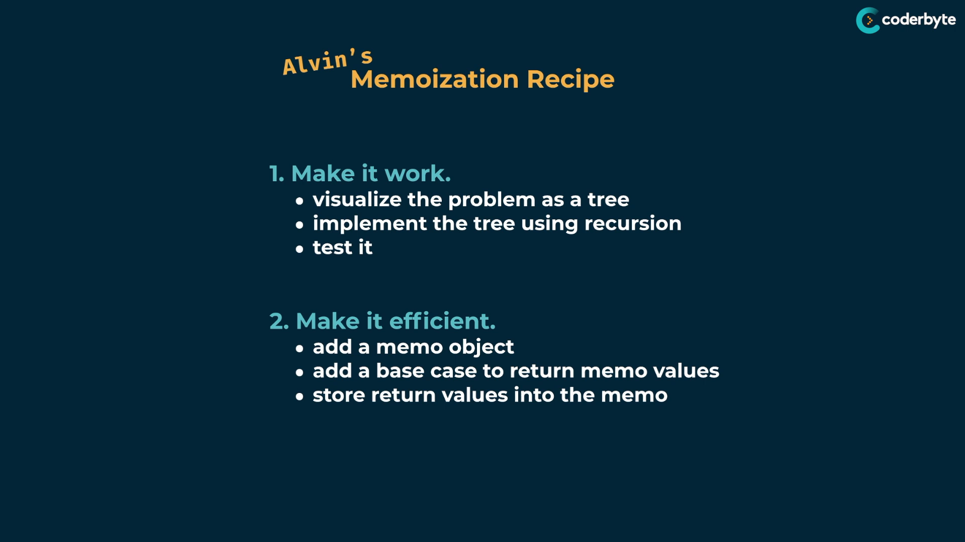

**Tabulation:**

**Fib:**

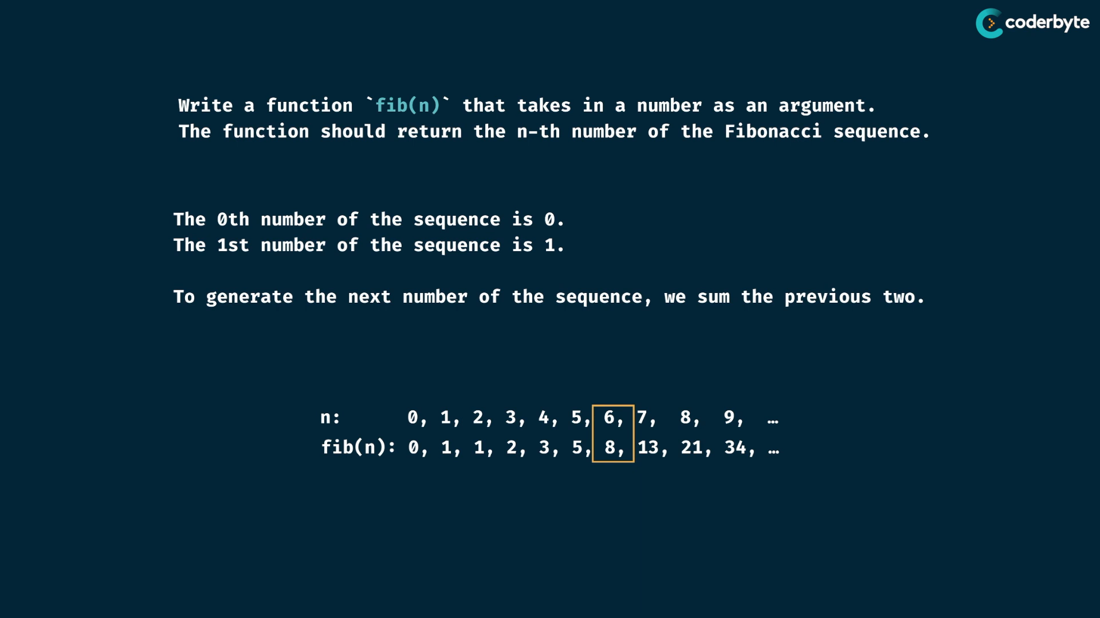

Tabulation – basically is building a table

* in memorization we do recursively i.e top down approach , but here we do iteratively i.e bottom up approach …
* tabulation table (i.e array) must be in size of input given in most cases i.e input size + 1

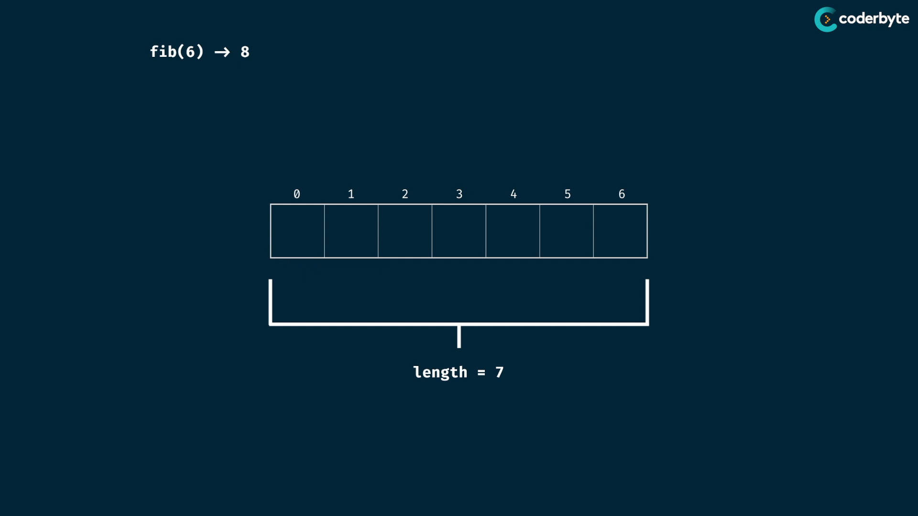

* we make each subprob. repr. the elements of the array and the array index is mapped as arg of the subprob.

The main thing is to initialize everything as base value

here its zero , since fib is sum value .. and the base sum value is 0 ..

if it is multiple value , then we end up filling it with one ..

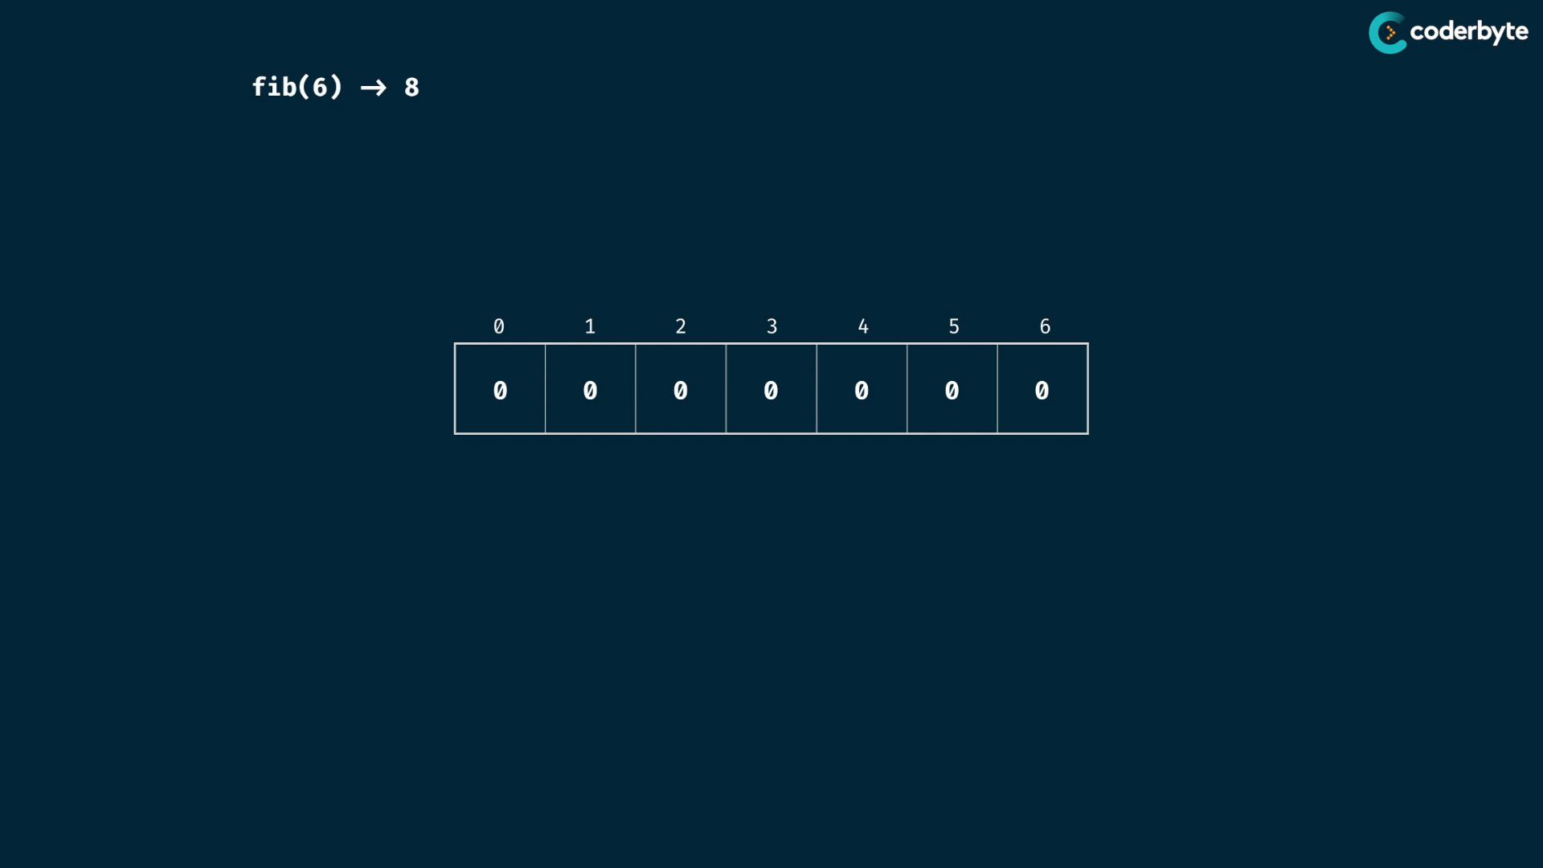

make the first index element as one , which is the seed case ..

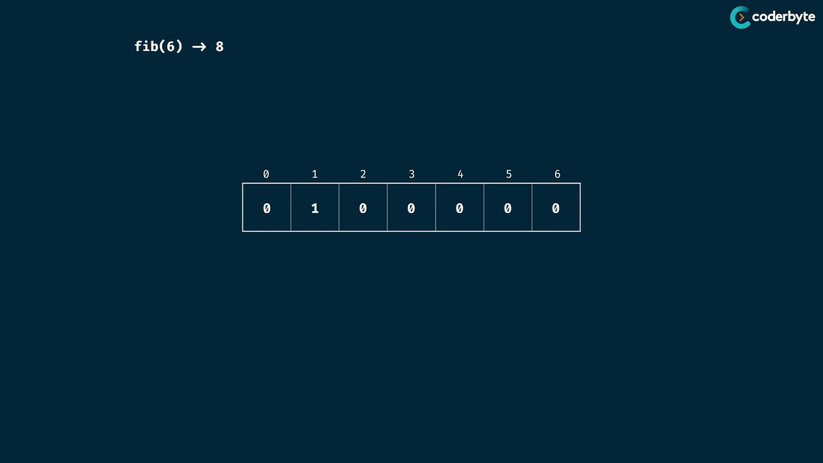

then others are found by sum consecutives ..

so 0th idx 0 is added to next two positions ..

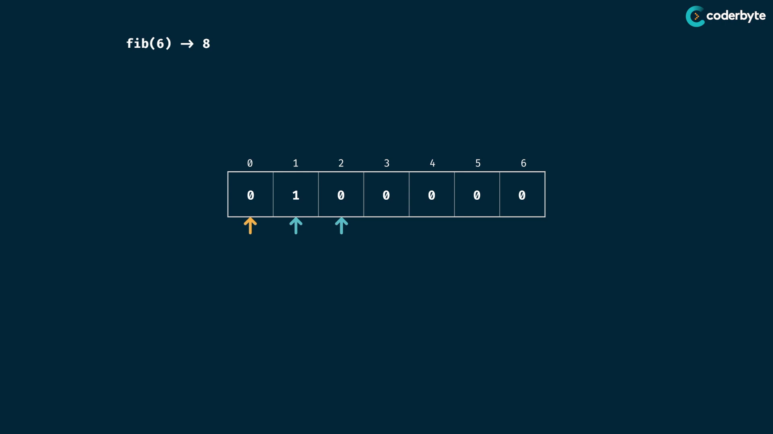

now idx=1 th value is added to the values of next two positions respectively ..

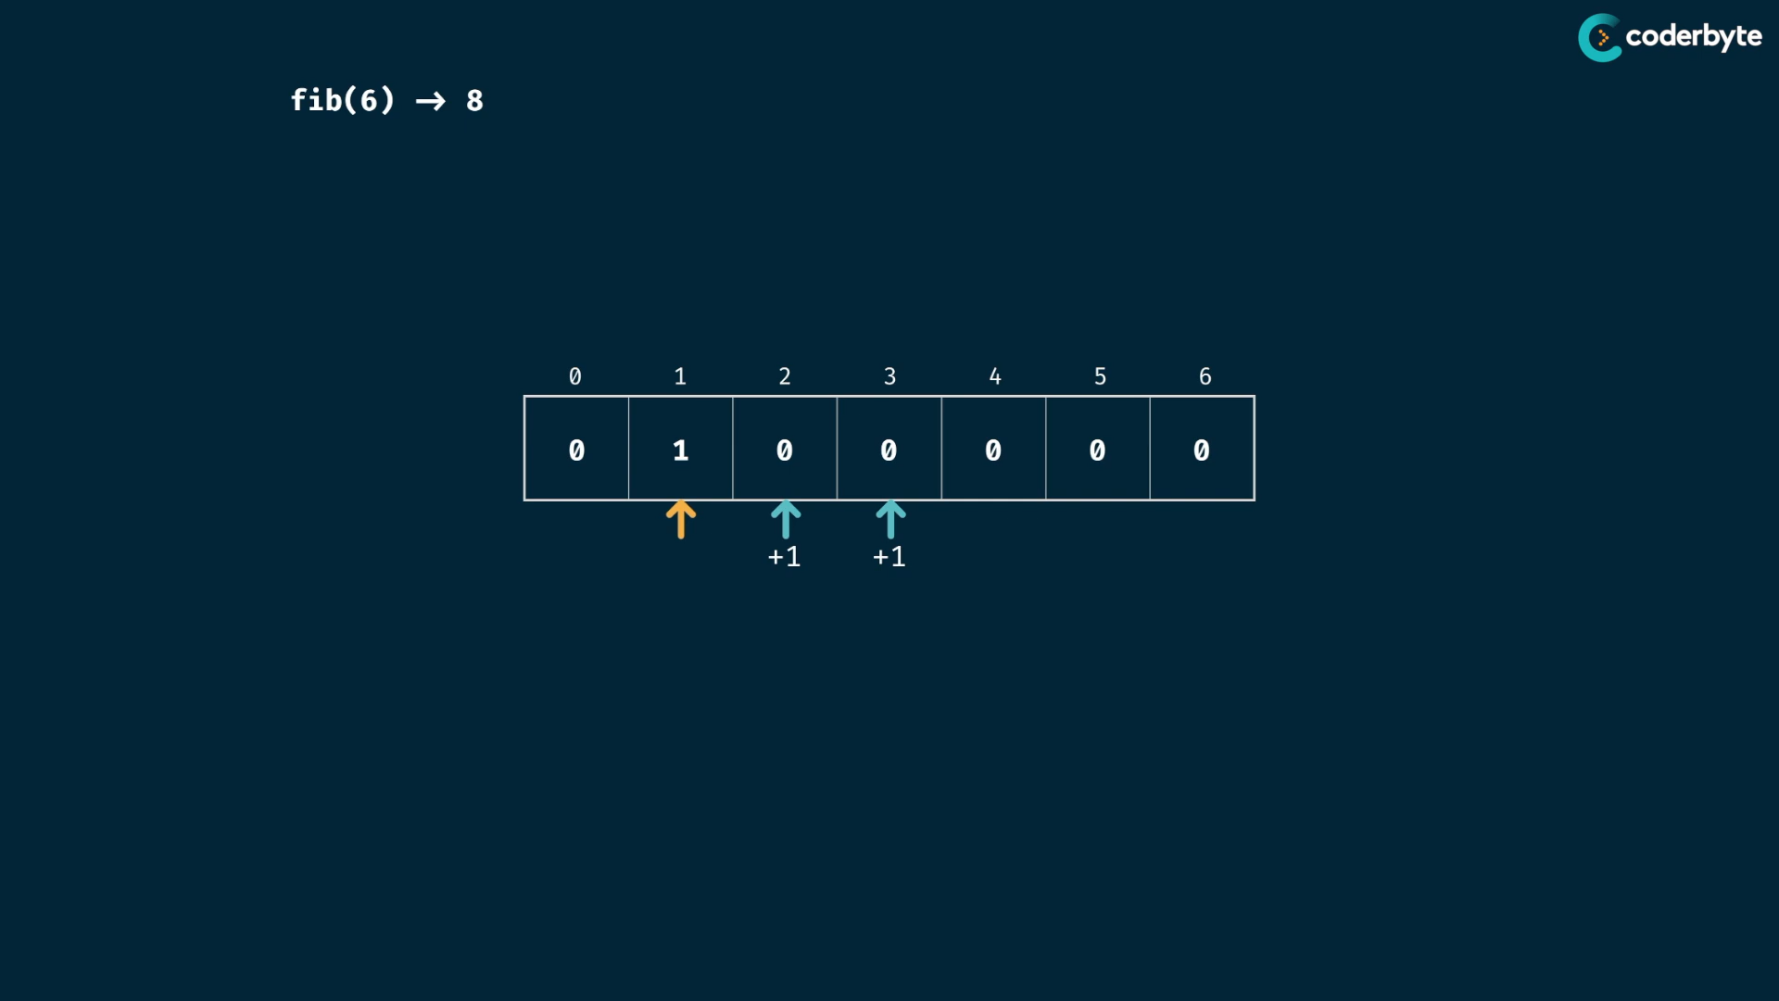

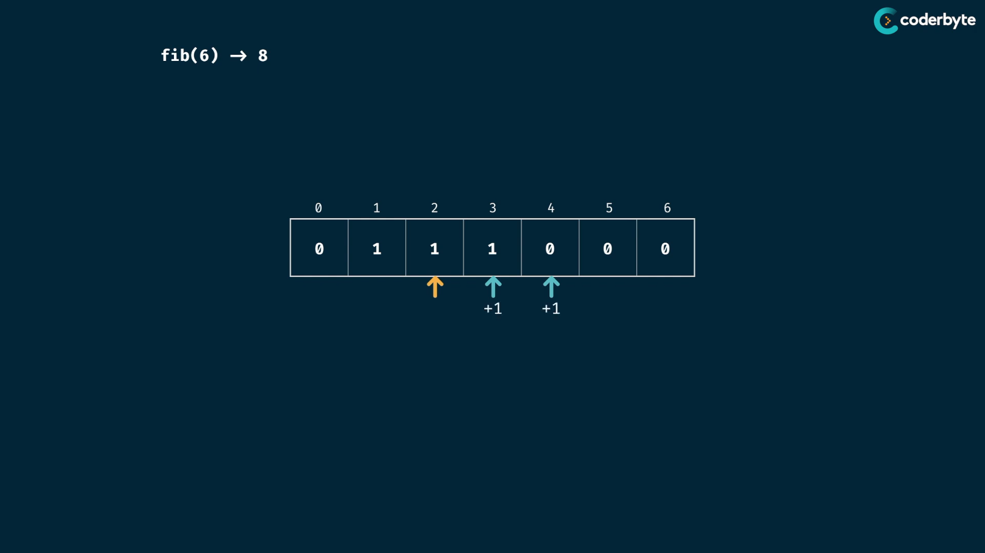

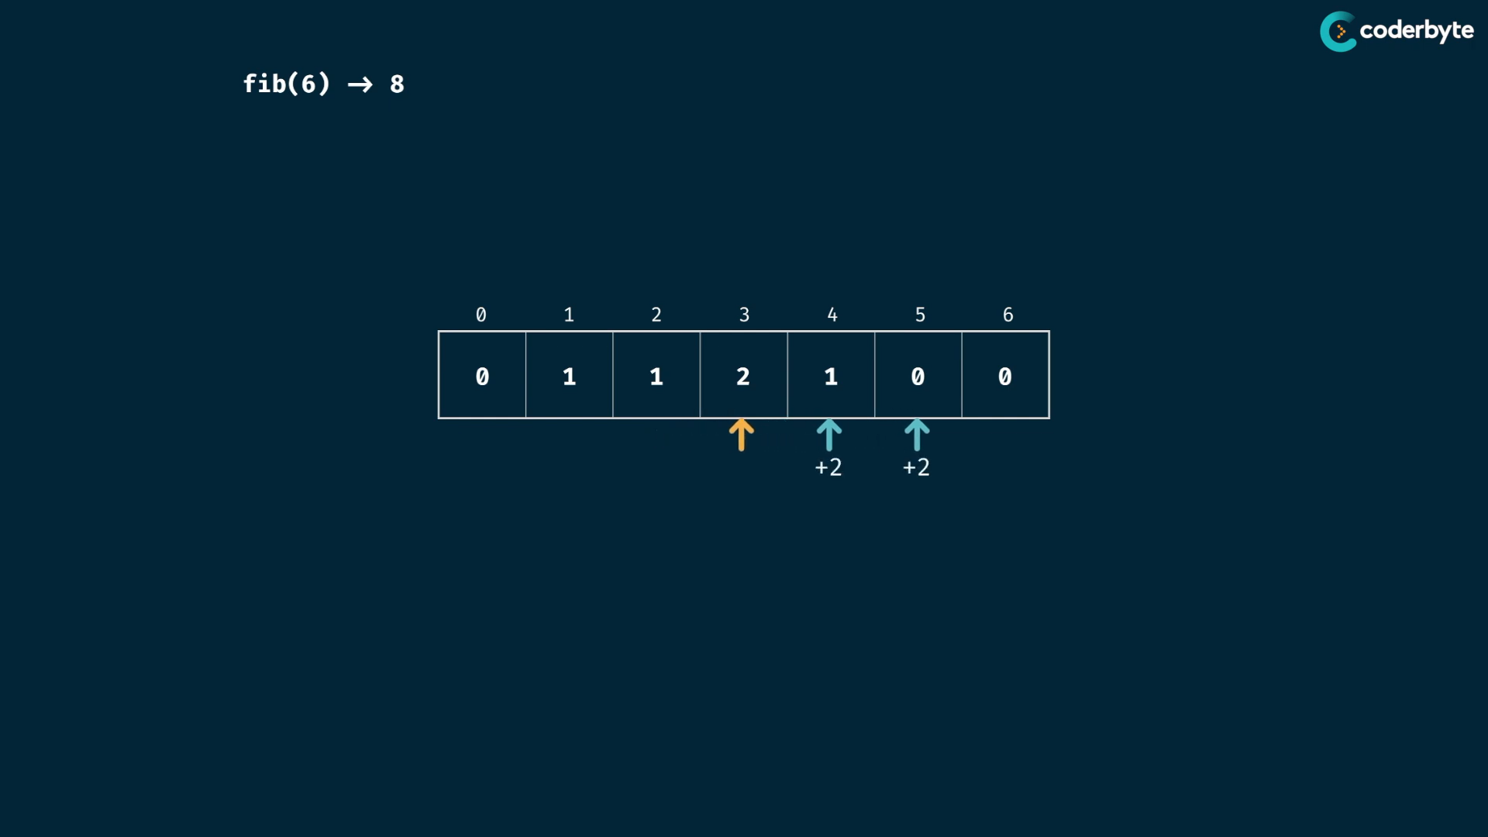

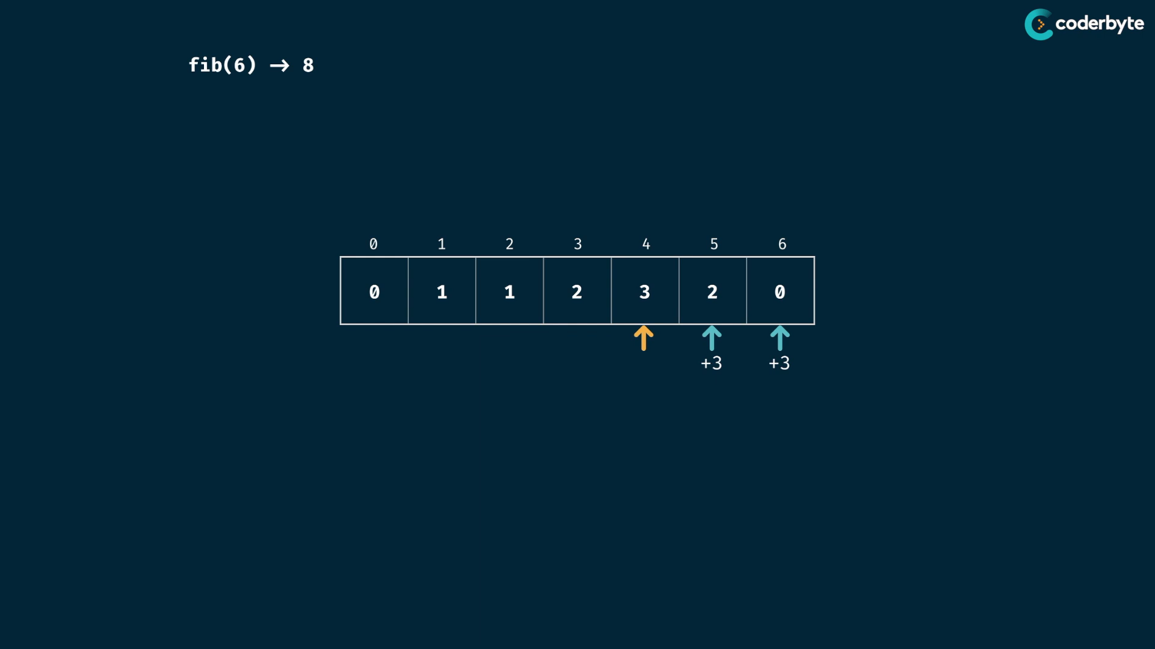

at last only one index addition takes place ..

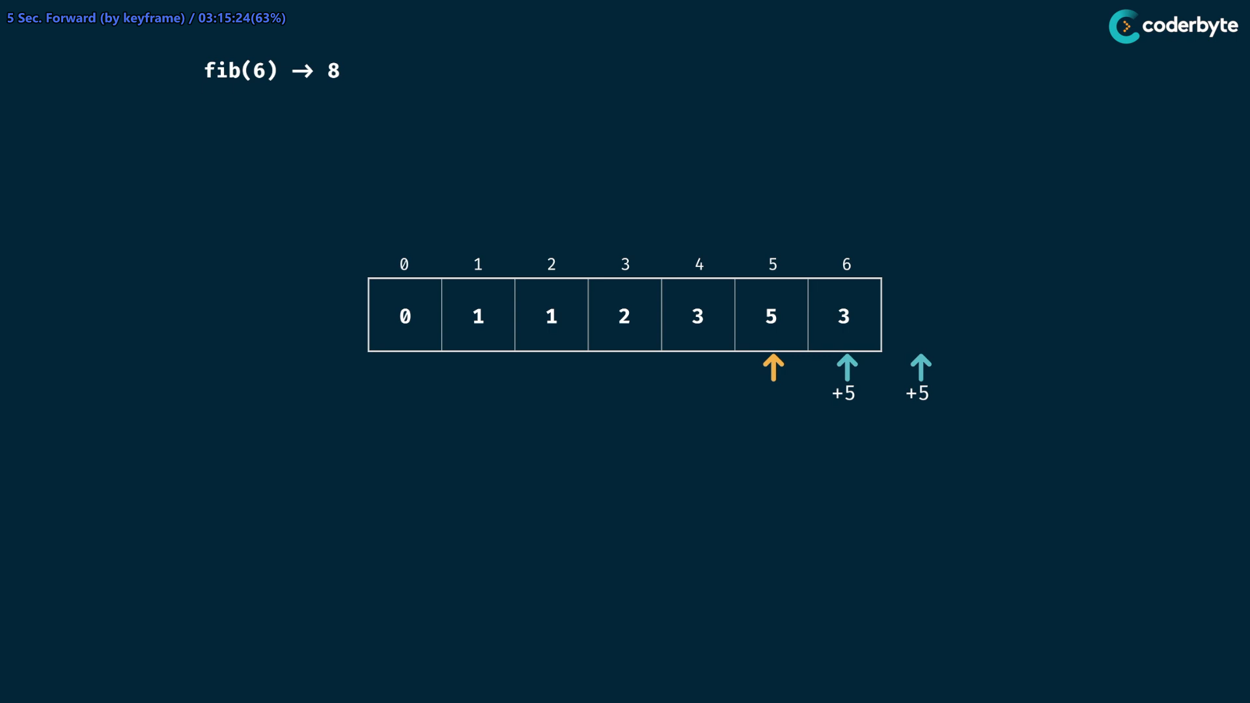

atlast none as next index…

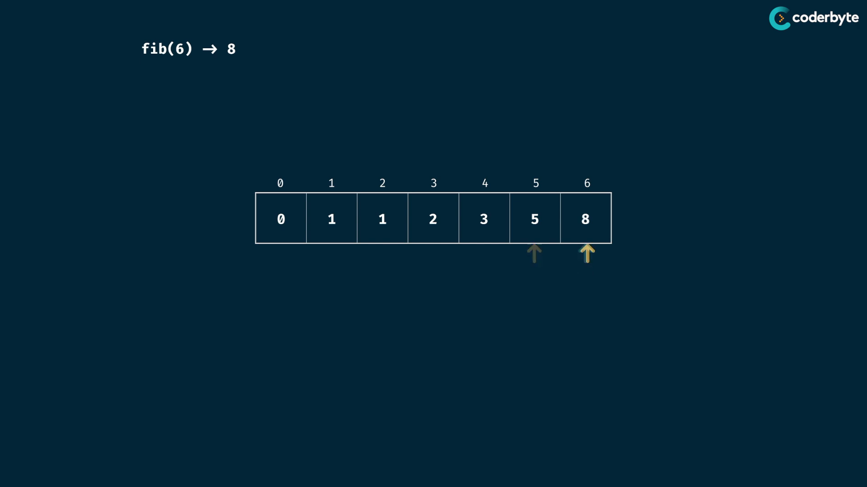

complexity is straight forward ,

tm.cmplx. is O(n) since we iterate through the size of array here

sp.cmplx. is O(n) since we just used the space of the array …

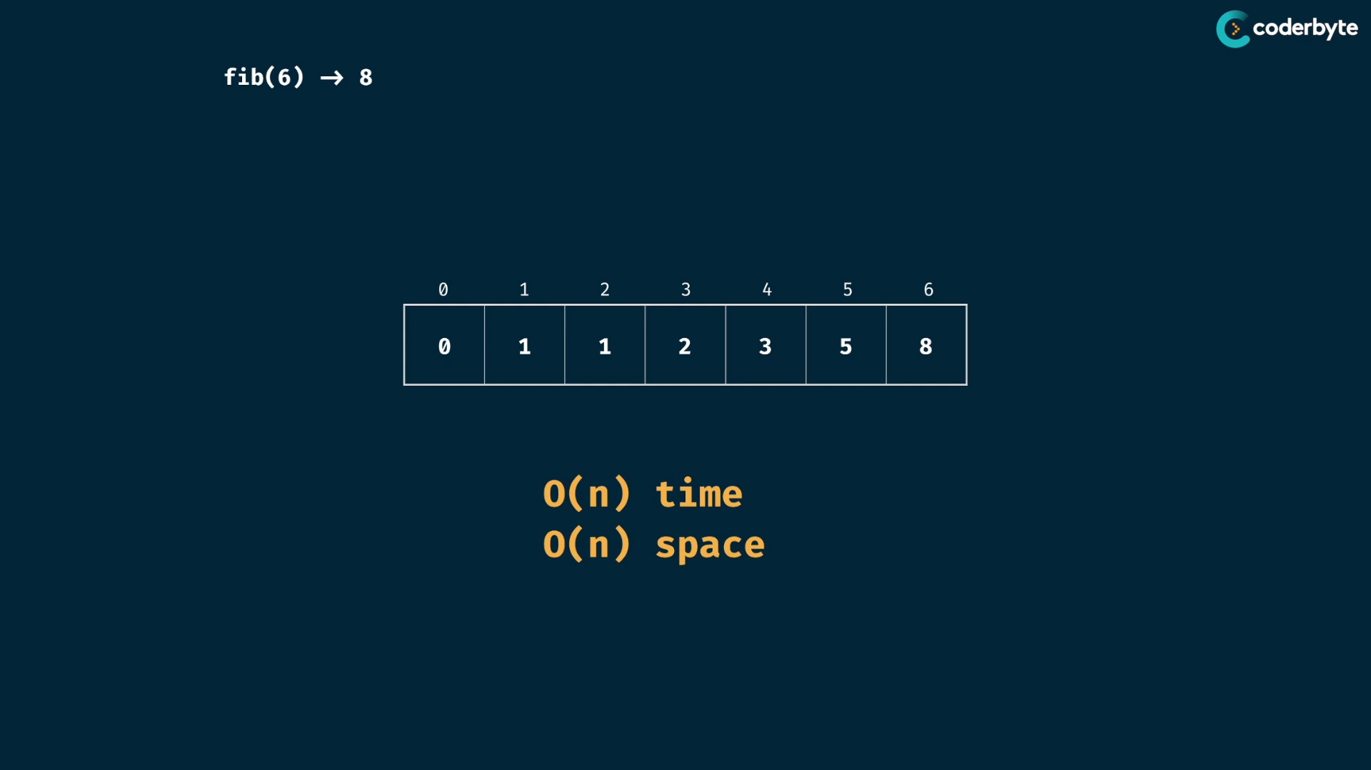

table:

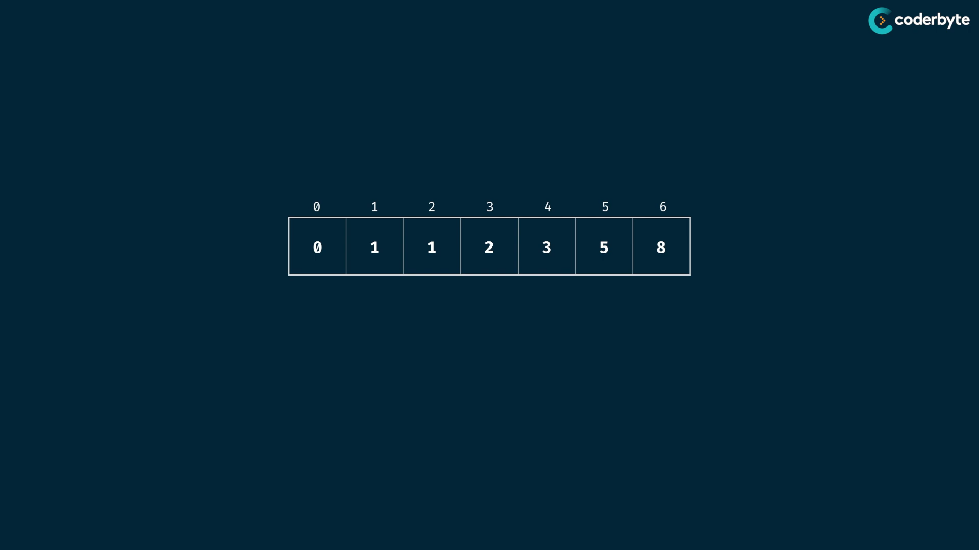

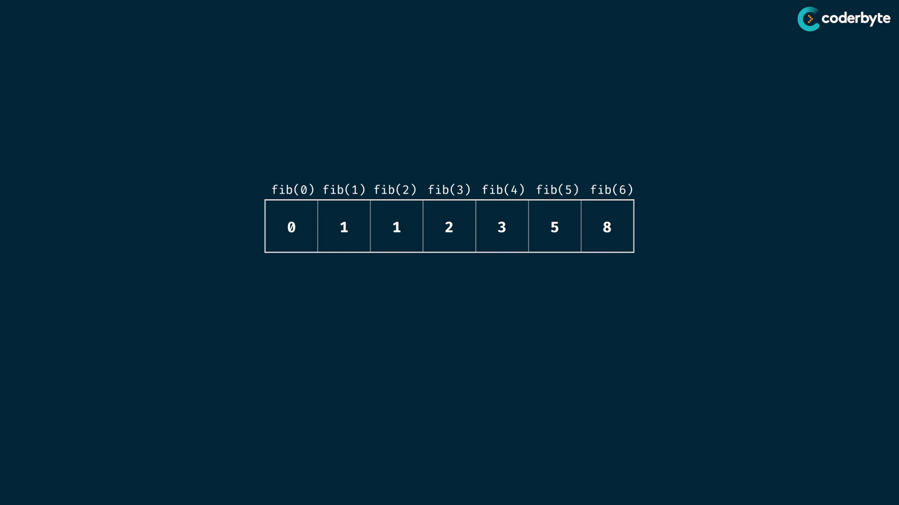

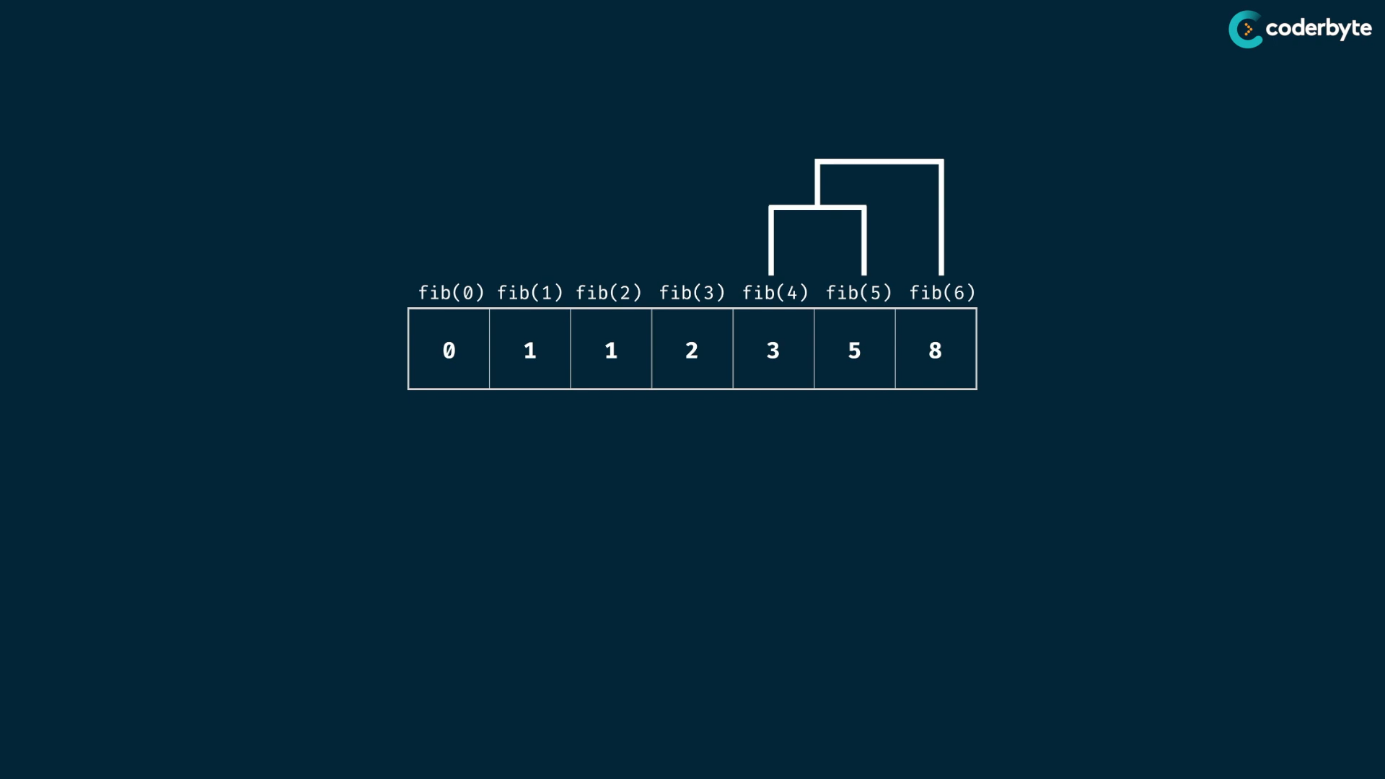

its just like tree … instead of recursive tree , we done on table ..

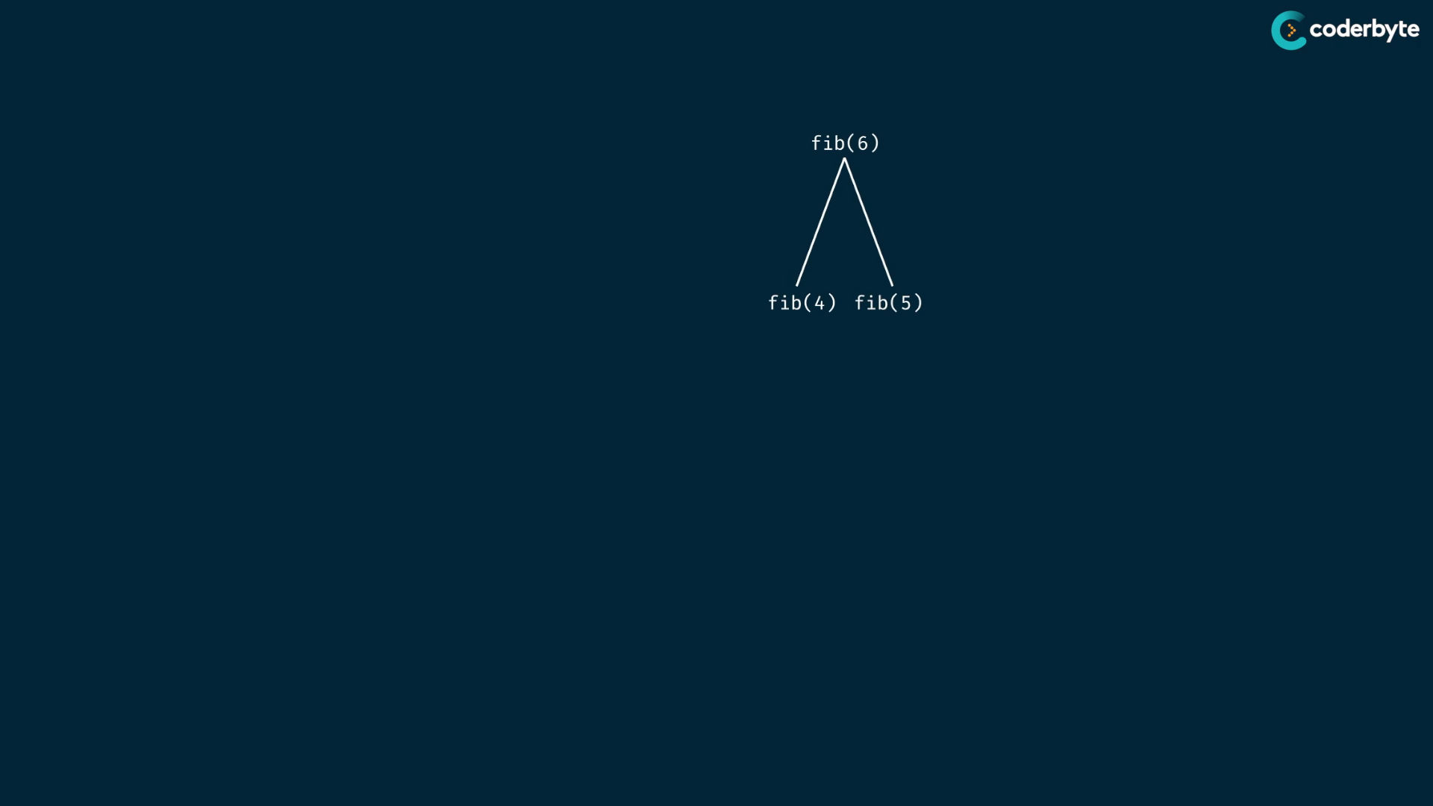

code :

*//+  tab. fib*

const fib = (n) => {

*// creates array of size n+1 with dft val as 0*

   const table = Array(n+1).fill(0);

*// seed case*

   table[1] = 1;

*// note: no need to manage array out of bounds in js ..*

*// since array size is dynamic in js..*

   for(let i=0;i<=n;i++){

       table[i +1] += table[i];

       table[i +2] += table[i];

   }

   return table[n];

};

console.log(fib(6)) *//=> 8*

console.log(fib(7)) *//=> 13*

console.log(fib(8)) *//=> 21*

console.log(fib(50)) *//=> 12586269025*

console.log(fib(1000)) *//=> 4.346655768693743e+208*

tm.cmplx – O(n) , Sp.cmplx – O(n)

**Fib at constant time:**

//+  tab. fib

*const* fib = (*n*) *=>* {

    if (*n* < 2) return *n*;

*let* bck2 = 0,bck1 = 1;

    for(*let* i=2;i<*n*;i++)

        [ bck2, bck1 ] = [ bck1, bck2+bck1 ]

    return bck1+bck2;

};

console.log(fib(6)) //=> 8

console.log(fib(7)) //=> 13

console.log(fib(8)) //=> 21

console.log(fib(50)) //=> 12586269025

tm.cmplx – O(n) , Sp.cmplx – O(1) constant space .. i.e 2 spaces all time ..

Grid traveller using tab:

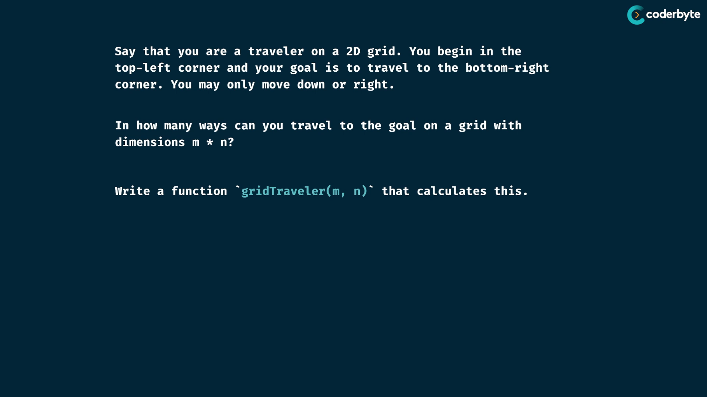

* first step to create table roughly the size of inputs..

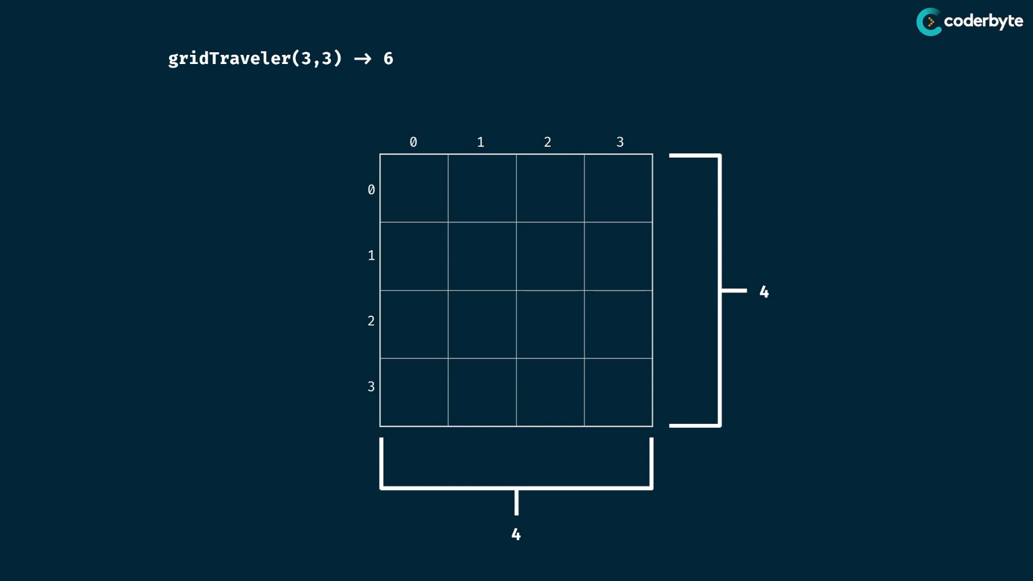

for 3,3 we maintain 4,4 table since bottom right of the table is to be 3,3

begin the table value with 0 here , since 0 repr. distance .. so that become the seed values ..

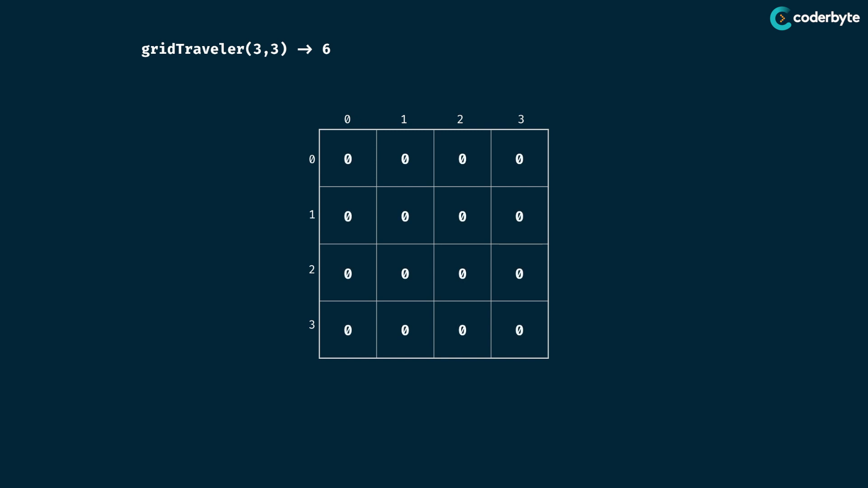

we observed that grid(1,1) gives 1 , so make it on the table …

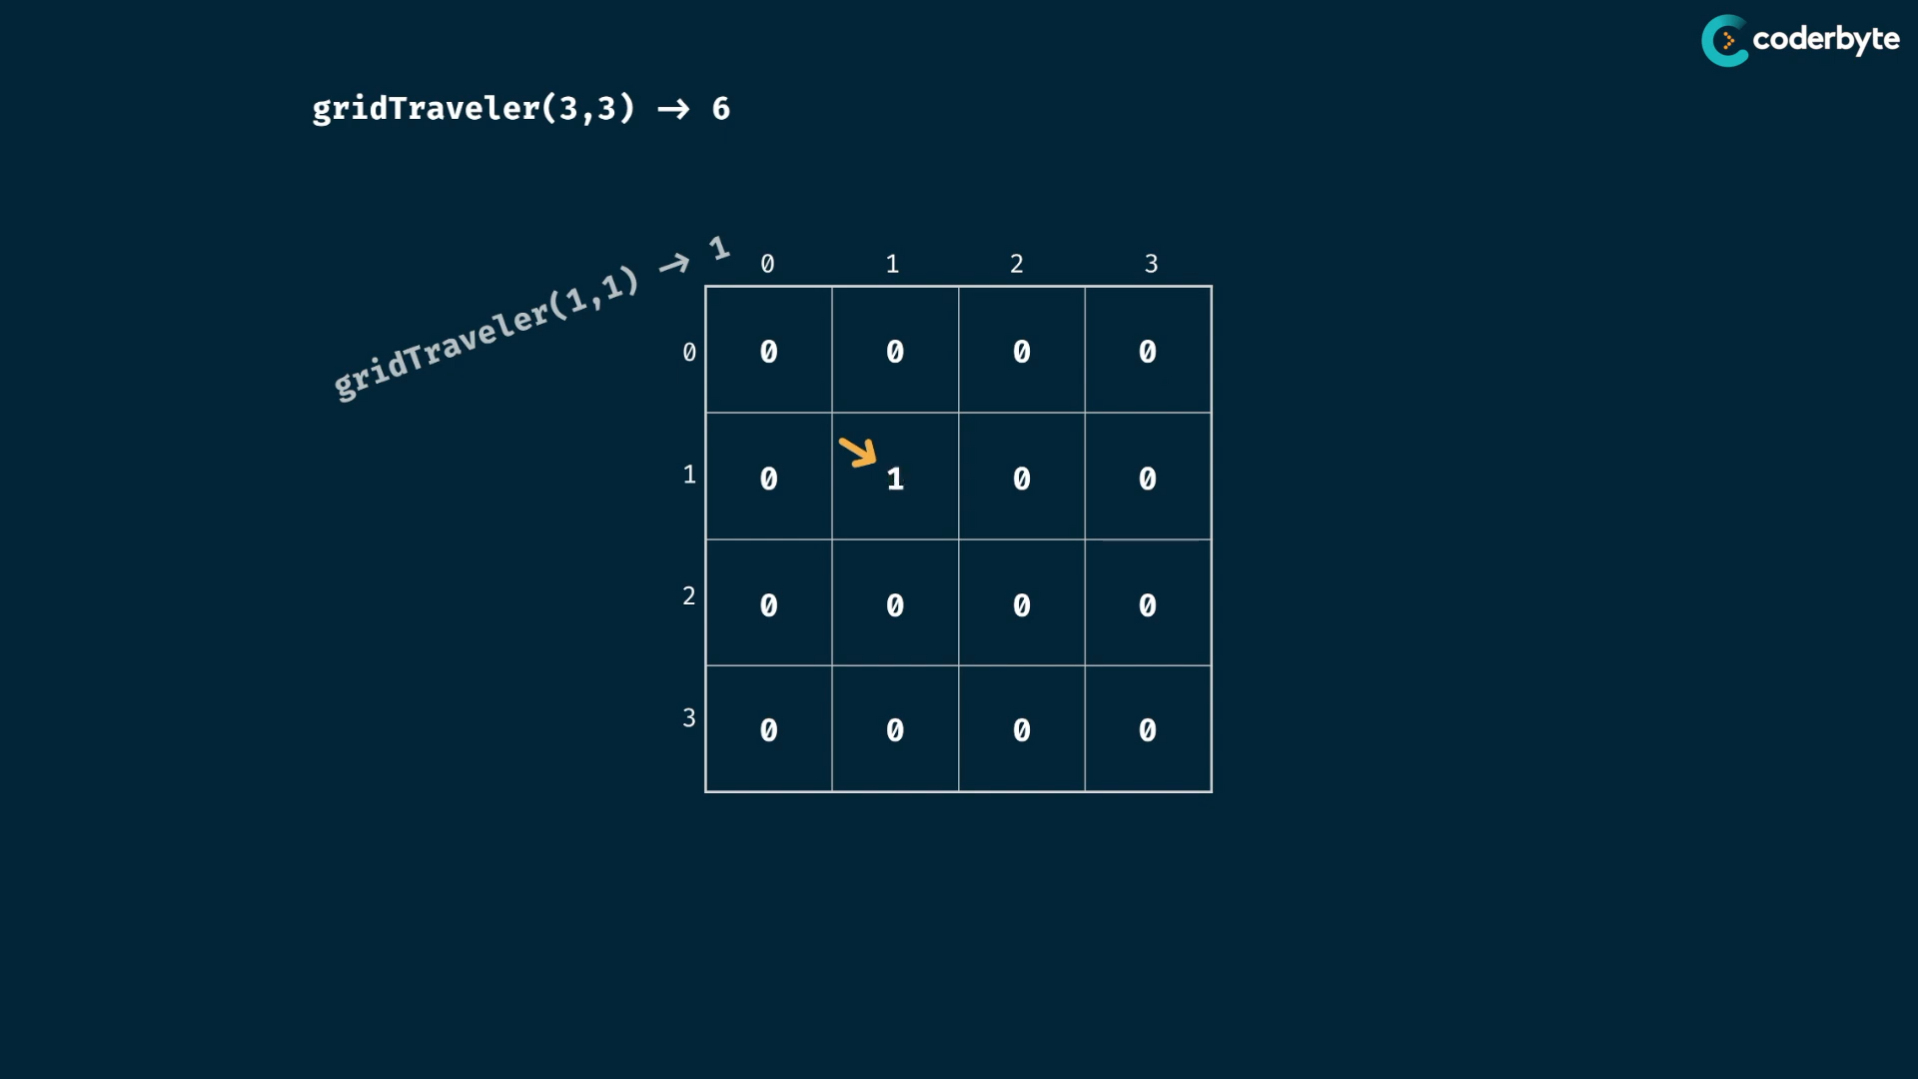

now iterate through table and combine those subprob. to give soln. of main prob.

we implement it with nested for loops since the dimension of table increases .

solve is done by taking current positions and add them to their right and down adjacents ..

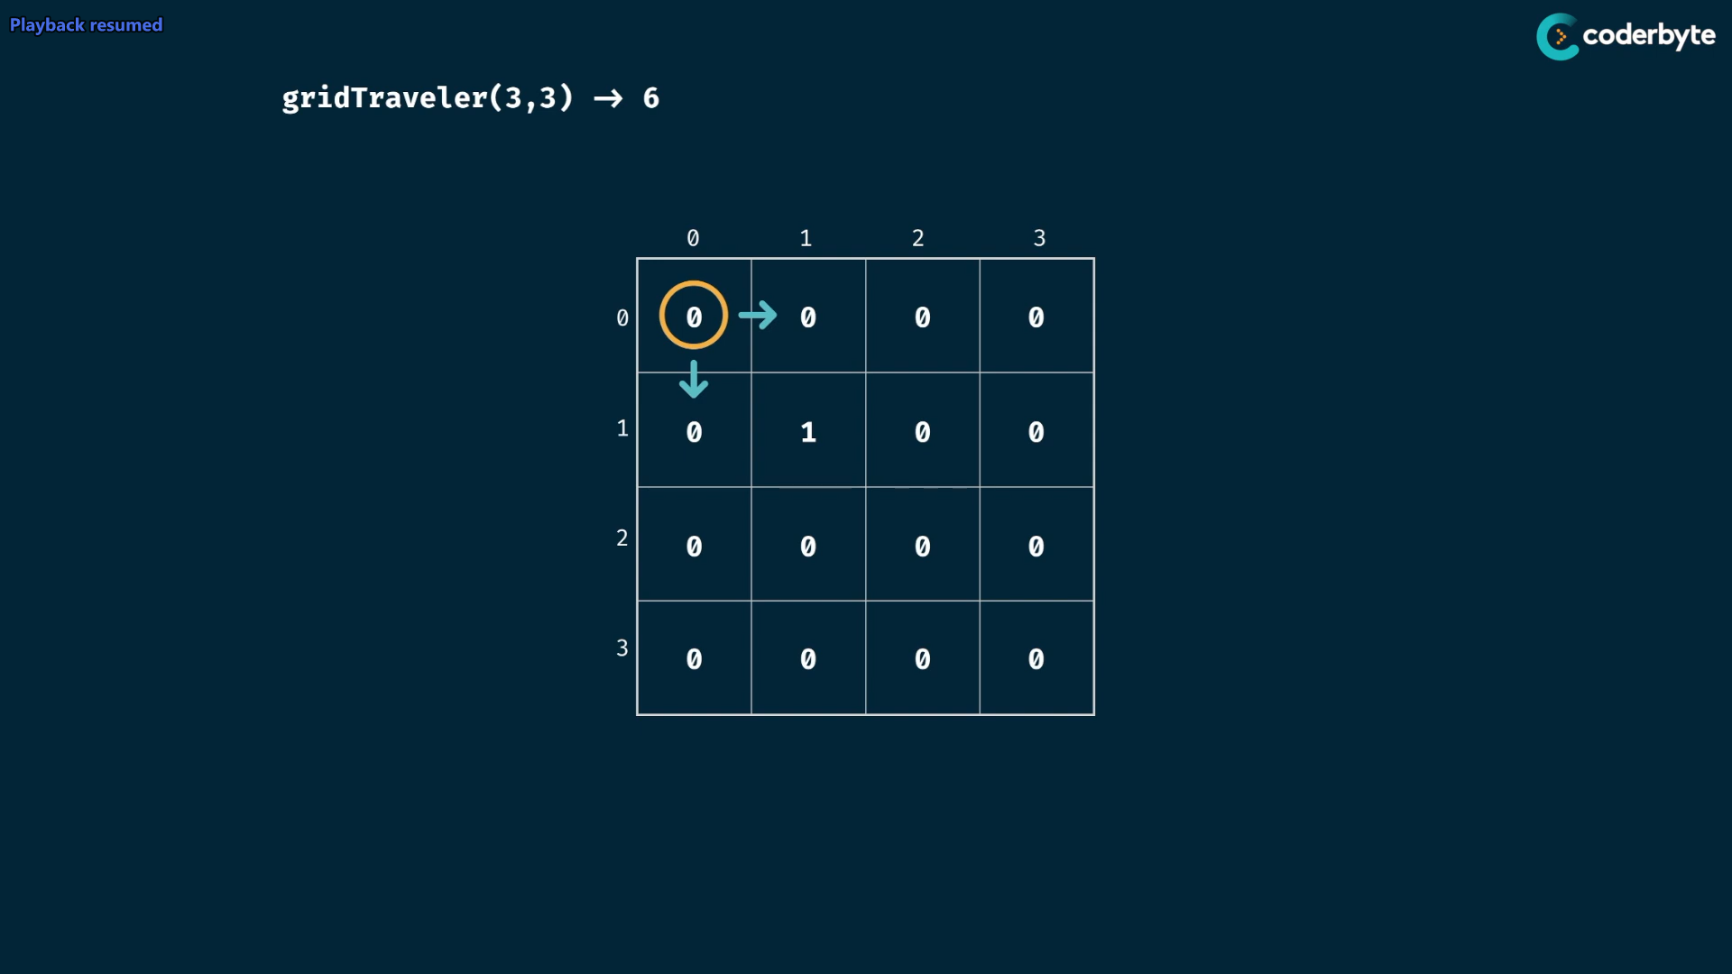

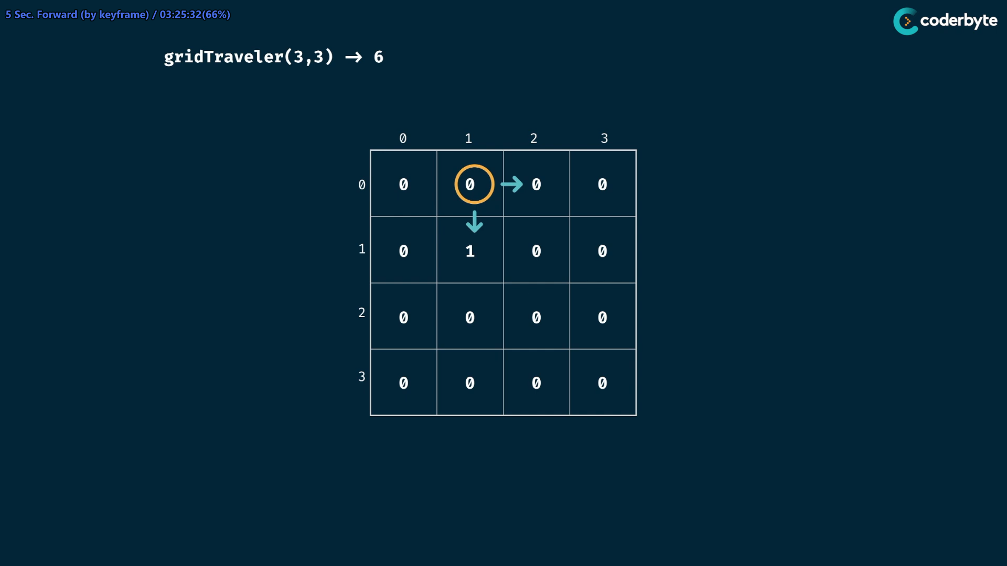

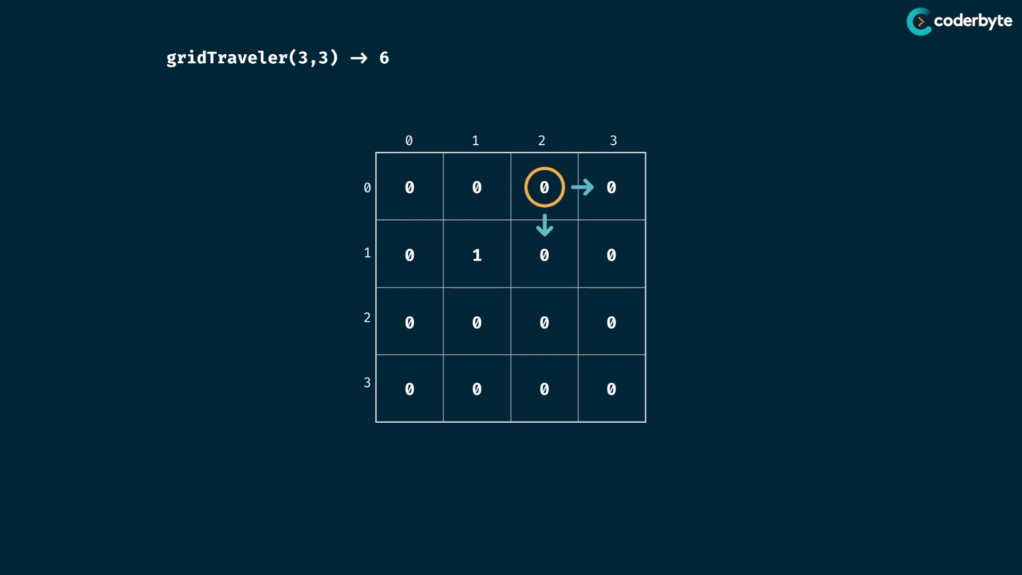

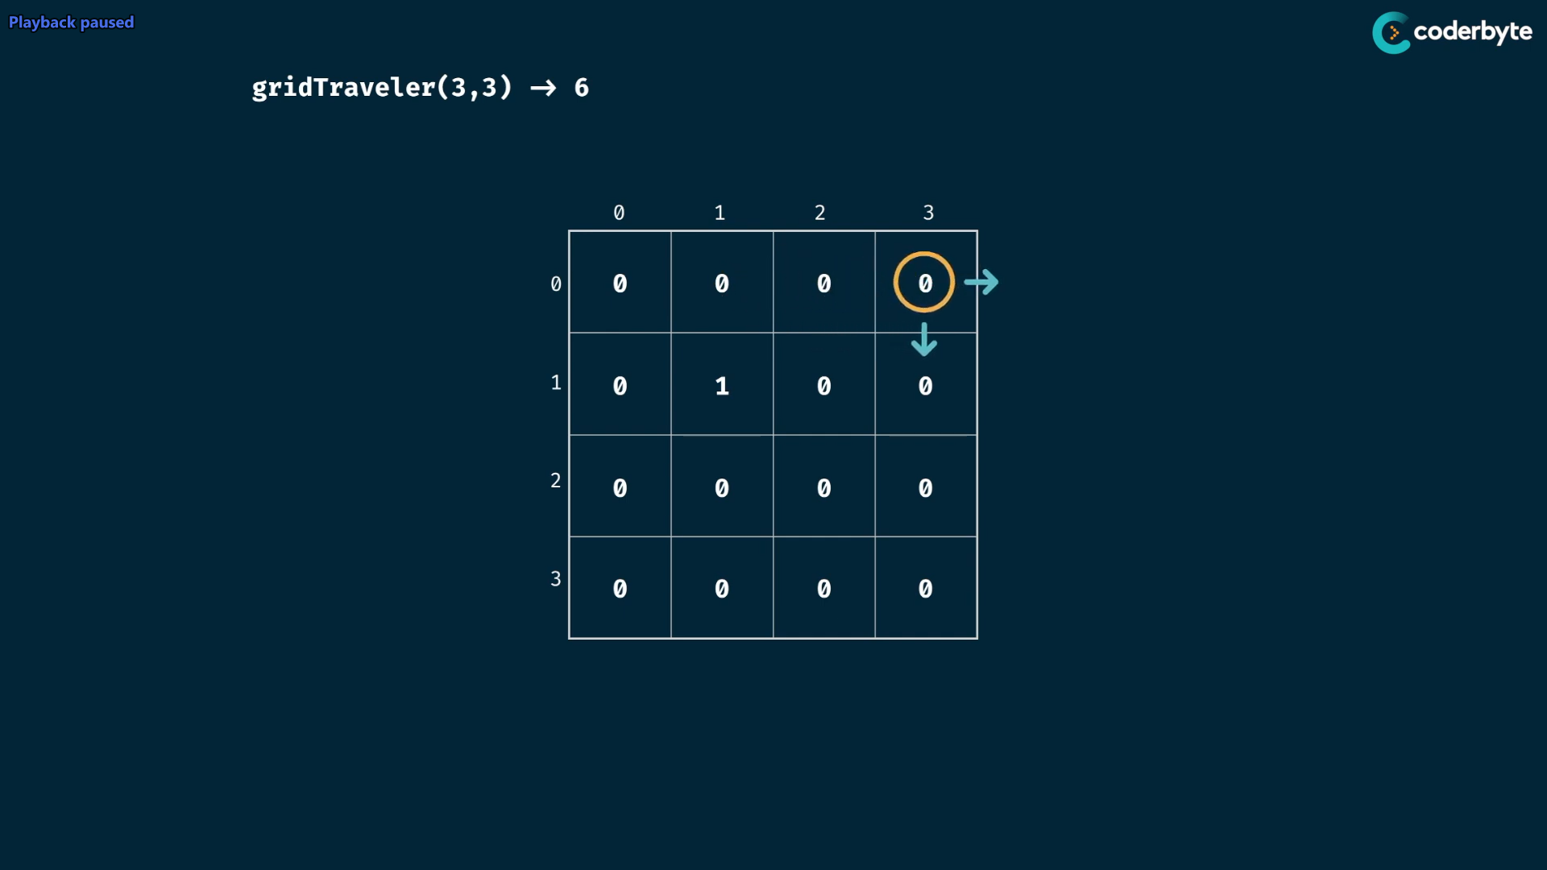

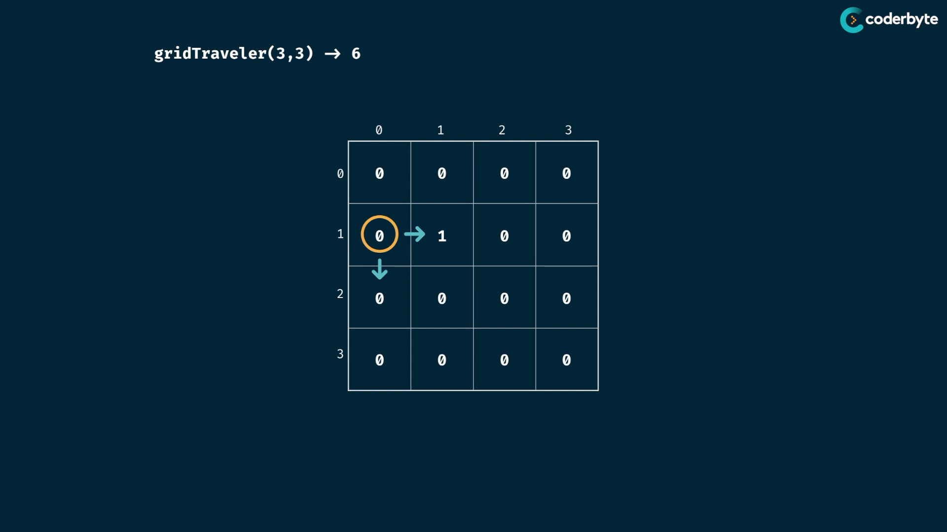 …. likewise goes on …

in prog. we have to manage the out of bounds things …

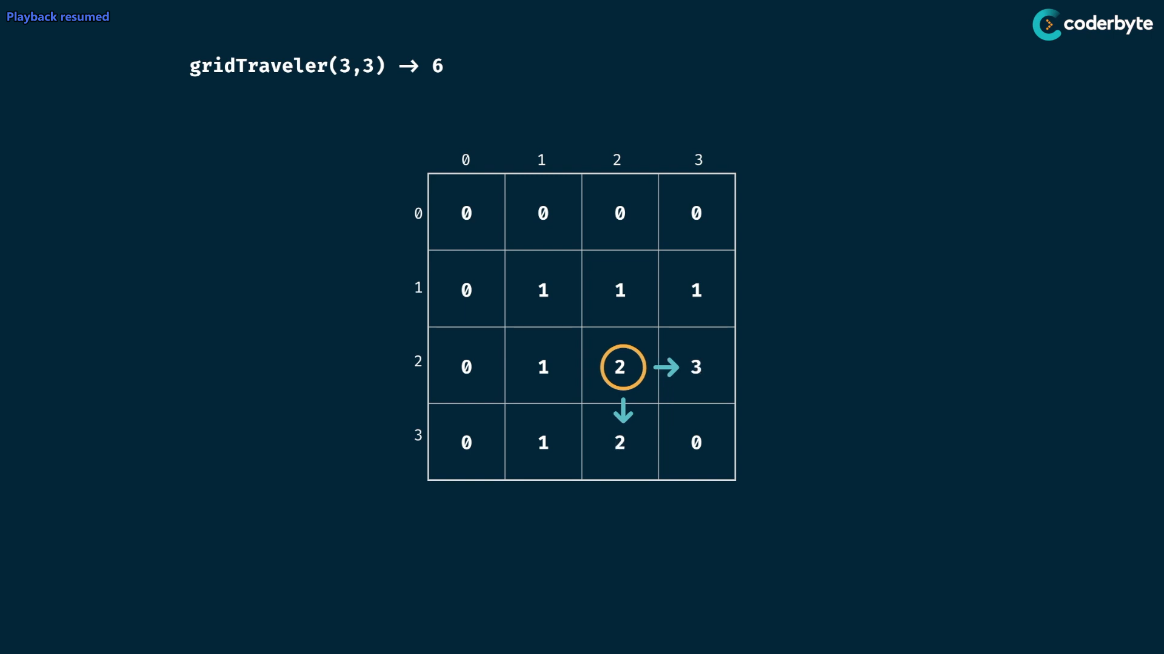

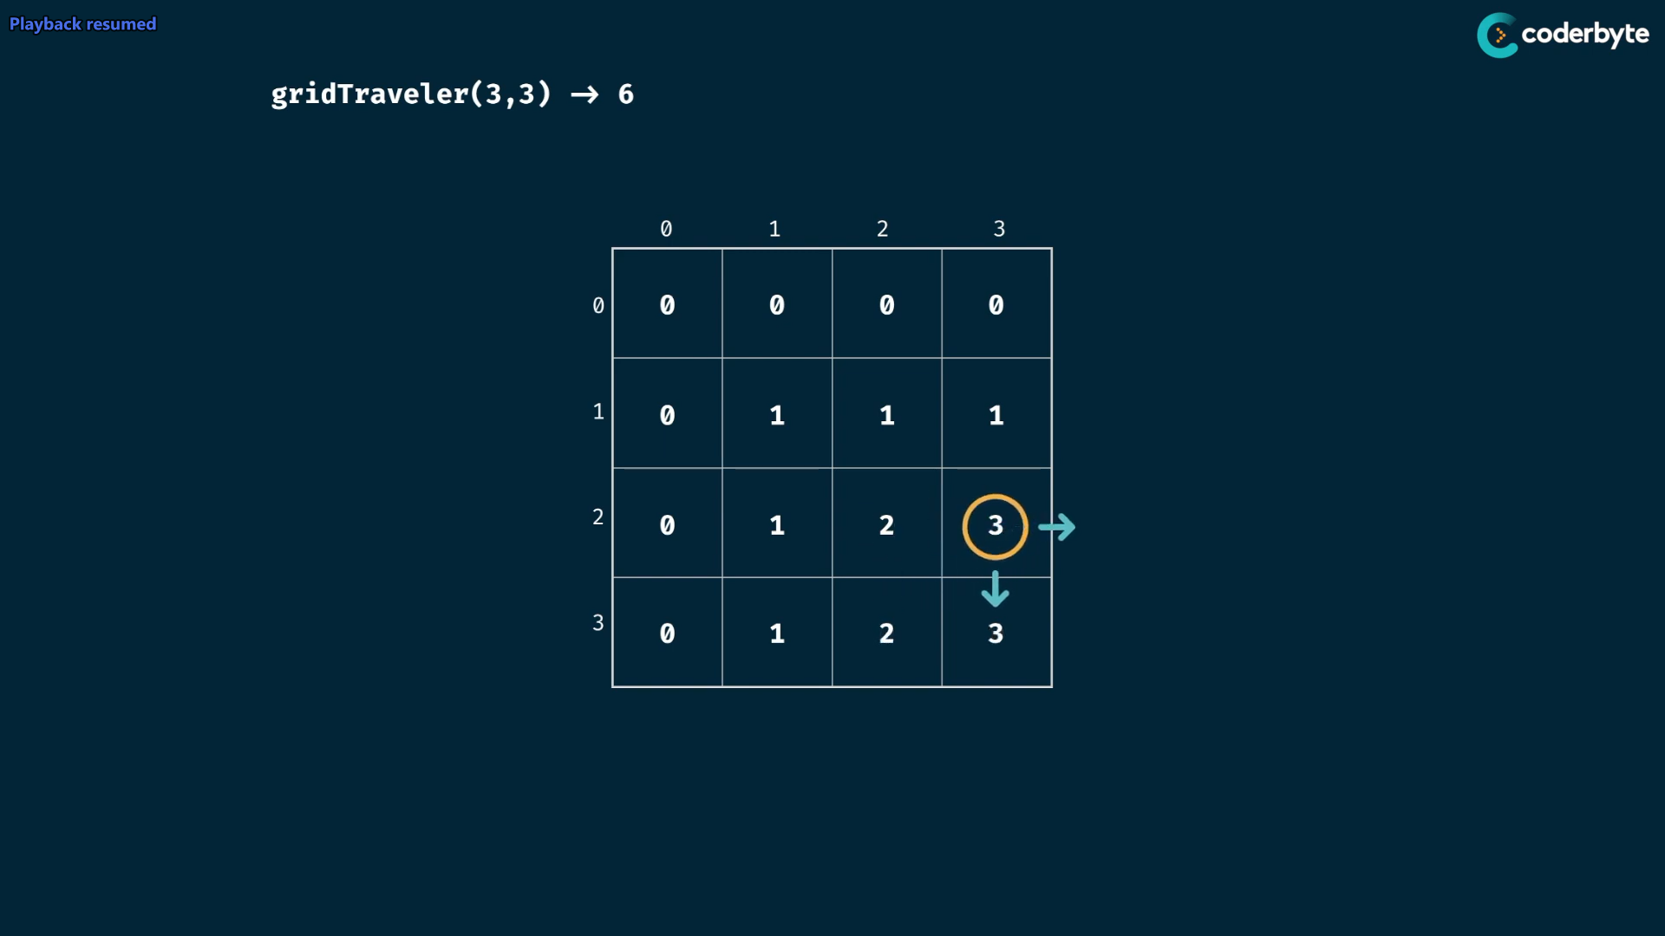

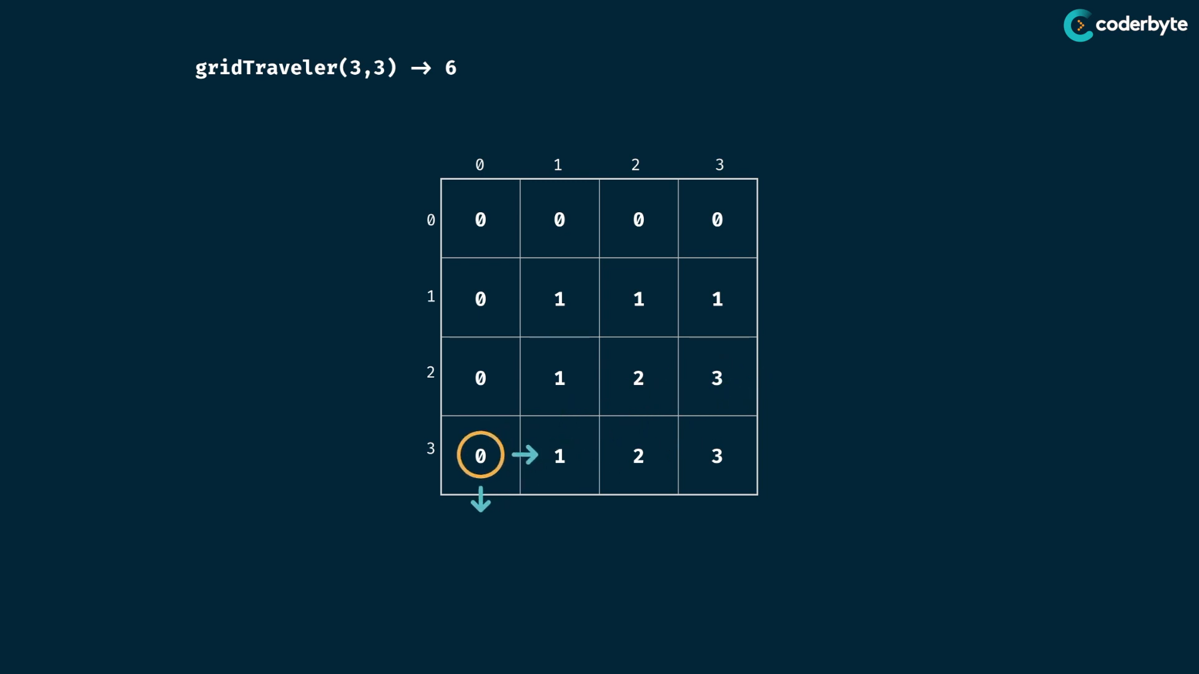

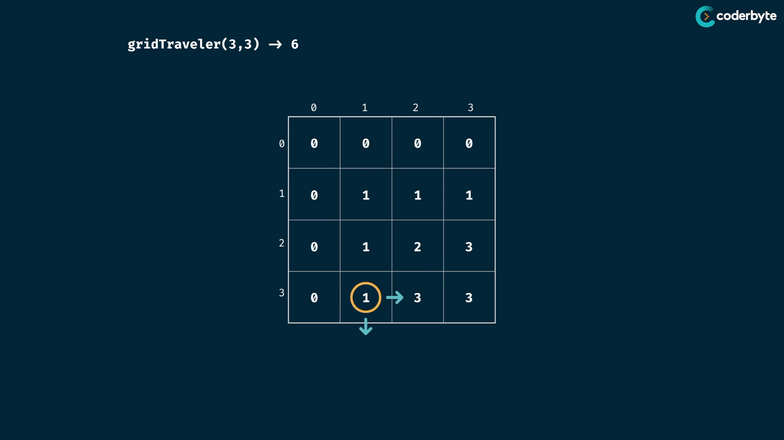

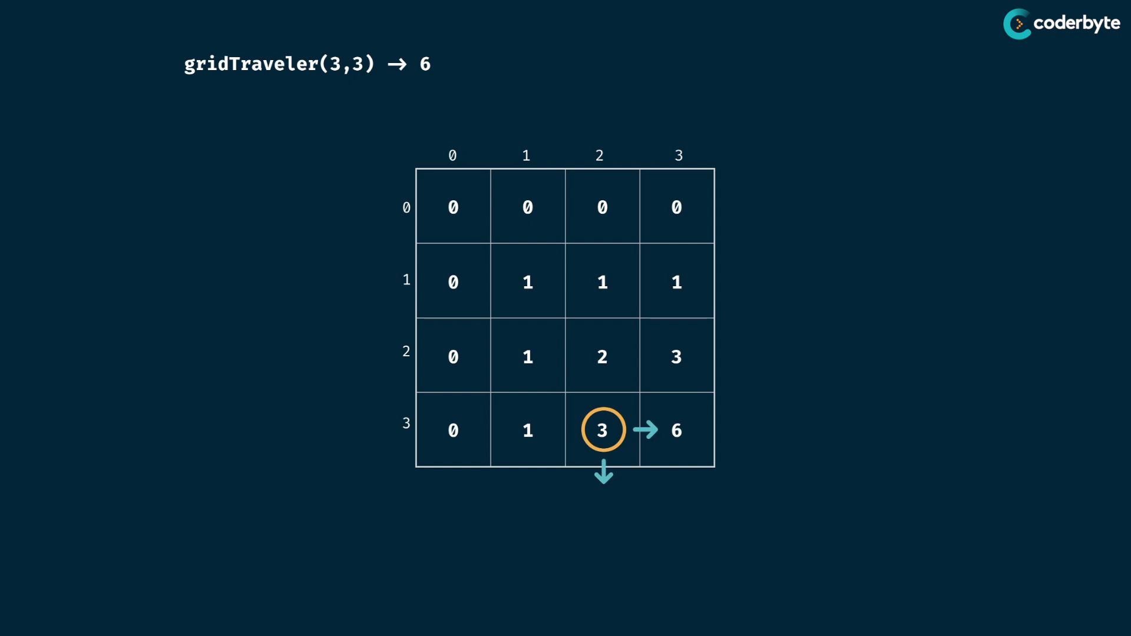

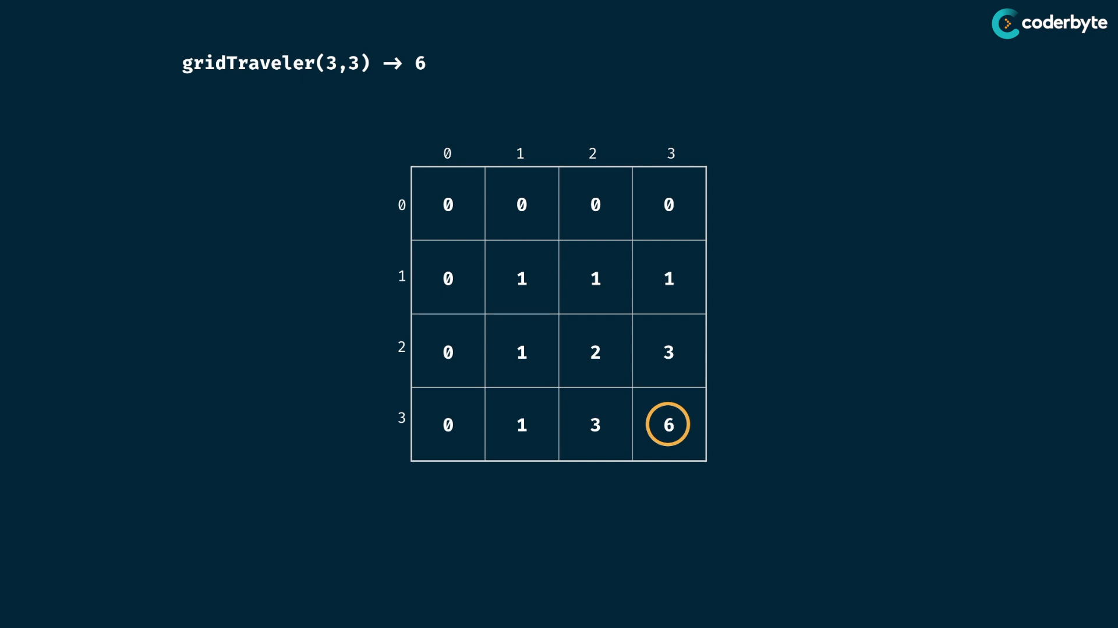

since table have m,n rows and columns, then the time cmplx. for iteration is O(mn)

and space is O(mn)

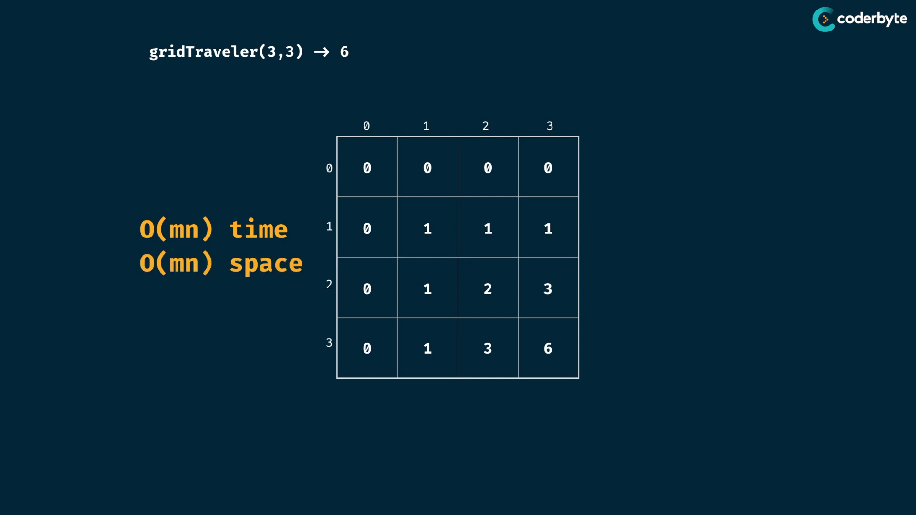

single array instance problem

*// array single instance prob. management*

ary1 = Array(3).fill(Array(4))

console.log(ary1)

*/\**

*[ [ <4 empty items> ], [ <4 empty items> ], [ <4 empty items> ] ]*

*\*/*

ary1[1][1] = 1

console.log(ary1)

*/\**

*[*

*[ <1 empty item>, 1, <2 empty items> ],*

*[ <1 empty item>, 1, <2 empty items> ],*

*[ <1 empty item>, 1, <2 empty items> ]*

*]*

*\*/*

ary2 = Array(3)

      .fill()

      .map( () => Array(4) );

console.log(ary2)

*// [ [ <4 empty items> ], [ <4 empty items> ], [ <4 empty items> ] ]*

ary2[1][1] = 1

console.log(ary2)

*/\**

*[*

*[ <4 empty items> ],*

*[ <1 empty item>, 1, <2 empty items> ],*

*[ <4 empty items> ]*

*]*

*\*/*

code :

//+ tab grid traveler

*const* gridTraveler = (*m*,*n*) *=>* {

*const* table = *Array*(*m*+1)

        .fill()

         .map(

            () *=>* *Array*(*n*+1).fill(0)

        );

    table[1][1] = 1;

    for(*let* i=0;i<= *m*;i++){

        for(*let* j=0;j<= *n*;j++){

*const* current = table[i][j]

            if(i+1 <= *m*) table[i+1][j] += current;

            if(j+1 <= *n*) table[i][j+1] += current;

        }

    }

    return table[*m*][*n*];

}

console.log(gridTraveler(1,1)); //=> 1

console.log(gridTraveler(2,3)); //=> 3

console.log(gridTraveler(3,2)); //=> 3

console.log(gridTraveler(3,3)); //=> 6

further updated:

*//+ tab grid traveler updated*

const gridTraveler = (m,n) => {

   const table = Array(m+1)

       .fill()

        .map(

           () => Array(n+1).fill(0)

       );

   table[1][1] = 1;

   for(let i=1;i<= m;i++){

       for(let j=1;j<= n;j++){

           table[i][j] +=  table[i-1][j] + table[i][j-1];

       }

   }

   return table[m][n];

}

console.log(gridTraveler(1,1)); *//=> 1*

console.log(gridTraveler(2,3)); *//=> 3*

console.log(gridTraveler(3,2)); *//=> 3*

console.log(gridTraveler(3,3)); *//=> 6*

Tabulation outline:

* for tab, see the prob. in form of table like tree for moi …
* based on input size , make the respective workable table
* fill table with basic value which has to repr. nothing , for number make it as 0 or 1 based on add or mul or other things,,, incase Boolean make it as false etc.. followed respectively.
* table is first filled with seed values which give the trivial ans , so that the prg. further run depends on it .
* iterate the table using nested loops based on table dimensions
* do correct operation on each cell of the table based on observing prob.

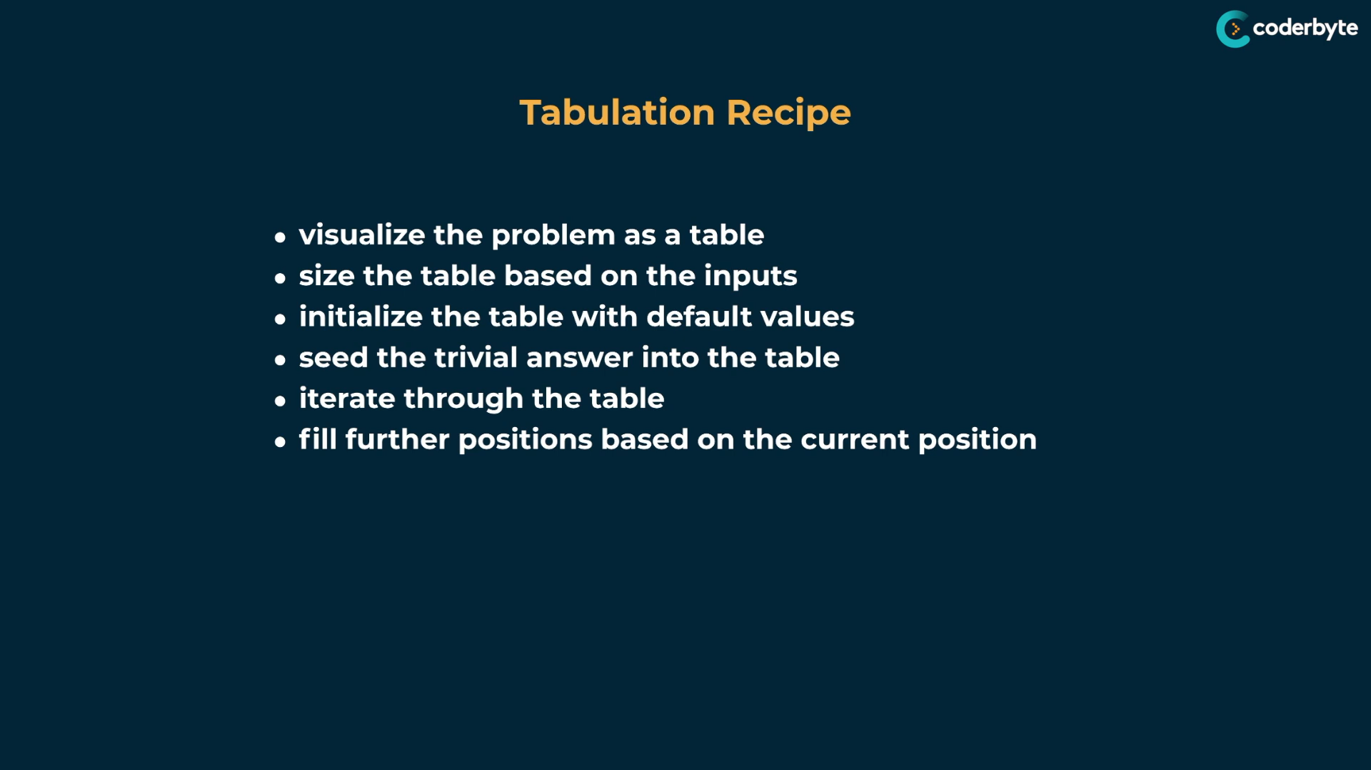

**final advice of DP:**

* find there is overlapping subprob. is present or not
* focus on input and output of the problem , particularly its type
* find trivial smallest input and find its unique behaviours of base and seed cases .

string prob – empty string

array prob – empty array

number prob – 0 or 1

* relate the smallest case with the larger ones
* think recursively to use memorization
* think iteratively to use tablulation

note:

* mostly memorization is loved by many then tabulation, but interview we always have an option of selecting one
* draw pseudocode and process …. so that you much understand the prob. and soln effectively .. and also easy for explaining others.

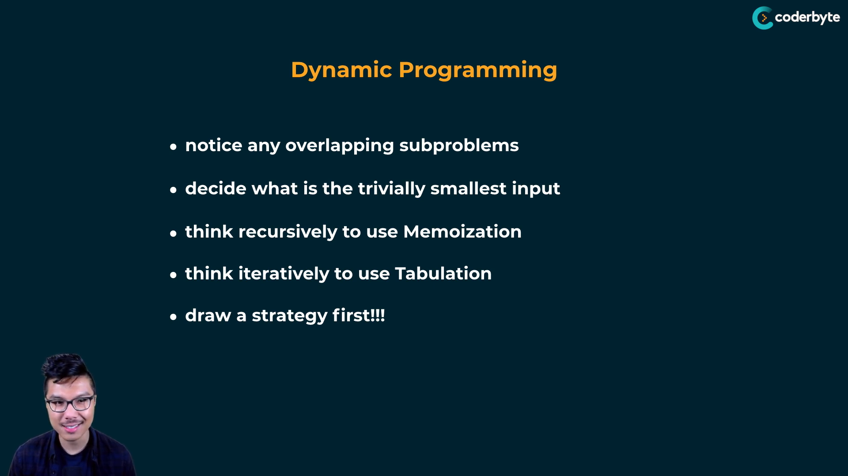

go and solve - [www.coderbyte.com](http://www.coderbyte.com)